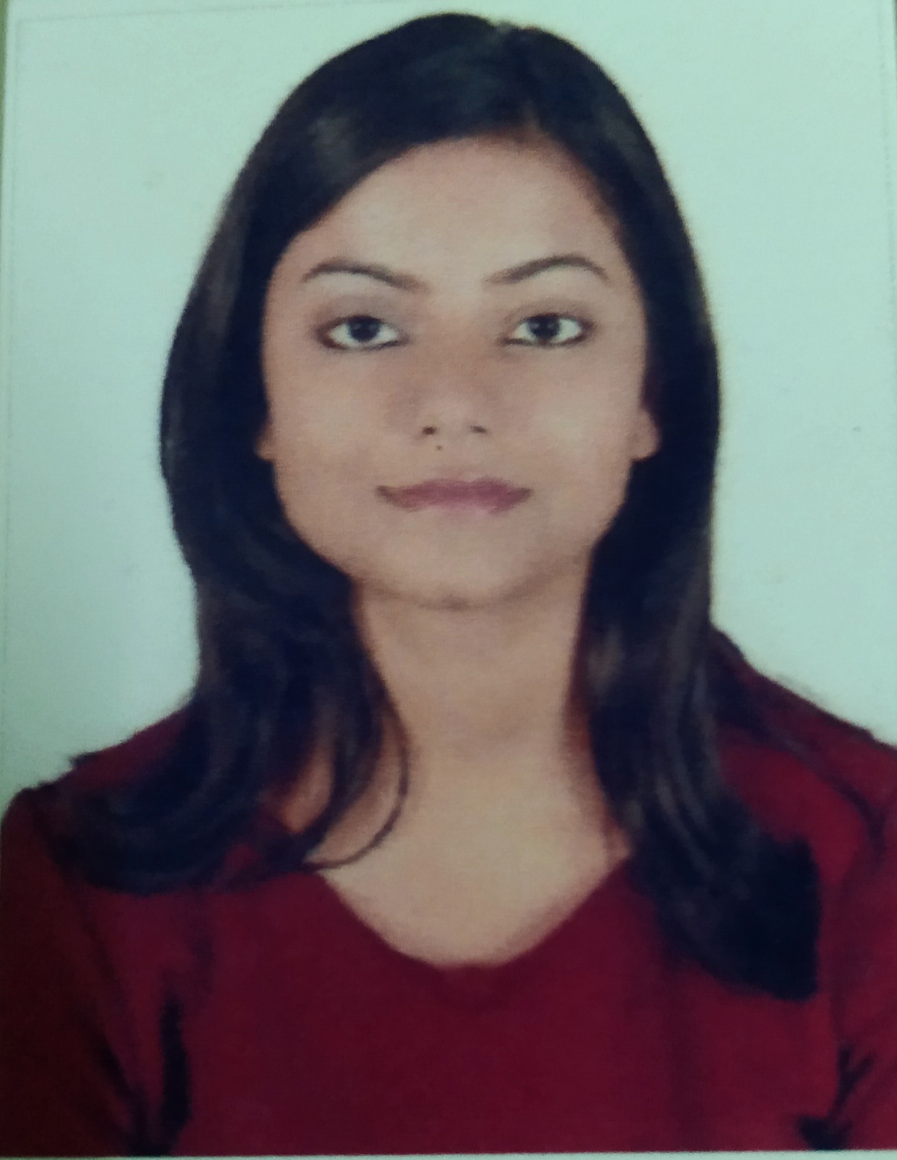 |  | SYONA PRASAD  Research & Innovation Engineer
PROFILE DESCRIPTION  Working as Research & Innovation Engineer in field of Data Analytics over 1.9 years. Aiming to utilize my strong prioritization skills and analytical ability to achieve the goals of your company. Possess a Bachelor of Engineering degree from Birla Institute of Technology, Mesra in Information Technology with a CGPA of 7.84. Have been consistently praised as focused and hardworking. Whether working on academic, extracurricular, or professional projects, I apply analytical, critical thinking, management, teamwork, and communication skills.  Enclosed is my resume for perusal. Please contact me at 7762850155 or via email at prasadsyona@gmail.com to arrange for a convenient meeting time.  Contact  PHONE:  7762850155  Email- prasadsyona@gmail.com  Hobbies  Singing and Listening to good music  Dancing  Travelling  Badminton  Yoga  AsPIRATIONS  Leading an Analytics team.  Being able to gain new skill sets every day that are applicable to current role and future career opportunities  Being able to make use of technology and my skill sets to contribute to the organization.  Being able to work with a strong management team and be a part of it.  OTHER KEY ACHIEVEMENTS  o Microsoft Certified Data Analyst Associate  o Udemy Certified [Microsoft Power Bi Complete 2020 edition].  o Udemy Certified for [Business Analyst Intelligence Course].  o Annual recognition Award 2019 for best Data team practices by Adrosonic IT Consultancy Services.  o HPES/RCPL- Winter training (Core java) Dec 2017-Jan 2018  o Steel Authority of India Limited — SQL database analytics, Summer Trainee MAY 2016– JULY 2016  o Certificate for scoring 10 CGPA in all India secondary examination.  o Certificate of merit for securing a rank of 160(International rank) in the final round of Math’s Olympiad, 2011-12.  o Certificate of merit for securing a rank of 118(International rank) in the final round of Science Olympiad in 14th National Science Olympiad. |  | EDUCATION  Birla Institute of Technology, ​Mesra —​B.E. (Information Technology) MAY 2015 -MAY 2019 cgpa-7.84/10  Delhi Public School, Ranchi ​— ​C.B.S.E. (12th Boards) Year: 2015 Percentage:91.2%  Bharatiya Vidya Bhavans, (West Bengal) ​— ​C.B.S. E (10th Boards) Year: 2013  CGPA:10  WORK EXPERIENCE & PROJECT DETAILS  Project Name: The Shipowner’s (Account Management Program)  2019(Aug)-2020(Dec)  Role: Understanding business requirements and accordingly building Reports/Dashboards in Web and Mobile apps for the Brokers and Member associated with Shipowners Club (United Kingdom based Marine Insurance firm), used by different Underwriters to keep track of the Profit gained from respective Broker and its Member based on premiums and profit values annually.  Successfully delivered Power Bi reports for Phase 1, Phase 1.1 and Phase 2 of AMP.  Tool: Microsoft Power BI, Microsoft Dynamics 365  Salesforce  2020(Jan-Feb)  Taking up business requirements to clean and transform the data to create attractive and insightful Reports, and Dashboards in Salesforce environment.  • Tools - Salesforce  Power BI Template app-  2020(Feb -till date)  Integrated Azure Devops with Power Bi to create a generic template app and published it to Microsoft App source for any organization to install and use and have complete 360 degree view of their Sprint and Project Health.  Create Sprint-End, Current Sprint Status ,Sprint shortcomings , Work item Status and Details Work Item Report providing complete user interaction with the app.  Responsibilities:  Communicate client’s business requirements by constructing easy to understand data and process model.  Draft and maintain business requirements and align them with functional and technical requirements.  Hands on working with Tableau for creation of Reports and Dashboards  Using different visualization methods to create informative and attractive reports, dashboards and KPI’s by importing data from different data sources like Excel, Microsoft CRM Dynamics 365 etc. to Power BI.  Expertise and hands on experience in Data modelling, Design, Data testing and analysis, DAX & M Queries, Power BI Visuals/charts, PowerPivot, mobile apps & Power Bi service.  Experience in working with Reports or Dashboards creation in Salesforce according to the Business requirements.  Experienced in practicing Agile development principles; specifically, the Scrum development methodology for every phases of Projects.  Well versed with Azure DevOps server and using it for tracking daily effort and standups.  Ability to manage multiple deliverables in parallel in a fast paced, demanding environment.  Adaptable and flexible in all working environments.  SKILLS

