AMAN RAMESH KUNDALIYA 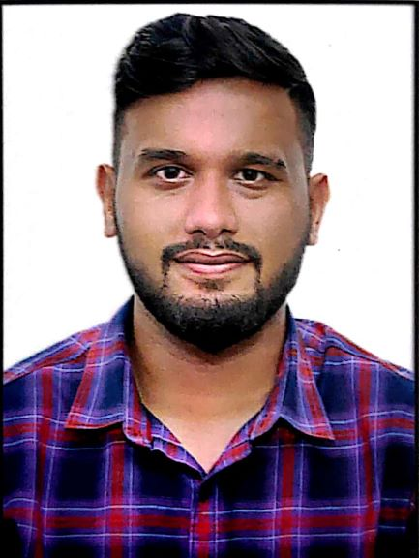

# Contact: -9971235974 Email: amankundalia09@gmail.com

# Career Objective:

To seek an Organization where my skills find ample opportunities for up-gradation of my knowledge and growth of my career and where I can prove myself. I also admire and acknowledge an Organization’s values and will prove an asset to them.

# Professional Summary:

* IT professional with 2 plus years of experience as a Salesforce Developer.
* Worked with Stakeholders and various divisions of Business using Agile Methodology to gather and document requirements for CRM implementation.
* Involved in Release Management process for continuous Integration of systems and code base.

# Educational Qualification:

* Completed B.tech in Information and Technology from Bhagwan Parshuram Institute of Technology ,affiliated to Guru Gobind Indraprasth University of Technology with overall 74%
* 12th from St. Marks Public School(CBSE Board) in 2013 with 85%
* 10th from St. Marks Public School(CBSE Board) in 2011 with 87%

# Technical Skills:

* Languages : Apex, Java, SOQL,C/C++
* Databases : MySQL
* Tool : ANT Migration Tool, Apex Data Loader, Source Tree, VS Code
* Frameworks : Salesforce Lightning

# Certifications:

* Salesforce Sales Cloud Consultant
* Salesforce Platform Developer I Certification
* Salesforce Administrator Certification

# Company Profile:

**Company Name:** Cognizant Technology Solutions

**Project Name:** Sales Cloud (HealthCare)

**Technology:** Salesforce Lightning Framework

**Period:** March 2018-October 2019

**Description:**

Emblem Health wanted to transform their way of doing business. So they came up with the idea of implementing Salesforce. This project is being developed in accordance with the agile technology

**Roles and Responsibilities:**

* Participate in software development on the Salesforce.com platform using Agile/Scrum methodologies
* Communicating with clients and stakeholders for problem resolution and requirement gathering
* Working on Salesforce Lightning framework customization.
* Working on Lightning Components, Apex Triggers, Batch Classes, Apex classes, configuration and possible customization.
* Data Migration of Marketing Data like Accounts, Contacts, Opportunities from Legacy Systems to Salesforce.
* Translate simple to complex user stories into functional and actionable software within the Salesforce environment
* Attend daily stand-ups, planning sessions, and retrospectives to plan, track, and code development taskss

**Company Name:** West Communications

**Project Name:** UCaas Post-Sales Implementation Automation

**Period:** October 2019-March 2020

**Description:**

Ucaas business unit sells and maintain PBX products (Voicemaxx CEetc.). Salesforce will reduce overall implementation time by automating the process. Salesforce will create tight interaction between ITC and MaxxPoint to reduce the implementation time.

**Roles and Responsibilities:**

* Worked on UCaasS to ITC integration and Postman Tool.
* Worked on Apex Web Services to make Apex class methods callable so that external applications can integrate with Salesforce.

**Company Name:** Iqvia

**Project Name:** Roche Engagement Process

**Period:** April 2020-Present

**Description:**

Roche wants their Engagement Process to be built on Salesforce.com Platform. By engaging with customers they can use their input to help us understand how to serve patients, their caretakers and physicians best. And this, in turn, is key for them to remain commercially successful

**Roles and Responsibilities:**

* Worked on Salesforce Configuration and Customization .
* Participated with developing Jira Tickets using Agile Methodology.
* Set up the Deployment Process Involving VS Code, Source Tree and Git.
* Involved in end to end activities from Development, Unit Testing to deployment.