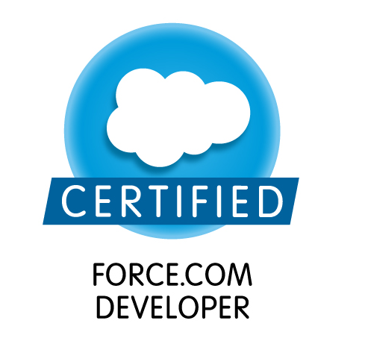
Sushant Yadav

Summary:
- ~4 years of experience in the Information Technology (Salesforce) industry.
- ~2.5 years of Salesforce Lightning Experience.
- Salesforce Certified Developer(App Builder, ADM 201, Platform Developer-1, Platform Developer-2).
- Reusable Lightning Components.
- Experience in Agile Methodology & DevOps.
- Experience in Git, Bitbucket, Jira, Confluence, Box
- Hands on Experience on Lightning and Communities implementation.
- Salesforce DX SFDX, Visual Studio (Development & Deployment).
- Sound development experience on Salesforce.com using the Force.com platform and a good understanding of the CRM.
- Experience in SFDC development using Lightning, Apex classes, Communities, Triggers, Visual Force, SOQL, SOSL.
- Proficiency in SFDC Administrative tasks like creating Profiles, Roles, Users, Record Type, Approvals, Workflows, Validation rules, Reports, Dashboards, Tasks and actions.
- Administration, Configuration, Implementation and support experience on Salesforce.com platform.
- Experience in Data Migration using Import wizard and Apex Data Loader.
- Experience in using tools like Form Assembly, VS code, ANT migration tool, Mavensmate, Force-IDE, Workbench, Process Builder, WorkFlow.
- Deployment using ANT, VS code, SFDX, Version Controlling.
- Lightning Component Debugging using VS code, Lightning Optimizer, Lightning inspector
- Experience working with salesforce.com sandbox and production environment.
- Good experience with Communities, SOQL, SOSL, Relationships.

Skills:
- CRM: SALESFORCE.COM
- Languages/Technologies: Lightning, Aura Framework, Apex, Visualforce, Force.com, Apex Triggers, Data Loader & Import Wizard, SOSL & SOQL.

Experience:
Accenture (Bangalore, Karnataka) July 2015 – Till Date

Certifications and Achievements:
- App Builder Certified, ADM 201 Certified Developer, Platform Developer-1, Platform Developer-2

Education:
- B.E. in Mechanical Engineering from PES Institute of Technology, Bangalore affiliated to VTU (2011-2015) (CGPA – 7.45) (74.5%)
- 10th from CBSE (Army School, Faridkot) with 90.04% in the year 2008
- (10+2) from CBSE (DAV public School, Kota) with 63.4% in the year 2010

Projects Undertaken:

CLOUD FIRST DELIVERY TOOLKIT :-

Role: Salesforce.com Developer
Description: The Cloud First Delivery Toolkit is a custom application built on the Force.com platform to enable Accenture’s Value Delivery Methodology. Specifically, it has three distinct components:
- PMO: Allows teams to manage requirements from inception through deployment, manage the change control process throughout a program, allocate work effort to effectively manage the work effort across distributed teams, collaborate with client and internal team members, manage project management activities (i.e., action items, issues/risks, key decisions), and manage testing defects. NOTE: This is the primary use of the Cloud First Delivery Toolkit. The Toolkit is now mobile-enabled and provides a friendly mobile experience for day to day project delivery needs.
- Estimator: Based on our SaaS ADM Estimator, allows resources to estimate work effort for each requirement. NOTE: Most project teams leverage our ADM Excel based estimators versus this component. They either data load or manually enter estimates from the ADM estimators into the Cloud First Delivery Toolkit.
- Capacity Planner: Allows resources to plan releases based on estimated work effort and available resource capacity. NOTE: Most projects often leverage more robust capacity tools outside of the Cloud First Delivery Toolkit when developing detailed resource models/staffing models.

Responsibilities:

- Created Visualforce pages & Apex Code
- Designed, developed and deployed Apex Classes, Controller Classes and Apex Triggers for various functional needs in the application.
- To write SOSL and SOSL as required.
- Implemented various advanced fields like Picklist, Custom Formula Fields, Field Dependencies, Validation Rules, Workflows, sharing rules and Approval Processes for automated alerts, field updates and Email generation.
- Preparing the unit test plans & documents.
- Executing unit test plans.
- Got the chance to work on Javascript, Jquery, Bootstrap.
- To write Batch Classes to automate the sending of mails.
- Implemented critical requirements related to Burn Down Charts, Gantt Chart, Sprint Planning View.
- Worked in delivering Agile Toolkit Package.
- Created Managed Package based on each release and the requirements.
- To write trigger and unit test classes for code coverage.
- Environment: Force.com, Apex, Visualforce, Apex Triggers, SOSL & SOQL.

- Wyndham Worldwide :-

Responsibilities:

- Communities Setup using Napili Template.
- Working on Account Contact Relationship Object introduced as part of Winter 17 to create many to many relationship between account and contact.
- Worked on Creating Apex Sharing Rules, Sharing Rules.
- Configuring Case object for the support agent to log cases related to site(Hotels).
- Setting up Salesforce1 app for the sales rep with different permission settings.
- Cleaning up existing data and loading the data related to different franchises in salesforce using DataLoader.

- ENEL :-

Enel is an Italian multinational manufacturer and distributor of electricity and gas. Enel, which originally stood for National Board for Electricity, was first established as a public body at the end of 1962, and then transformed into a limited company in 1992

Responsibilities:

- Setting up Communities for Enel Customers using Napili Template.
- Created Reusable Lightning Components that were used for 50 different record types.
- Created custom solution of filtering picklist values based on record types in Lightning.
- Custom solution for dependent picklist that is not present out of the box.
- Using Process Builder to implement some of the functionality.
- Designed, developed and deployed Apex Classes, to implement UI and pre-validations while creation of community pages using reusable components
- Deployment using Eclipse (Force IDE)to different orgs.
- Used translation Workbench to translate picklist values in the communities.

- National Grid :-

National Grid plc is a British multinational electricity and gas utility company headquartered in Warwick, United Kingdom. Its principal activities are in the United Kingdom and Northeastern United States. It has a primary listing on the London Stock Exchange, and is a constituent of the FTSE 100 Index.

Responsibilities:

- Agile Methodology with 2 weeks sprint.
- Created Reusable Lightning Components that were used in the Case chevron for the CSR to create the cases.
- Lightning Project with Customization around case object.
- Version controlling Using BitBucket.
- Project management Using Jira.
- Development & Deployment using VS code (SFDX).

Personal Details:
- Address : A-204, Keerthi Gardenia, Near Vibgyor high school, thubarahalli, whitefield- 560066
- Email : Sushantrao177@gmail.com
- Phone : +91 9972394651

