Mr.YugeshBabu

Phonenumber:91-8367667676 Email address: [byugesh8@gmail.com](mailto:byugesh8@gmail.com)

Profile

6+ years of IT Industry experience as a DevOps Engineer, with Configuration Management, Build, Release Management and Quality Assurance using CVS, Subversion, GIT, Mercurial & Clear Quest on UNIX and Windows environment. Knowledge of puppet as a Configuration Management tool, to automate repetitive tasks, quickly deploy critical applications, and proactively manage change. Set up the framework for one click build and deployment on non-production environments.

# Education

Information Technology | Masters

University of the Cumberlands

# Work Experience

## 03/2017 – presentDevOps Engineer

San Jose, United StatesWestern Digital

Providing infrastructure solutions based on amazon web services(AWS) in a fast-paced, challenging, innovative company focused on reliability and customer service.

Decisive and effective quality and operations manager are skilled in leading cross-functional teams to meet customer quality and production demands with deadlines.

Research, endorse and implements network enhancements improving system reliability and performance.

Involve in DevOps migration/automation processes for build and deploy systems.

Implement the build automation process for all the assigned projects in vertical apps domain monitors the UTA/production environments for any downtime issues by performing regular CRON job updates in servers. Working with git hub enterprise to manage source code repositories and performed branching, merging, and tagging depending on the requirement.

Created Python scripts to totally automate AWS services which includes web servers, ELB, Cloud Front distribution, database, EC2 and database security groups, S3 bucket and application configuration, this script creates stacks, single servers, or joins web servers to stacks.

Worked with batch team to schedule and monitor batch jobs on weekly basis.

Worked as Admin on JIRA tool, Customized the dashboard based on team's requirement.

## 06/2013 – 07/2015LINUX System Administrator

Chennai, IndiaOlam Information Services Pvt Ltd

Responsible for installation, configuration, and administration of Red Hat Linux, Solaris systems.

Maintained network and data security, maintained security compliance policies on the OS for SOX and internal audits.

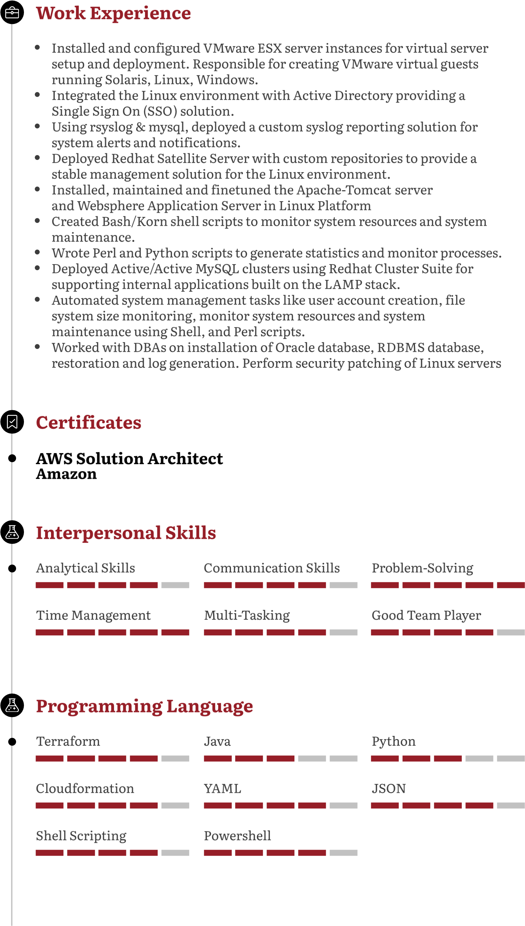

Cloud Platfrom

Docker

Kubernetes

Jenkins

Chef

Puppet

Ansible

Datadog

Cloudwatch

Nagios