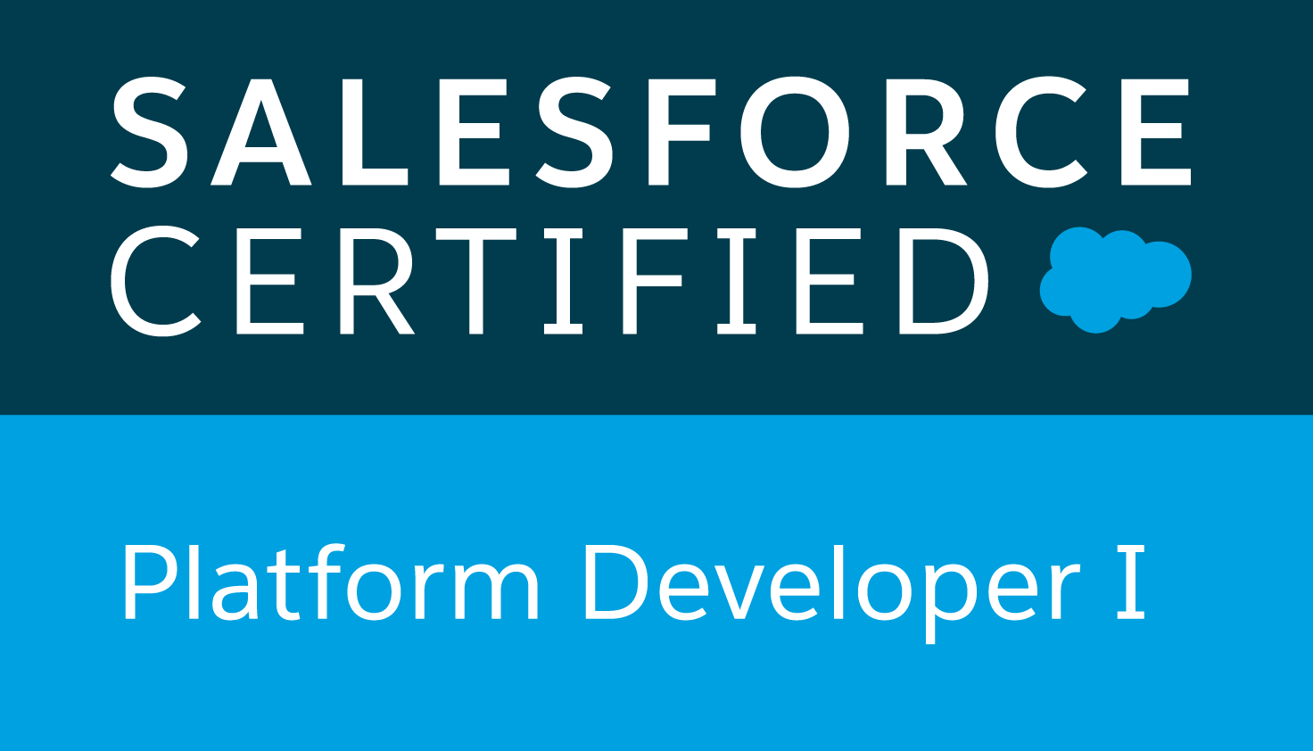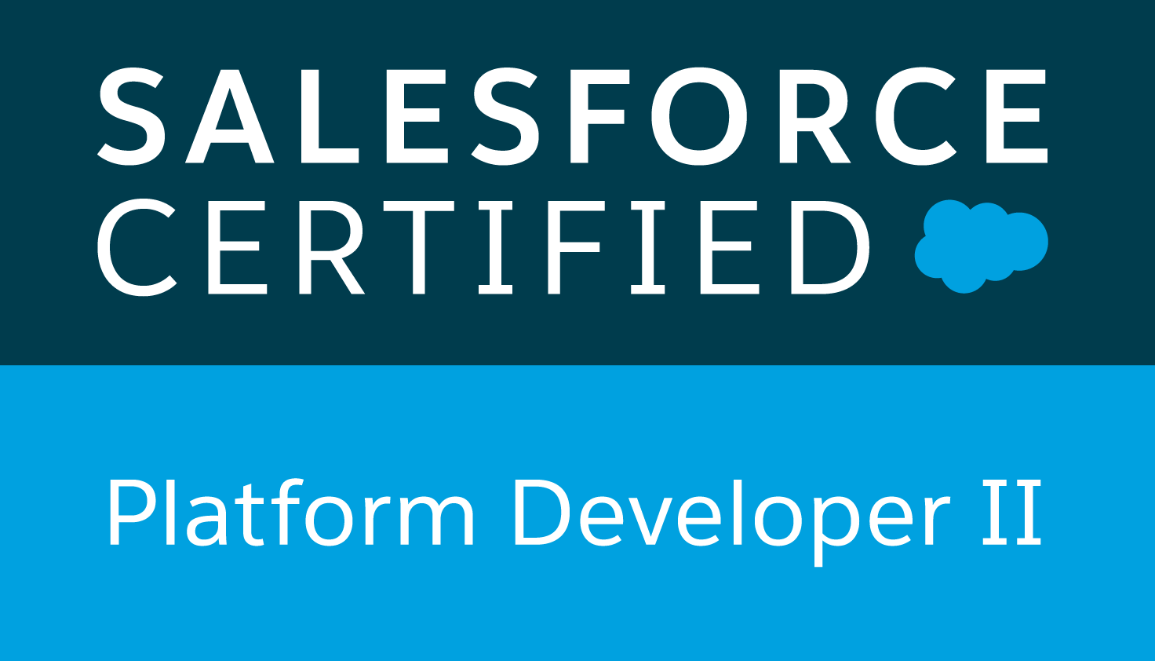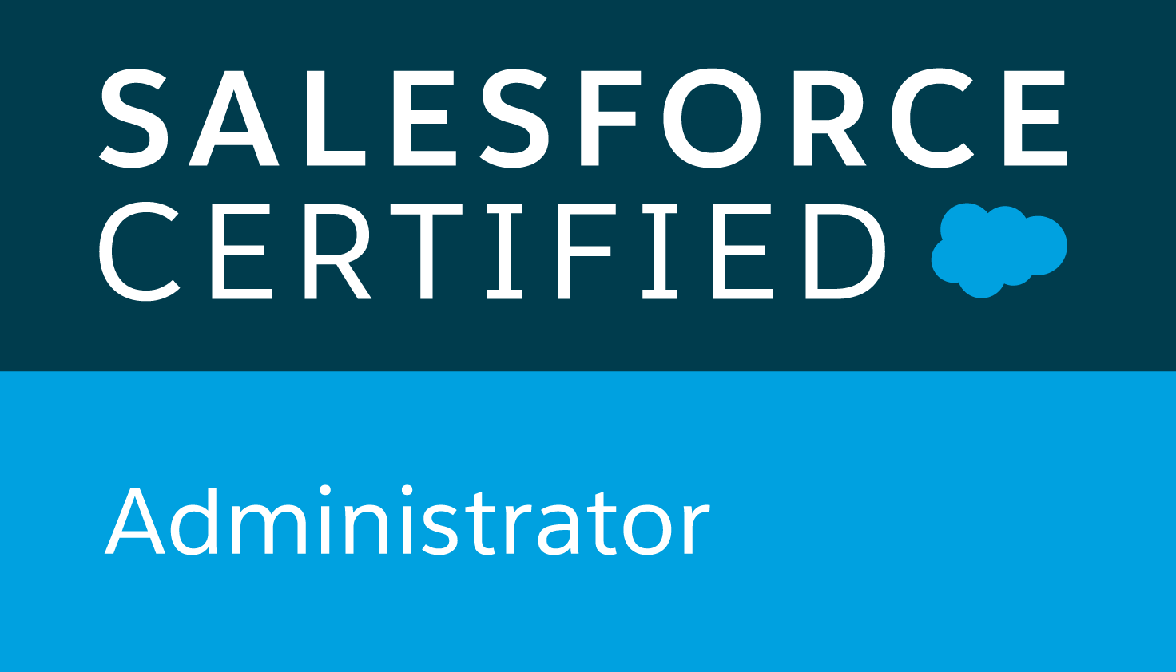

**Aarthi Reddy Kompelli**

**Salesforce Developer/Administrator**

[kompelliaarthi@gmail.com](mailto:kompelliaarthi@gmail.com)

Trailhead : <https://trailblazer.me/id/areddy398>

**PROFESSIONAL SUMMARY:**

* Highly Skilled professional with almost 7 years of Hands - on experience in [salesforce.com](http://salesforce.com) CRM both as developer and Administrator which involved customizations, Workflow rules, Approvals, Data modeling and validation for challenging CRM projects in finance and banking domains.
* Highly adaptable to new environments and have good experience working on classic and lighting experience interfaces.
* Excelled in working with various salesforce standard objects like Accounts, Contacts, Opportunities, Products,Cases, Leads and Campaigns.
* Extensively worked on Administrative tasks like creating Custom Objects, Fields, Page Layouts, Workflow rules, validation rules and Approval processes and Email generation as per application requirement.
* Experience in Data modeling, Data Management and customizing according to the requirement by implementing user engagement. Worked with various kinds of scenarios that required custom formula fields and validations. Data migration using Import wizard,Data Loader with Bulk API and other tools like workbench.
* Created data flows across platforms and data integrations and migrations using External Objects and External Data sources.
* Worked Extensively on Data Security by controlling access at various levels of the organization by creating users, profiles, Permissions sets and maintained record level security by creating roles and role hierarchy, sharing rules for both internal and external users.
* Experience in working with lightning flows by choosing right automations tools like process builder, flow builder and creating approvals. Linking external services and using them in flows.
* Experience in event monitoring, query event logs and visualizing them.Engaging Chatter and managing rollout straggles.
* Expertise in SFDC Development using Lightning Web Components , Lightning Application, Aura Components framework, Apex Language, VisualForce Pages, Classes, Controllers, Triggers, Apex Web services.
* Possess knowledge on Sales, Marketing, Service and Analytics Cloud as part of experience Business process in Force.com platform and recommended solutions to improve their process using [salesforce.com](http://salesforce.com)
* Experience on Lightning Components and server-side controllers to meet the business requirements.
* Extensive experience working with REST and SOAP API and have good knowledge on Bulk, Streaming API and user interface API.
* Developed Apex Triggers, Apex Classes and Test methods, Controllers & Extensions to support Visual force pages, Test Classes for Unit testing as per the functional needs in application. Batch Apex for data processing and writing queries in SOQL and SOSL, customized queries to avoid governor limits.
* Good understanding in SAAS,PAAS,IAAS cloud computing services.
* Co-ordinated with a team of developers in working with source code by using continuous Integration tool Jenkins.
* Experienced working with various App exchange products or CPQ products like CPQ Confidential sterling CPQ, APPTUS CPQ , Cases, Campaigns, Forecasts, Reports and Dashboards.
* Internal & External systems integration SOAP, REST Web services and Enterprise tools, Apigee, Metadata API, Schema classes.
* Experience with Shield Platform Encryption, planning and working with large data volumes within salesforce and Apex metadata API for simplifying apps setup and upgrade experience.
* Knowledge of working with version control systems like Eclipse IDE
* Expertise in working with Cross Functional Technical and Business Teams within an Organization.

**EDUCATION:**

* Masters in Computer Science, University of Central Missouri, Warrensburg MO.
* Bachelor in Engineering, KITSW.

**CERTIFICATIONS:**

* Salesforce Certified Platform Developer -2
* Salesforce Certified Platform Developer -1
* Salesforce Certified Administrator

**TECHNICAL SKILLS:**

|  |  |
| --- | --- |
| **Salesforce** | Apex Language, Apex Classes, Apex Triggers, SOQL, SOSL,Visual force(Pages, Components &amp; Controllers), Salesforce1, Metadata API Apex DataLoader, Force.com Apex Explorer, Dashboards, Reports, Custom Objects,Force.com, Eclipse IDE Plug-in, UI Customization, Web services. |
| **Business Process** | Service Requests and Activities, Opportunities, Quotes and Proposals, Order Management, Campaign Management, Case Management, Contract Management, Pricing, Approval, Partner Deal Registration, Data Cleansing and Deduplication, Agreements and Entitlements. |
| **Salesforce Tools** | Eclipse, Force.com Eclipse IDE Plug-in, Force.com Explorer, Change Sets, Force.com ImportWizard, Force.com Excel Connector, Force.com Platform (Sandbox and Production). |
| **Integrating Tools** | Apex Data Loader, Import Wizard,Data Import, Mass Delete. |
| **Other CRM** | Service max, Apptus, CPQ |
| **Relational DB** | SQL Server, My SQL, MS Access,DB2 |
| **Operating Systems** | MS Windows, Linux, Unix. |
| **Programming Languages** | C++, JAVA,HTML5,CSS3,JavaScript, XML,Apex,Visual Force. |
| **Web Services** | REST API and SOAP API. |

**PROFESSIONAL EXPERIENCE :**

**Client: Deutsche Bank - NJ September 2019 -Till Date**

**Role: Salesforce Developer**

Deutsche Bank is a German multinational [investment bank](https://en.wikipedia.org/wiki/Investment_banking) and financial services company headquartered in [Frankfurt, Germany](https://en.wikipedia.org/wiki/Frankfurt). It is one of the largest foreign-based employers in New York City. The bank uses SalesForce.com as its customer-relationship management platform coupled with machine learning software for client management. The combined system allows the bank employees to spot potential customer issues, and proactively resolve them before they become a problem.

**Responsibilities:**

* Performed the role of Salesforce Developer and minor Admin tasks in the organization.
* Responsible for the enhancements and migration support of Salesforce.com application.
* Customized both Sales Cloud and Service Cloud.
* Responsible for requirements gathering from business users and prepare technical requirement specification document, Implemented Agile Methodologies in developing SDLC.
* Extensively worked on Agile methodology and attended Daily status/standup meetings.
* Worked on Salesforce Lightning Components for building customized components according to business requirement.
* Developed Lightening Web Components, Salesforce Lightning Design System and Lightning Components, Aura Framework, JavaScript Controllers, Server-side Controllers.
* Executed daily build deployments in Jenkins, troubleshot any deployments issues and coordinated with a support team as needed.
* Implemented Quote-to-Cash solution using APTTUS CPQ. Depth understanding of the APTTUS CPQ, APTTUS CLM data model and functionality.
* Research Salesforce and Apptus CPQ capabilities as needed to suit business requirements.
* Experience in release management, Sandbox creation, Change Sets, Workbench, SVN, Jenkins, SFDX.
* Implemented Apex Data loader “Command Line Interface (CLI)” to Load data into Salesforce from staging area.
* Used Salesforce Connect with Heroku as a part of proxying external data into external and also other tools like ETL.
* Attended daily meetings, weekly scrum meetings and sprint review meetings.
* Experience in implementing Apex Classes, Controllers & Triggers, Visual force, [force.com](http://force.com).
* Lightning migration, Visual force Pages for lightning experience (lightning out), Alternates for Java Script Codes, report filtering, create record events with pre-defined value, LDS, CTI.

**Client**: **Charter Communications Denver, CO December 2017- July 2019**

**Role**: **Salesforce Developer/Administrator.**

Charter Spectrum is a trade name of Charter Communications, used to market consumer and commercial cable television, internet, telephone, and wireless services provided by the company. salesforce.com has given Charter visibility into its sales pipeline and lead conversion ratios, as well as other key metrics such as average time for survey completion and average installation time.

**Responsibility**:

* Followed Agile SCRUM methodology that includes iterative Application Development, two-week Sprints and Backlog and Refinement Meetings.
* Enabled Aura Framework, by adding Aura Attributes and Aura Handlers for Events to focus on Logic and Interactions in Lightning Applications.
* Created modern Enterprise Lightning Apps combining Lightning Design System, Lightning App Builder and Lightning Component features.
* Upgraded Apps from Salesforce Classic to Lightning Experience to develop rich user interface and better interaction of pages.
* Participate in technical design sessions, develop technical solution documentation aligned with the business objectives.
* Created various Profiles, Roles, Page Layouts and Configured the permissions based on the Organization hierarchy requirements.
* Designed and deployed the Custom objects, Entity-Relationship data model, Formulas, Validation rules on the objects, Page layouts, Custom tabs, Components, Roles, Profiles, Public Groups, Permission Sets, Custom Settings and Labels to suit to the needs of the application.
* Created Users, Roles, Public groups and implemented Role Hierarchies, sharing rules and Record Level Permissions to manage sharing access among different users.
* Designed Complex Logic involving Apex Controllers (Standard and Custom Controllers) and Triggers to Support the Forecasting Application confined to Governor Limits.
* Implemented the Single and Mass Email Messaging feature to automate the Emails based on Business logic.
* Implemented reassignment functionality for opportunities and other objects.
* Designed, developed, and deployed Apex Classes and Apex Triggers.
* Experience using data loader/workbench to delete/import/export data.
* Worked on QA testing and run test scripts in HP ALM.
* Implemented code coverage and Test classes.
* Made Documentation on new functionalities and POC’s which are implemented on project.
* Worked on both Salesforce.com Custom and Standard Objects including Accounts, Leads, Opportunities, Cases, Reports, Dashboards and Activities.
* Worked with custom Reports and report generation.
* Involved in daily standup meetings, Scrum. This resulted to bring good solution to the business requirements.
* Implemented Pick lists, Dependent Pick Lists, Lookups, Master Detail Relationships, Validation and Formula Fields to the custom objects

**Client**:**American Family Insurance, Madison, WI March 2016 - September 2017**

**Role**: **Salesforce Developer/Administrator.**

American Family Insurance, also abbreviated as AmFam, is an American private mutual company that focuses on property, casualty, and auto insurance, and also offers commercial insurance, life, health, and homeowners coverage as well as investment and retirement-planning products.Using marketing automation can helped streamline and measure their marketing effectiveness and workflow with less effort.

**Responsibility**:

* Involved in Salesforce.com Development, Customization, and Integration, Support and Testing.
* Interacted with the business, users, and other stakeholders for Requirements Gathering, Analysis, planning and implementation.
* Worked on Salesforce.com Standard Objects like Accounts, Contacts, Leads, Campaigns, Reports and Opportunities.
* Designed, implemented, and deployed the Custom Apps, Custom objects, Page layouts, Custom tabs, Components to suit to the needs of the application.
* Worked extensively on Workflow Rules, Validation Rules, Approval Processes, Flows, Process Builder, web-to-lead, web-to-case.
* Created various profiles and configured the permissions based on the organizational hierarchy requirements.
* Queried salesforce.com database with SOQL & SOSL using Force.com Explorer or Workbench.
* Used Data Loader and Import Wizard to deal with legacy data and scheduled timely data backup operations using Apex Scheduler.
* Involved in handling data migration for the objects like Users, Accounts, Leads, Contacts, Campaigns, Campaign Members, and Quotes.
* Maintained user roles, security, profiles, and workflow rules wherever necessary.
* Interacted with the Salesforce.com premium tech support team on a regular basis.
* Used multiple Sandboxes for testing and migrated the code to the Production instance after all the test cases were cleared.
* Customized the Dashboards to track usage for productivity and performance of business centers and their sales teams.
* Stays current on new Salesforce features, new releases and functionality and provide worked with Lightning and UI components.
* Customized salesforce layout & functions to best suit employer's needs.
* Tracked and performed daily routine necessary applications such as merging duplicates, task assignments, maintaining and upgrading security permissions.

**Client**: **Datamatics Tech- Hyderabad**  **September 2011 - July 2014**

**Role**: **Salesforce Administrator.**

Datamatics is a provider of consulting, information technology (IT),data management and [business process management](https://en.wikipedia.org/wiki/Business_process_management) services. Its services use [robotics](https://en.wikipedia.org/wiki/Robotics), [artificial intelligence](https://en.wikipedia.org/wiki/Artificial_intelligence) and [machine learning](https://en.wikipedia.org/wiki/Machine_learning) algorithms.

**Responsibility**:

* Created Page layouts, Search layouts to organize fields, Custom links, related lists, and other components on record pages.
* Implemented Pick lists, Dependent pick lists, Lookups, Master detail relationships Junction objects and formula fields to the Custom objects.
* Involved in development of Time-based Workflow Rules, Triggers, Validation Rules, and other customizations with Salesforce.com.
* Configured security and organizational hierarchy for Salesforce implementation.
* Expected to learn on the job towards developing domain knowledge along with technical/proprietary skills.
* Worked with various salesforce standard objects like Accounts, Contacts, Opportunities, Products,Cases, Leads and Campaigns.
* Worked on Administrative tasks like creating Custom Objects, Fields, Page Layouts, Workflow rules, validation rules and Approval processes and Email generation as per application requirement.
* Experience in Data modeling, Data Management and customizing according to the requirement by implementing user engagement. Worked with various kinds of scenarios that required custom formula fields and validations. Data migration using Import wizard,Data Loader with Bulk API and other tools like workbench.
* Involved in Data Security by controlling access at various levels of the organization by creating users, profiles, Permissions sets and maintained record level security by creating roles and role hierarchy, sharing rules.