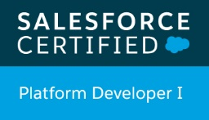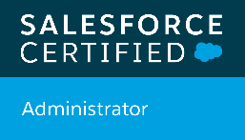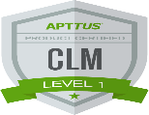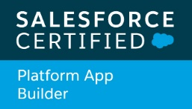Haritha Surkanti

Mobile No. : +91-7989417770

[haritha.surkanti@gmail.com](mailto:haritha.surkanti@gmail.com)

**Experience Summary:**

* Having 3 years of hands-on experience in Apttus CLM and in various phases of Software development including Configuration, Customization and implementation of SFDC (Salesforce.com).
* Experience in data migration from Legacy Systems using Apex **Data Loader.**
* Experience in **Designing, Development, Unit Testing** and **Deploying Salesforce** Applications.
* Experience with User Interface, Page Layouts, Record Types, Work Flows and Approval Processes.
* Hands on experience on creating custom Objects and Tabs, designing Custom Fields and Field-Level Dependencies, Validation Rules.
* Expertise at administrative tasks such as User management, creating **Profiles**, **Roles** and **Permission Sets**, **Process Builders**.
* Experience on working with Force.com IDE, **Data Loader**, Import Wizard and salesforce.com Sandbox Environments.
* Experience in metadata migration using **Change Set.**
* Have worked with **Triggers, Apex Classes** and writing SOQL and SOSL queries.
* Experience in writing **Test Classes and Test Coverage** for all the apex classes designed.
* Experience in **Customizing the application, Testing** and **Deploying Salesforce** Applications.
* Have knowledge in web technologies like HTML, CSS and **JavaScript.**

**Academic Qualifications:**

* 2017 - Bachelor of Technology (B. Tech) from CVR College of Engineering with 75%.
* 2013 - Board of Intermediate Education from Narayana Junior College with 91%.
* 2011 - S.S.C from St. Augustine High School with 92%.

**Certification:**

* APTTUS 201 CLM Product (Salesforce Platform)
* Salesforce Platform App Builder
* Salesforce Platform Developer 1
* Salesforce Administrator
* Copado Administrator

**LinkedIn URL:**

* <https://www.linkedin.com/in/haritha-r-751470131/>

**Trailblazer URL:**

* <https://trailblazer.me/id/harithasurkanti>

**Work Experience:**

Working as **Software Engineer** in **Birlasoft Limited** from September 2017 - till date

**Projects:**

**Project 1 : Viacom Apttus CLM**

**Client : Viacom International INC**

**Role : Apttus Developer**

**Duration : September 2018 – Till date.**

**Technologies : Salesforce.com, Apttus CLM.**

**Implementation:**

* Requirements gathering
* X-author for MS-Word
* Wizard Configuration
* Template migration using X-Author Migration Manager
* Data migration using Data Loader

**Project Description:**

The product has capability to perform full Contracts Lifecycle Management.

**Responsibilities:**

* Complete development of Contracts and Approvals management system leveraging the Apttus Contract Lifecycle Management CLM.
* Development of flow of creating Agreements through Opportunities.
* Configuring of different Record Types, profiles, page layouts.
* Validation rules, workflows, process builder.
* Team management, assigning and distribution of works with ensuring timely completion of the same.
* Involved in review process of documents like issues, Bugs, Test cases using JIRA for the team and fixing up the same.
* Work demo and presentation at various levels and customers at different phases.

**Project 2 : Disney Apttus CLM**

**Client : Walt Disney**

**Role : Apttus Developer**

**Duration : September 2017 – September 2018**

**Technologies : Salesforce.com, Apttus CLM.**

**Project Description:**

Disney Television consists of News/Legal group in which they generate documents as an agreement. By using custom classic and lightning wizard we have made it easy for them to fill in the data, which also auto populates data from any parent record if needed using custom settings and showing the required data. Generating documents in different format as per the requirement and showing the required data using Apttus CLM.

**Responsibilities:**

* Primary role was development using Apttus CLM.
* Created Objects, Fields, Page layouts and maintaining Relationships between objects.
* Create Process Builder to update the records
* Implemented security and sharing rules at object, field, and record level for different users.
* Used Apex Data Loader for migrating data from external system.