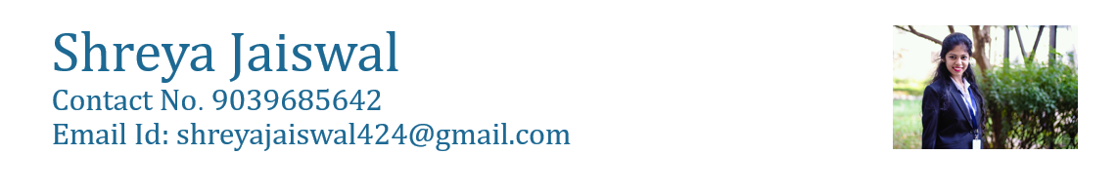

# EXECUTIVE SUMMARY

Amicable and experienced Business Analyst capable of cultivating long-term business relationships with clients. Specializing in optimizing strategic goals for the industry. Adept at leading team members in surpassing goals as well as delivering exceptional user experience.

# Academic Qualification

|  |  |  |  |
| --- | --- | --- | --- |
| **COURSE** | **COLLEGE** | **YEAR** | **PERCENTAGE** |
| **B.E.** | **Acropolis Institute of Technology and Research, Indore** | **2012-2016** | **8.8 CGPA** |
| **12th** | **ITMA Vidya Niketan, Indore** | **2011-2012** | **78%** |
| **10th** | **MarThoma Hr.Sec. School, Indore** | **2009-2010** | **8.8 CGPA** |

Experience

|  |  |
| --- | --- |
| **Company Name** | Capgemini |
| **Place** | Mumbai, Maharashtra |
| **Role** | Business Analyst |
| **Period** | Dec 2017– Till date |
| **Work Done** | * Worked on a web application that has been developed to maintain the various phases of an SDLC lifecycle for any application. This platform helps user to onboard their application on the platform and go through various phases to check the health metrics of their application. * Worked as a Business Analyst to gather the requirement from the client and giving presentations for various enhancements that is to be done on the platform or for adding up the new features to the platform. Experience in requirement gathering, documenting and planning * Tools/ Technologies: Microsoft Excel, PowerPoint, Word,SharePoint, Redmine, Microsoft Teams, Git, MySQL, Tableau, Power BI, Data Analytics, AWS |

|  |  |
| --- | --- |
| **Company Name** | Capgemini |
| **Place** | Mumbai, Maharashtra |
| **Role** | Consultant |
| **Period** | July 2020– Till date |
| **Project** | GE-Power |
| **Work Done** | Onboarding a web application to the GE environment for application monitoring |

|  |  |
| --- | --- |
| **Company Name** | Capgemini |
| **Place** | Mumbai, Maharashtra |
| **Role** | Consultant |
| **Period** | April 2020- June 2020 |
| **Project** | GE-Renewables |
| **Work Done** | Worked as a consultant for the team for providing solutions to the team on building their environment in the most suitable manner so that it includes all features required by client with minimal cost. |

|  |  |
| --- | --- |
| **Company Name** | Capgemini |
| **Place** | Mumbai, Maharashtra |
| **Role** | Event Head |
| **Period** | Oct 2018- Nov 2018 |
| **Project** | Grand Tech Meetup |
| **Work Done** | * Grand Tech Meetup was a meetup and hackathon conducted for various startups and Capgemini so that Capgemini could collaborate with these startups. * Worked as an event lead, who was responsible for organizing the event. The main motive of the event was to bring out |

|  |  |
| --- | --- |
| **Company Name** | Capgemini |
| **Place** | Mumbai, Maharashtra |
| **Role** | Team Lead |
| **Period** | Jan 2017- Nov 2017 |
| **Project** | Devops Enabler Platform |
| **Work Done** | * Worked as a team lead in enhancing the platform depending upon the business requirements. Worked on Jira board to mark stories and efforts spent on each task and to keep track of the deliverables. Designed business use cases, user stories, sprint plan and help the team in implementation. |

|  |  |
| --- | --- |
| **Company Name** | Capgemini |
| **Place** | Mumbai, Maharashtra |
| **Role** | Trainee |
| **Period** | Sept 2016- Dec 2016 |
| **Project** | Capgemini Training |
| **Work Done** | * Training and development for adapting the work culture and enhancing skills. |

**Certifications & Achievements**

* Have been part of selling a product I am working with, which has generated revenue for the company
* Certified Business Analyst
* Certified in MS Excel
* Certified in Agile Project Management
* Certified in Microsoft Powerpoint
* Managed multiple projects and multiple events as a team lead.
* Lead of creative team.
* Top 5 in Disrupt Program in Capgemini
* Won extra mile award.
* Won star performer of the quarter.

# Skills & Abilities

* **Business Analysis:** Designing and implementing the requirements gathered from the clients. Defining requirements of all types and document with process flows. Keeping the client posted on the development of their request. Introducing and implementing solutions for a range of projects. Experience in creating project plan and maintaining it. Lead, develop and execute strategy to create, develop and sustain highly motivated performing employees and teams. Drive the delivery of project deliverables leveraging teams. Conducting project meeting with the team regularly to review project deliverables and deadlines.
* **Independent and outstanding team player:** Self-motivated / team player that works well with individuals-groups in a complex, global organization.
* **Exceptional analytical, organizational/prioritization and communications skills:** Ability to liaison and negotiate solutions between business, operations and technology.
* **Ability to manage multiple clients and businesses together:** Ability to work in challenging & demanding timelines.
* Communication Skills
* Leadership Quality
* MathematicalTechniques,StatisticalAlgorithms,SQLquerying,Spreadsheet skills MS Word, MS Excel, MS Power Point
* Proficiency in building and maintaining positive client relationships