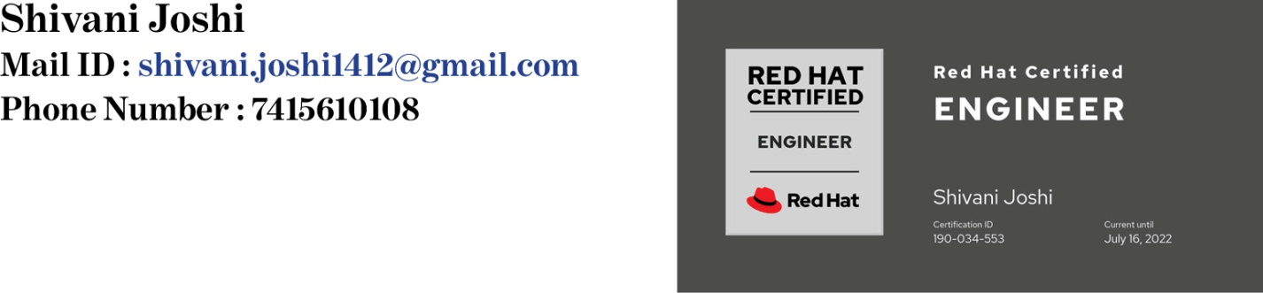

**CAREER OBJECTIVE**

Intent to build a career with leading corporate in hi-tech environment with committed and dedicated people, which will help me to explore myself fully and realize my potential. Willing to learn and explore new technologies and skills.

**EXPERIENCE**

From 6th Aug 2019 to 6th April 2020 - Worked as Linux Administrator at Alpha Infolab Pvt Ltd.

**Job Responsibilities**: -

Worked as Linux Administrator with Configuring Apache, Send mail, Dovecot, PMTA, Samba, DNS, NFS, FTP, DHCP, MySQL Servers. Worked on Hosting Websites on Linux Servers and managing SSL certificates. Provided Proxy and VPS Dedicated and Shared servers to clients. Worked on Proxmox Virtual Environment, Vyatta Router and Firewall, IPv4 addresses, IPv6 addresses, OS virtualization, Routing Protocols and Networking.

**CERTIFICATIONS**

* Certified in **“Red Hat Certified Engineer” RHCE (ID 190-034-553 Current Until July 16,2022)**
* Certified in **“Red Hat Certified System Administrator” RHCSA (ID 190-034-553 Current Until Feb.28, 2022)**
* Certified in **“Embedded Systems”**

**ACADEMICS**

2018 Bachelors of Engineering in Electronics & Communication from Lakshmi Narain College of Technology & Science, Bhopal with **6.65 CGPA**.

2014 12th from Carmel Convent Senior Secondary School, Bhopal, CBSE Board with **77.80%**

2012 10th from Carmel Convent Senior Secondary School, Bhopal, CBSE Board with **8.0 CGPA**.

**SKILLS**

* Programming : Python & Shell Script
* OS : Linux
* Virtualization : VMware, VirtualBox, RHV
* Cloud : AWS
* DevOps : Docker
* Network : CCNA

**PERSONAL DETAILS**

Date of Birth: 14-Dec-1995

Permanent Address: C-194 Adarsh Nagar, Hoshangabad Road, Bhopal.

Languages Known: English and Hindi

**HOBBIES**

* Reading Books
* Cooking
* Dancing

**PERSONAL STRENGTH**

* Last to Leave the Sinking Ship
* Positive Attitude towards Life
* Good Listener

**Declaration:**

I do hereby declare that the statements given above are true, complete and correct to the best of my knowledge and belief.

*Date: 10th March 2021*

*Place: Bhopal Signature*

|  |
| --- |
|  |

|  |
| --- |
|  |