Dushyant Kumar Betav dj010985@gmail.com
126-A, Samarth Park Colony, Umaria, +91-9827440307
Rau - 453331, Indore, Madhya Pradesh.

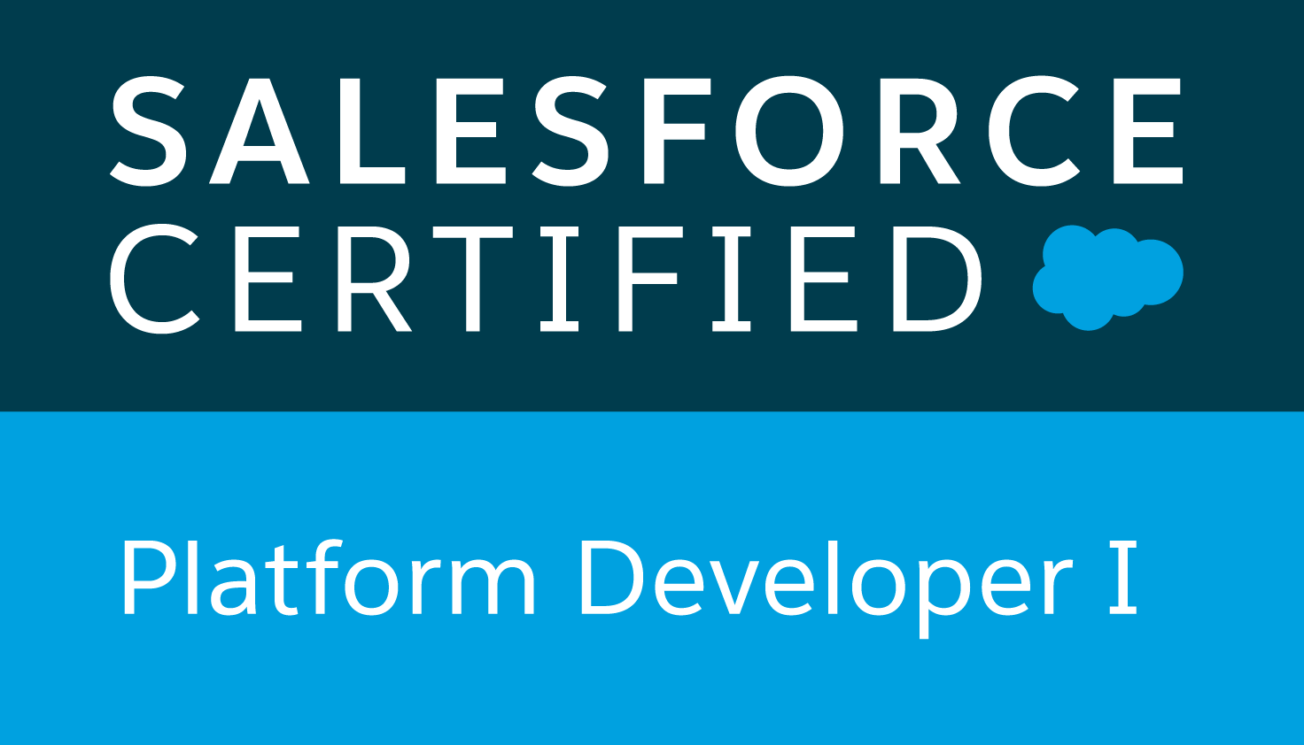

Professional Summary
5.5+ years experienced Salesforce Professional with hands on experience in every phase of Software Development Life cycle with agile methodology involving onsite and offshore coordination. Good knowledge on the Salesforce platform Community Cloud, Service Cloud, SF Dev-Ops and Testing. Experienced in deployment using various deployment tools like CI/CD, Change sets. Experience in data migration and integration using Data Loader, Import Wizard. Proficiency in SFDC Administrative tasks like creating Profiles, Roles, Users, Page Layouts, Record Types, Email Services, Approvals, Workflows, Reports, Dashboards. Good experience in designing of custom objects, custom fields, role-based page layouts, custom tabs, custom reports, report extractions to various formats. An effective team player who continuously seeks opportunities to master new domains and willing to work in a challenging and cross-platform environment.

Core Qualifications

- Over 9 years of overall professional IT experience with 5.5+ years of experience in Salesforce.com and Force.com.
- Experience in Lightning framework like Lightning Web Component (LWC), Aura framework.
- Experience in Salesforce Development using Apex development, Apex, Triggers, Web Services, Visual force pages, Rest API’s.
- Experience in Automation process using Salesforce automation tools, such as Flows, Process Builder, Workflows, Formulas, Assignment Rules, E-mail Alerts. Excelled in working with various Salesforce.com standard objects like Accounts Contacts Opportunities Products Cases and Leads.
- Experience in data migration tools like Data Loader, Import Wizard.
- Experience in deployment using CI/CD using Bit bucket, Jenkins, Sonar Cube, Vera Code.
- Highly proficient with Community Cloud, Service Cloud Service Force.com web-services, Rest API and Code optimization with Governor limits of Salesforce.
- Hands on configuration of Salesforce Platform including Security controls, Roles, Sharing Settings, Profiles.
- Experience in working with Debug Apex Scripts using Debug Logs and System Log Console to catch Exceptions.
- Good understanding of Salesforce.com Governor Limits with an ability to optimize code to respect those limits.
- Excellent communication and inter-personal skills accustomed to work in both large and small team environments.
- Sound ability to integrate various business processes across different systems.
Certifications
- Salesforce certified ADMINISTRATOR
- Salesforce certified PLATFORM DEVELOPER - I
- Salesforce certified PLATFORM DEVELOPER – II
Other Skills
Bit bucket, Jenkins, Sonar Cube, GIT, GitHub, JIRA, Slack, JavaScript, HTML5/CSS, and PHP.

Professional Experience

- Working as Advisory Consultant in IBM India Pvt. Ltd, from February 2021 to till date.
- Worked as Associate developer in Chetu India Pvt. Ltd, from December 2016 to February 2021.
- Worked as Software Engineer in Parkhya Solution Pvt. Ltd, from April 2014 to April 2016.
- Worked as Software Engineer in Innovative India Technology from April 2011 to April 2012.

Education

- MCA from S D Bansal College of Technology, Indore with 65% marks.
- BCA from Radha Krishnan College, Neemuch (MP) with 68% marks.
- Higher Secondary Certificate from MP Board (Bhopal) with 46% marks.
- High School Certificate from MP Board (Bhopal) with 65 % marks.

Work Experience

Project 1

Senior Salesforce Developer.

Technologies : Lightning Web Component, Salesforce SFA Apex Language, Apex Classes/Controllers, Apex Triggers SOQL, SOSL, Visual Force Pages / Components, Apex Web Services, AJAX, Workflow, Lightning Framework, Component Event, Application Event, Aura Method, Lightning Data service, JSON, HTML5, JQuery, Bootstrap, CSS.

Description: Covid-19 Vaccine management system supports the management of Covid-19 vaccinations across country, all in simple and easy to use package. The system enables users to schedule vaccination, capture consent for vaccination, check eligibility for vaccination, records vaccination details including vaccine batch code saline batch code etc. Also capture adverse reaction post vaccination and generate real time operation reports. It helps management to coordinate of Covid-19 vaccination. This project is run in an agile fashion.

Responsibilities : Working on a Large-scale complex Salesforce development.
Salesforce Configurations across all the Standard objects like Accounts Contacts etc.
Worked on configuring Community site and also customizing it by including custom logics using Lightning Web Component, Flows, Apex Triggers and Classes.

Project 2

Senior Salesforce Developer.

Technologies : Lightning Web Component, Salesforce SFA Apex Language, Apex Classes/Controllers, Apex Triggers SOQL, SOSL, Visual Force Pages / Components, Apex Web Services, AJAX, Workflow, Lightning Framework, Component Event, Application Event, Aura Method, Lightning Data service, JSON, HTML5, JQuery, Bootstrap, CSS. .

Description: This application enables the HR MRT process, replacing a manual xls application. The application will be simpler for the end user, more efficient and result in enhanced data collection and processing that can be used for end reporting. The MRT process is regulatory driven ultimately allows the bank to fulfill its regulatory mandate more easily and with reduced risk. This application is built on strategic infrastructure, with significant automation and reduction in reliance on manual process.

Responsibilities : Analyzing Business requirements documents with the team.
Developed Lightning Web Component.
Good understanding of standard and custom objects and metadata. Salesforce Project deployments including release and environment management.

Project 3

Role Salesforce Developer.

Technologies : Salesforce SFA Apex Language, Apex Classes/Controllers, Apex Triggers SOQL, SOSL, Visual Force Pages / Components, Apex Web Services, AJAX, Workflow Approvals Chargent Payment Gateway, Dashboards, Lightning Framework, Component Event, Application Event, Aura Method, Lightning Data service, Case Management, JSON, HTML5, JQuery, Bootstrap, CSS.

Description: The Customer has the platinum portal where they charge $35 per month to each membership client. In platinum portal membership clients are able to access account, unlimited attorney strategy session, tax review and access video training, check billing history and ask for an advisor for tax review etc. They have two partners in their firms in which one partner Magentrix which will run in website background will generate invoices, billing, add edit credit card details etc also this site uses Chargent payment gateway for making payment.

Responsibilities : Working on a Large-scale complex Salesforce development.
Salesforce Configurations across all the Standard objects like Accounts Contacts Cases etc.
Worked on configuring community site and also customizing it by including custom logics using triggers, Classes and VF Pages.
Good understanding of standard and custom objects and their limitations. Salesforce Project deployments including release and environment management.

Personal Details

Name : Dushyant Kumar Betav.
Father’s Name : Mr. Ramesh Chandra Betav.
Gender : Male.
Date of Birth : 01 September 1985.
Nationality : Indian.
Marital Status : Married.

Declaration

I hereby declare that the above written particulars are true to the best of my knowledge and belief.

Date:
Place: Bengaluru (Dushyant Kumar Betav)

