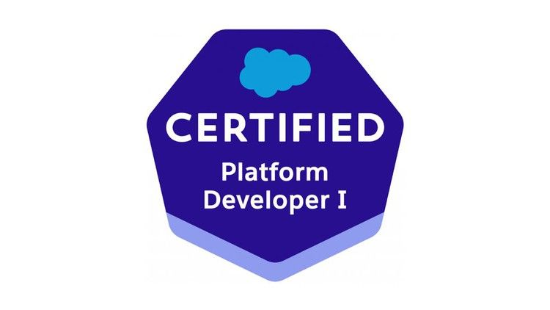

**Nazeer Basha S**

[nazeer245056@gmail.com](mailto:nazeer245056@gmail.com)

+919000245056

# Summary:

* Having 6+ years of experience and 3.4 years of Salesforce experience in which as Salesforce CRM Developer which involves Administrator, Development, and LWC
* (3+ Year experience on Non IT).
* Strong experience in Support, ProdCopy sandbox Development, UAT and maintenance of Product / business applications including Cloud Based, Client-Server applications.
* Created multiple Lightning Components, added CSS and Design Parameters that makes the Lightning component look and feel better.
* Proficient with Salesforce data model and customizing objects, fields, formula fields, rollup summary fields, page layouts, search layouts, creating custom objects and custom Tabs, record types, relationships (Lookup, Master detail & Junction objects), custom reports and dashboards.
* Excellent understanding of Org Hierarchy Roles, Profiles, permission sets, Users, object level security, field level security, record level security and sharing rules.
* Hands-on experience with declarative programming using Workflow rules, Process Builder and actions Field update, Email alert, Create tasks.
* Experience in implementing MVC (Model View Controller) design by using Visualforce, Apex Standard and Custom Controllers, Controller Extensions for business logic on Standard and Custom objects.
* Proficiency in SFDC development using Apex classes, Apex Triggers, Test classes.
* Knowledge in writing Apex REST web services in Salesforce to access Salesforce data and used Force.com REST API Web services for Outbound calls from Salesforce.
* Knowledge and experience in developing Custom **Lightning Components**, using Standard Lightning Components, building Lightning Apps using Lightning App Builder and Lightning Data service.
* Strong experience with Force.com migration tool, Change Sets for migrating Salesforce components across various Sandbox and Production instances.
* Having Experience in Creating Custom Lightning components and Html, css and Javascript.

# Education:

* B.tech(Mech) from JNTUA (2015)

**Professional Experience:**

* Working as a Salesforce Developer at TCS. From July 2019 to Till date.

# Technical Skills:

Salesforce Technologies **:** Salesforce CRM, Salesforce SFA, Apex Language,

Apex Classes/Controllers, Apex Triggers, SOQL, SOSL, Visualforce Pages, Lightning web componet, Apex Web Services, AJAX, Workflow

Certifications : PD1

Languages : Apex, Javascript, HTML, CSS,

Tools **:** Apex Data loader

Web services APIs like REST, Force.com Explorer,

Operating Systems **:** Windows XP/Vista/7,

**Project 1:**

Project : **YMCA Groups**

Client : **YMCA USA**

Role : Sales force Developer & Admin

Start Date : Jan 2022

End Date : Sep 2022

Platform : Salesforce CRM,Force.com

Technologies **:** Salesforce CRM, Sales Cloud,Lightning

**Project Description :**

YMCA is the leading nonprofit committed to strengthening individuals and communities across the country. Every day YMCA help people connect to their purpose, potential and each other. Working locally, and focus on supporting young people, improving health and well–being and inspiring action in and across communities. We implemented the complete, end-to-end CRM solution for their business needs using Sales force CRM and the Force.com platform.

**Responsibilities:**

* Analyzed and implemented the requirements in Salesforce.com.
* Developed Apex Controllers, extensions and Apex Triggers for various functional needs in the application.
* Worked on sales force lightning like using lightning component, lightning events, and Lightning application.
* Developing customized solutions in Aura Components.
* Worked on lightning component bundles like component, Controller, Helper, CSS.
* Create Reports and Dashboards

**Project 2:**

**Project 2: Vehicle Sales application - SalesClould(2021 Feb to 2021 December)**

* Understanding the requirements from the customer
* Daily issues are discussed with onsite coordinator and direct interaction with the client.
* Created Custom fields, field dependencies and various relationships of business object
* functionality and tabs in the Salesforce.com
* Created and updated page layouts, search layouts and pick lists among various fields
* Created and updated Workflows to automate the business needs
* Providing support to the customers and developed the new enhancements like implementing the additional functionality to the existing triggers, vf pages and apex classes.
* Customized page layouts for Salesforce.com Standard and Custom Objects
* Development using Apex, Triggers, Visual force Pages, Custom Controllers, Update existing profiles for new application etc.
* Configured users’ roles, permissions and profiles as per the business requirements
* Responsible for performing administrative functions in Salesforce CRM such as create/modify pick lists and lookup fields
* Configured the Knowledge Articles.
* Configured Salesforce for Social Media
* Prepared MOM document and also track the daily, weekly and monthly record of incidents and enhancements for the entire team in order to follow the SLA.
* Daily requirements are discussed with the team members by attending meetings to provide the enhanced support to the customers.
* Maintain and develop Custom Objects to build new application
* Creating Quick actions and Data tables using Lwc components.

**Environment:**  Apex Language, Visualforce, Force.com IDE, SOQL, SOSL, HTML, CSS, ApexData loader, Workflow, Custom Objects, Custom Tabs, Email Services, Security Controls,Lwc components.

**Project 3:**

# Demac Property’s

# (Salesforce Developer)

**Responsibilities:**

* Interacted with various business team members to gather the requirements and documented the requirements.
* Created users, roles, public groups and implemented role hierarchies, sharing rules and record level permissions to manage sharing access among different users.
* Configured Profiled-based IP address restrictions, Organization-wide IP address restrictions and Profile-based login hour restrictions.
* Maintained language settings and advanced currency management.
* Designed and deployed Custom tabs, validation rules, Approval Processes and Auto-Response Rules for automating business logic.
* Created workflow rules and defined related tasks, email alerts, and field updates.
* Designed, developed, and deployed Apex Triggers, Apex Classes, Visualforce Pages, Controller & Extension Classes, and Test Classes for Unit testing and for various functional needs in the application.
* Created page layouts, search layouts to organize fields, custom links, related lists, and other components on record pages.
* Implemented pick lists, dependent picklists, lookups, master detail relationships, validation and formula fields to the custom objects.
* Used field level security along with page layouts to manage access to certain fields.

**Environment:**  Salesforce.com platform, Apex Language, Triggers, validation rules Workflow, Reports, Custom Objects, Custom Tabs, Sandbox.

**Previous Experience 1:**

Worked as a Trainee Engineer at GGS Engineering Services Pvt Ltd, Hyderabad

From Jan 2019 To June 2019

**Previous Experience 2:**

Worked As a Production Engineer at Elixir Met Form Pvt Ltd, Hyderabad from Sep 2015 Dec 2018

**Place:** Banglore

**Date: Nazeer Basha Shaik**