|  |  |  |  |
| --- | --- | --- | --- |
|  | |  | **A digital marketing strategist, journalist, corporate communications expert and a PR professional with10 years of experience. I have developed big creative ideas throughout the marketing funnel uncovering social insights and used it to fuel creative development and distribution for maximum relevance and impact.**  Experience  July2018 –Present  **Communications Director**  Brands2life (B2L)  Sep 2017- –July 2018  **Creative Head**  Redefine Marcom  June 2014- August 2017  **Strategic Communications Consultant**  Dec 2012–May 2014  **Senior Manager- Corporate Communication, PR &Digital Marketing**  Times Internet (Times Of India Group)  Oct 2011–Nov 2012  **Senior Creative Strategy Specialist**  Anandbazaar Patrika Group ( ABP)  Sep 2009–Sep 2011  **Journalist**  India Today Group Activities **Food Critic ,Gourmand turned Gastronome Food Writer | Restaurant &Culinary Consultant| Food Branding and Marketing eVangelist| Startup Consultant** Achievements  * **Topped** all India senior secondary examination (COMMERCE STREAM) * Was **a topper in the subject economics** at +2 level * **Topped the first year examination** at the undergraduate level[B.COM(H)] * Was awarded **scholarship by Hindi academy** for excellent performance in the subject. * Was awarded **scholarship by Sanskrit academy** for excellent performance in the subject for consecutive 2 years. * Was rewarded by the **National Literacy Mission (NLM) f**or outstanding work done in the area of **community service under the programme EACH ONE TEACH ONE.** |
| HEENA SHARMA | |
|  | |
| Phone Icon | Phone:  +91-9899865209 |
| At Symbol Icon | Email:  heena.sharma2010@gmail.com |
| Location Icon | Address  BA-239/2 Tagore Garden  New Delhi-110027  India |
|  |  |
|  |
| **Skills** |

**strategic communications planning, online marketing, digital media communication, creative writing, search engine optimization strategies, creative process, social media, creative advertising and brand marketing, PR**

**Education**

**Digital Unlocked, An Online programme on Digital& Social Media Marketing strategy(DSMMS), ISB Hyderabad &FICCI *- Top Performer getting certified with 26 badges***

**PGDMM, Times School of Marketing (TIMES CENTRE FOR MEDIA STUDIES), Times of India Group – *First Rank holder(75%)***

***2008-2009***

**B.com(H), SRCC(SHRI RAM COLLEGE OF COMMERCE), Delhi University**

***2005-2008 - First Rank Holder(75%)***

**Grade 1- 12, Holy Child School – *CBSE All India Topper and Merit Scholarship Holder ( Class 12th- 94 %, Class 10th-92%)***

**India Today- Roles & Responsibilities**

• Handled content creation &coordination, editing, packaging and release for signature properties of India today Group like **India Today English, India today Home, Business Today,Money Today, Reader's digest, TIME,HBR, Robb Report, India Today Conclave.**

• Ideation and conceptualising as well as finalising the layout and design of the pages for the stories

• Ensuring correct grammar and language fidelity of the final product ;check copy for readability, style and agreement with editorial policy.

• **Designing , conceptualising event properties** and resource deployment customised to client needs.

• Facilitation of generation of consumer insights and driving strategic consumer communication for the brand.

**• Monitoring other news Web sites and TV/radio broadcasts as** well as phones, e-mail and social networking accounts (e. g. Twitter, Facebook) to ensure the most comprehensive, competitive coverage

• Research related news and provide links to offer greater story depth.

• Handling entire gamut of **Marketing activity content- publicity brochures, handouts, poster, e-mailer blasts and other promotional tools .**

• Research and travel to provide adequate information for articles

• Liaise with in-house teams of writers, photographers, printers, designers and production staff

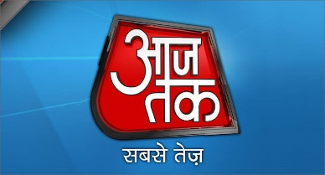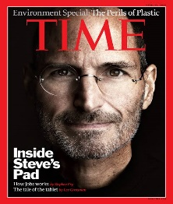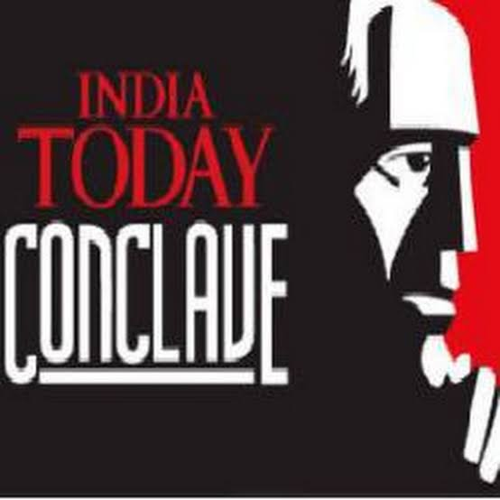

**ABP - Roles & Responsibilities**

* Managing the thematic inventory, handling the creative content arena, initiating the editorial based integration programmes and devising strategies for various brands under the group **like The Telegraph, Business World,Fortune,Telegraphindia.com(website),My Anandabazar.com(mobile portal), Marketing Whitebook etc**
* Seeking out and **investigating stories via contacts, press releases and other media**
* **Creating and developing content for niche sites for various events** like Business World Marketing whitebook launch
* **Creating non-article content - e.g. tweets,facebook updates, video clips, databases** – to facilitates inclusive reporting, reflecting diverse communities in all content.
* Drive **corporate strategy** and message development, pitch and announcement strategies.
* Develop **branding initiatives, internal communications and external media relations**.
* Determine communications strategy and execute programs to deliver communications objectives throughout the organization.
* Develop communication strategies for delivery of corporate culture and business strategy.
* Manage media relations and maximize media opportunities.
* Develop **internal publications such as newsletters, releases, email announcements, planned publications, on-line, intranet, video, special projects and assignments**.

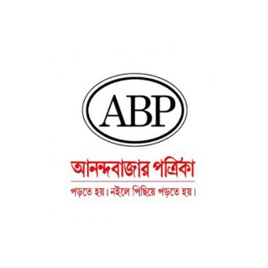

**Times Internet-Roles & Responsibilities**

* Led digital marketing strategy for group online ventures such as news sites, communities, e-commerce, leisure portals; print publications like **The Times of India, The Economic Times , Gaana.com, Timescity, Speaking Tree, Huffington Post, I Diva, MensXP etc. in the News, Entertainment, Sports, lifestyle, Edtech, Fintech, Marketplaces genres**
* Producing engaging, industry-leading editorial and thought leadership content, to support marketing and other strategic initiatives. Content includes white papers, case studies, blogs, videos, presentations etc**.**
* Communicate regularly with senior leadership, internal stakeholders and traffic team colleagues to understand objectives and opportunities.
* Built **media buzz and hype with blog reviews, capturing eyeball through social networking sites for online of IPL online streaming, Boxtv.com and Gaana.com**
* **Launched IPL online streaming on social networking** sites, mobile messages, print and electronic media recording incremental season viewership of 58 million
* **ASO (App Store optimization), Creating , distributing and marketing content for various Mobile apps.**
* Drive **corporate strategy and message development**, pitch and announcement strategies.
* Drive **strategic PR initiatives to increase** awareness for products and services
* Develop internal publications such **as newsletters, releases, email announcements, planned publications, on-line, intranet, video, special projects and assignments**
* Establishing work flow for requesting, creating, editing, publishing, and retiring content. Work **with technical team to implement appropriate CMS.**

 

**Roles & Responsibilities-Redefine Marcom**

* Was responsible for leading the **creative team comprising of writers, designers, Video editors, UI/UX designer, SEO/SEM/SMO analysts** and ideating with unique event concepts and event collaterals.
* Supervised the creative process from conceptualization **to execution (production). Developed and designed thematic concepts for Corporate Events, Live Events, Conclaves , Activations and Exhibitions adhering to the client brief** following their brand guidelines &communication strategy.
* Worked closely with the Data team to **uncover insights and trends** and create path breaking pro- active campaigns.Also worked in **conjunction with the project teams(CS,BD and Operation) to prepare creative proposals** and present them to the clients.
* Ensured that all **content is on-brand, consistent in terms of style, quality and tonality and optimized for search and user experience for all channels of content including online, social media, email, point of purchase, mobile, video, print and in-person**. This was done for each buyer persona within the enterprise.
* Mapped out a **content strategy** that supported marketing initiatives, both short- and long-term, determining which methods work for the brand and why.
* The development of a functional content calendar throughout the enterprise verticals, and defining the owners in each vertical to particular persona groups.
* Supervised the writers, editors, content strategists; was an arbiter of best practices in grammar, messaging, writing, and style.
* Conducting **ongoing usability tests to gauge content effectiveness.** Gathering data and handle analytics and make recommendations based on those results.
* Leveraging market data to develop content themes/topics and execute a plan to develop the assets that lead to **critical behavioral metrics.**
* Ensuring consistent global experience and implement appropriate localization/translation strategies.

|  |  |  |  |
| --- | --- | --- | --- |
| Key Icon |  |  |  |

 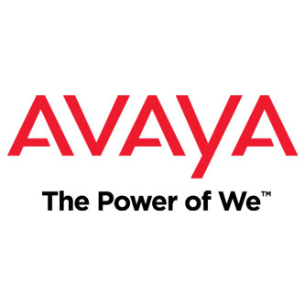

 

**Roles & Responsibilities-Consultant+Brands2Life**

* **Planning and executing social media, display advertising, SEM, email, ORM and online marketing strategies**
* Managing the social media presence of brands and leadership profiles through campaigns.
* Deploying digital engagement **strategies of gamification, social collaboration, digital innovation and employee advocacy etc. to build the brand's social presence.**
* Building social and digital strategies, goal & budget setting, content creation, execution and tracking.
* **Social media listening, monitoring and analytics** through use of tools such as Hootsuite etc. for the brand and reporting insights to the global teams.
* **Market Intelligence, Industry Insight, Competitor Benchmarking, Influencer mapping, Public Relations , Creative content,communication startegy and engagement.**
* **Team management** and collaboration with digital agencies & vendors.
* Traditional Marketing management**- ATL/BTL/TTL/EVENTS**
* Conceptualising the BIG IDEA & producing **engaging, industry-leading editorial and thought leadership content like white papers, case studies, blogs, videos, presentations etc.**
* Identifying up-sell and cross-sell opportunities through content analysis, and deploying content assets for higher conversion rates.

 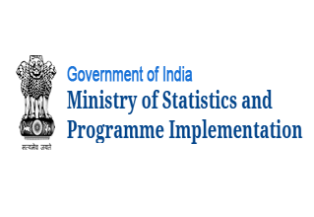  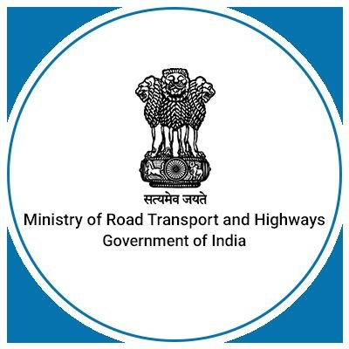

 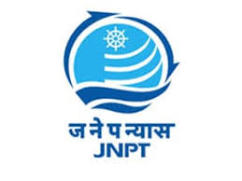 

**INTERNSHIPS UNDERTAKEN**

**TIMES OF INDIA GROUP (Research and Marketing Department)**

**Management Trainee-**To study the Channel management and distribution system of newspapers and magazines so as to become efficient in direct sales and Supply Chain Management

**ABT.ASSOCIATES INCORPORATION.(A Division of US AID)**

**Market Research Trainee-**To catalyze commercial sector engagement in In hand washing MARKET BASED PARTNERSHIP.I worked under the program establishing industry wide alliances to address hand washing promotion.I studied various Indian and international hand washing programs and alliances such as Central American partnership and the global hand washing partnerships