**AMIT R. KIRNAYKE**

UI/UX /Graphic Designer

UI/UX/ Graphic/illustrator designer with 4 years of experience in Digital Marketing & IT/ Ecommerce Industry. Adaptive nature with distinct individual character, Efficient producer & Compatible with

creative work environment.

[kirnaykeamit@gmail.com](mailto:kirnaykeamit@gmail.com)

+91-7083204892

At. Gajanan nagar ward no.1, pipri meghe,wardha, Maharashtra -442001

**SOFTWARE SKILLS**

9/10 9/10 8/10 7/10



7/10

6/10

**WORK EXPERIENCE**

UI/UX/Graphic Designer

Jumpking International LLP

Sep 2021 - Present Bangalore, Karnataka

Working on UI/UX design for existing website, social media post, branding & Marketing for their multiple bussinesses.

Freelance Graphic Designer

R&R Associates

Sep 2020 - Sep 2021 Wardha, Maharashtra

Worked on 3D Building Rendered models post processing work.

Jr. Graphic Designer

Arista System

Sep 2019 - Sep 2020 Nagpur, Maharashtra

Worked on Kith project where I have to make product Images ready for website & social media also worked on In-house projects like designing Web templates, Emailers etc.

Illustrator

Hi-Tech isolution LLP

Feb 2018 - Mar 2019 Ahmedabad, Gujarat

Worked on conceptual content based designs for promoting values of company by using designing softwares such as Illustrator & Photoshop.

**CERTIFICATES**



**PORTFOLIO**

6/10

4/10

4/10

Masters Program in UI/UX

Subhe e learning, Chandigarh

Graphic Designing Certificate

Pixxel Arts, Hyderabad-500016

**EDUCATION**

B.E. Electrical Engineering D.M.I.E.T.R. Sawangi(M), Wardha R.T.M.N.U

**LANGUAGES**

2021- 22

2017-18

2013-18

Marathi - Native

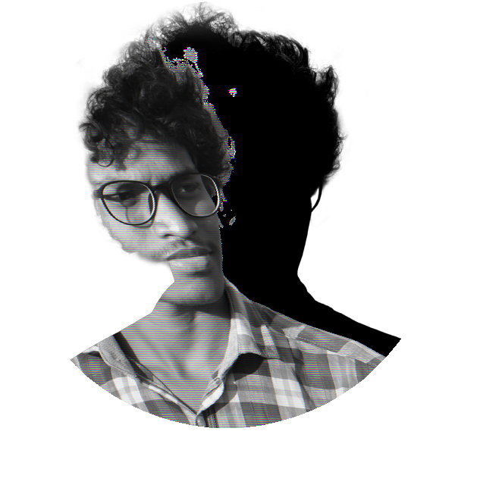

Hindi - Good

English - Good