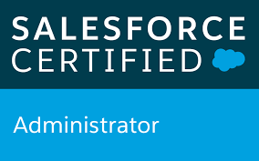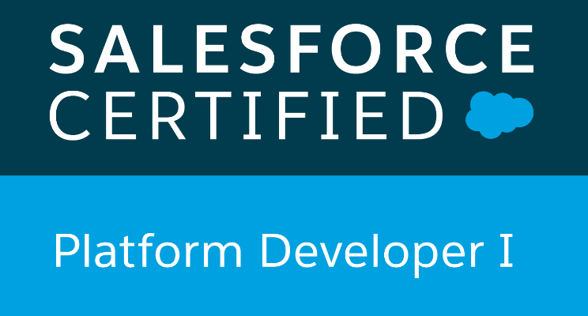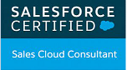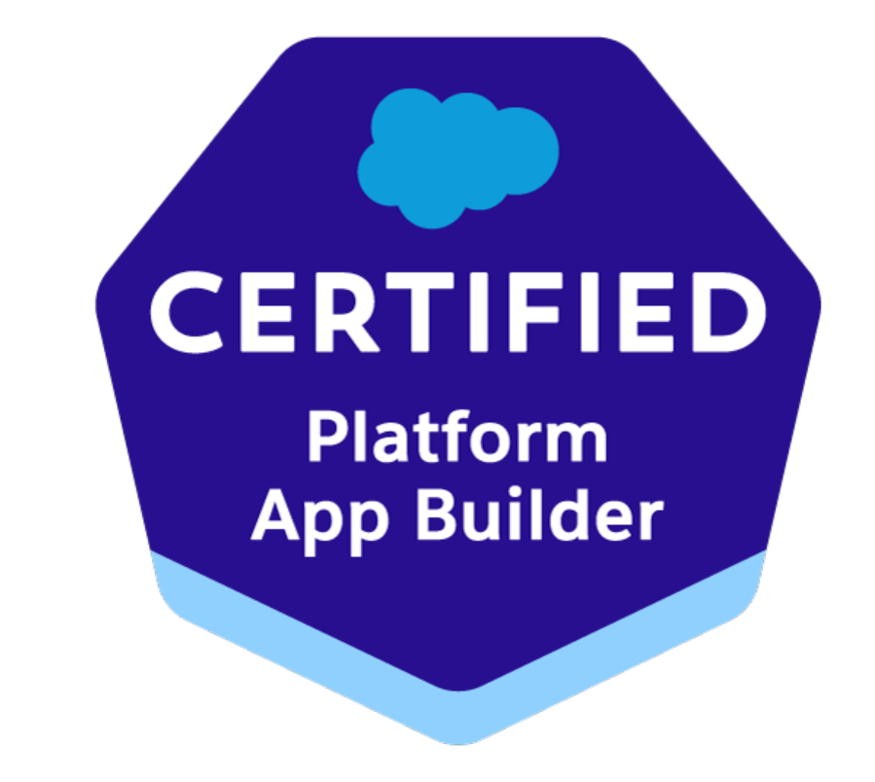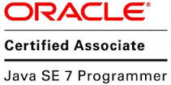

Richa goyal

Technical Architect

Mobile: +91 971 150 3805 * E-Mail: tellgoyalricha@gmail.com

OVERVIEW:

- 8.5 years’ experience in Software development
- More than Six years relevant experience in Salesforce customization and configuration
- 2 years’ experience in J2SE, J2EE platform.
- Strong UI skills with salesforce lightning, lightning web components, Apex along with backend logic
- Salesforce CRM knowledge
- Industry/ Domain Knowledge : Agriculture firms, banking, Computer/mobile hardware industries
- Strong communication skills with excellent team management skills well augmented with
problem solving, flexible and amiable attitude
- Three years of tenure on client side with high client satisfaction.

SKILLSET & CERTIFICATIONS:

- Salesforce Certified Platform Developer I, Salesforce Certified Administrator, Salesforce Certified Sales Cloud Consultant, Salesforce Certified Platform App Builder, Salesforce Certified Omni Studio Developer
- Oracle Certified Associate, Java SE 7 Programmer
- Salesforce CRM : Lightning Web components, Apex classes, Lightning, Triggers, Workflows, Validation rules, Data and Security Model etc. while working with salesforce CRM
- LANG/ TECH: J2SE, J2EE (JSP, Servlets, JDBC, Spring, Hibernate), HTML,
EXTJS, JavaScript
- DATABASES: Oracle, SQL
- OPERATING SYSTEMS: Windows 07 / XP/10
- TOOLS: Eclipse, Visual Studio Code, Data Loader, ANT, Git, Jenkins

PROFESSIONAL EXPERIENCE:
Organization: HCL (Sep 2021- Current)
Role: Team Lead
Client: ClubCorp
Project Name: ClubCorp
- Duration : Sep’21- current
- Role : Technical Architect
- Responsible for community migration using Apex, Lightning Pages, LWC, Trigger and configuration

Organization: IBM (July 2019-Aug 2021)
Role: Team Lead
Client: Verizon
Project Name: Verizon
- Duration : Dec’20- Aug’21
- Role : Package Consultant
- Responsible for customization using Apex, Lightning Pages, LWC, Trigger and configuration

Client: Australia
Project Name: DFSI
- Duration : Aug’19- Jan’20
- Role : Package Consultant
- Responsible for customization using Apex, Lightning Pages, Trigger and configuration
Development using Apex, Lightning, Trigger, Validation rule, Workflows etc.

Client: Sony
Project Name: Sony
- Duration : Jan’20-Feb’20
- Role : Package Consultant
- Responsible for customization using Apex, Lightning Pages, Trigger and configuration
- Integration through rest APIs for mobile application
Development using Apex, Lightning, Trigger, Validation rule, Workflows, process builder etc.

Organization: Fujitsu Consulting India (Feb 2013 -July 2019)
Role: Application Developer
Client: BridgeStone
Project Name: BridgeStone
- Duration : July’18- June’19
- Role : Sr. Salesforce Developer
- Responsible for customization using Apex, Lightning Pages, Trigger and configuration
Development using Apex, Lightning, Trigger, Validation rule, Workflows etc.

Client: Moody’s
Project Name: Moody’s Ligtning Conversion
- Duration : April’17- June’18
- Role : Sr. Salesforce Developer
- Responsible for customization using Apex, Lightning Pages, Trigger and configuration
- Integration through rest APIs for mobile application
Development using Apex, Visualforce, Lightning, Trigger, Validation rule, Workflows etc.

Client: Moody’s
Project Name: MRP
- Duration : Jan’17- April’17
- Role : Sr. Salesforce Developer
- Responsible for customization using Apex, Lightning Pages, Trigger and configuration
- Integration through rest APIs for mobile application
Development using Apex, Lightning, Trigger, Validation rule, Workflows etc.

Client: Monsanto USA
Project Name: Wheat
- Duration : Aug’15 – Dec’16
- Role : Sr. Salesforce Developer
- Responsible for customization using Apex, Lightning Pages, Trigger and configuration
- Integration through rest APIs for mobile application
Development using Apex, Visualforce, Lightning, Trigger, Validation rule, Workflows etc.

Client: ST Microelectronics (Worked on client side)
Project Name: DRP2
- Duration : May’15 – Aug’15
- Role : Java Developer
- Worked at client side closely with the client
- Development using JSP, Servlet, Ext JS, SQL Server ,Apache Tomcat

Client: Fujitsu America Inc. USA
Project Name: ISS Sustainment
- Duration : Oct’14 – Feb’15
- Role : Java Developer
- Development using JSP, JQuery, Servlet, SQL Server ,JBOSS
- Working on different Portals

Client: ST Microelectronics (Worked on client side)
Project Name: Notice
- Duration : April’14 – June’14
- Role : Java Developer
- Worked at client side closely with the client
- Development using JSP, Servlet, Spring, Hibernate, JavaScript, Ext JS, SQL Server ,JBOSS

Client: ST Microelectronics (Worked on client side)
Project Name: Notice
- Duration : Oct’13 – Feb’14
- Role : Java Developer
- Worked at client side closely with the client
- Development using JSP, Servlet, Spring, Hibernate, JavaScript, Ext JS, SQL Server ,JBOSS
Organization: CMC Jaipur (Feb’12 – Oct’12)
Role: Java Trainee

CMC Jaipur, Jaipur, Rajasthan
Project Name: Placement Portal
- Duration : Feb’12 – Oct’12
- Role : Java Trainee
- Development in Java (JSP, Servlet, JDBC, Java Beans, Spring, Hibernate)
- Database : MySQL, Oracle

Education:
- MCA from University of Kota with 77.02% (Second university topper)
- BCA from University of Rajasthan with 73.5%(Second college topper)

