THADISIRI MURALI MOHAN
Mobile: +91 8050813191 Email: thadisirimuralimohan@gmail.com
Linked In: www.linkedin.com/in/thadisiri/

Summary
Overall 9 years of IT experience including 3.6 years of experience in Robotic Process Automation using Automation Anywhere.

Automation Anywhere Certified Master RPA Professional (Version 11)
Areas of Expertise
Objective
A passionate RPA developer having experience in development, testing and deployment of bots to solve challenging business problems.

Areas of Expertise

Robotic Process Automation
- Extensive involvement in Robotic Process Automation development process by using Automation Anywhere
- Having hands on experience in Automation Anywhere
(Version 10.7, 11.1, 11.3).
- Experience in design, development, testing and deployment of bots using Automation Anywhere Enterprise platform
- Created Solution Design Document(SDD),Process Design Document(PDD)
- Extensively worked on Automation Anywhere in different scenarios like handling PDF, Excel Data, Database activities, Data migration, trouble shooting and creating & scheduling the tasks.
- Experience in structured and pattern-based data extraction using Web Data Extraction and export the data to Excel or database.
- Debugging and identifying the errors using Error handlers.
- Supporting existing processes and implementing change requirements as part of a structured change control process.
- The ability to conceptualize automated solutions and understands the prescribed design architecture.
- Planning, design, testing, prototyping and implementation of enhancements, control and tuning of pre-built automation processes
- Develop the bots by using Smart Recorder, Screen Recorder, Web Recorder Task editor.
- Hands on experience on MetaBots and Workflows.
- Hands on experience on AA control room.
- Web, Windows based application automation.
- Analyzing the problems and implement the processes to improve.
- Innovative ideas to reduce the time span of a process.

Technical skills

RPA Tools - Automation Anywhere (v10, v11x)
Scripting Languages - VB Scripting, SAP Scripting and My SQL.
Operating Systems - Windows 7, Windows 10.
Databases - SQL, Oracle

Experience

- Working as a Engineer in Avineon India Pvt. Limited from May 2011 to April, 2015
- Working as an Executive in Yokogawa India Limited from May 2015 to till date.
- Having 2.5 year working experience in client location (Singapore) till date.

Education

- B-tech in Electronics & communication Engineering from JNTU- Anantapur

Professional Experience and Achievements

Project 1: Intercompany POC Billing
Tools : Automation Anywhere (11.3), SAP 7.50
Role : RPA Developer

This bot will help to create Billing Plans, Create and Generate Invoice and Email to Customer and FIN.
Extract input excel file from SAP BI portal, calculates billing amount, access the SAP sales order page and enter amount in billing plan and release, Create and generate Invoice, email BI report to customer and Finance

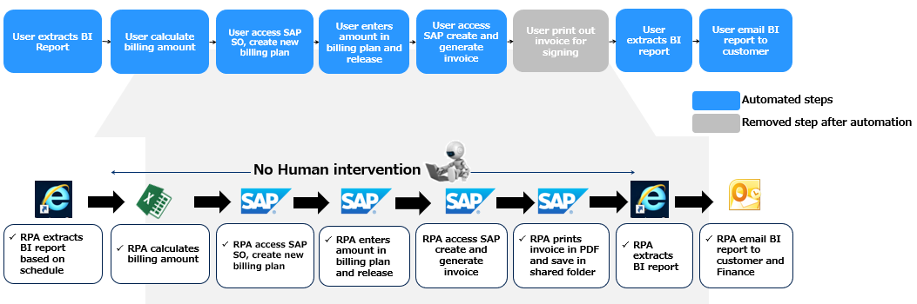

Responsibilities:

- Architecting client requirements using Automation Anywhere.
- Architected common Mail sending module.
- Helping the technical team to prepare Technical Design Document.
- Reviewing Technical Design Document before the development phase.

Project 2: Intercompany PO Receipt
Tools : Automation Anywhere (11.1), SAP 7.50
Role : RPA Developer

This bot will help to create Invoice Number, Material Document number and accounting document number. Robot receive billing documents from billing company and verify the amount and proceed to enter data in SAP application.

Responsibilities:

- Identified Manual driven activities and segregate the in scope and out scope activities for Automation.
- Handle the development and support team and make sure for the right productivity and accuracy of results.
- Send the Success/Fail emails after finishing job.

Project 3: New Debit Credit
Tools : Automation Anywhere (11.3), SAP 7.50
Role : RPA Developer

This bot will help to create Invoice numbers on Credit note and Debit note. Robot will receive emails from user. When new email arrives robot trigger automatically.

Responsibilities:

- Used agile methodology for development and refining requirements in each iteration.
- Prepare Requirement plan which will specify the information and control mechanisms that will be used for measuring, reporting and controlling changes to the system.
- Establishing and maintaining agreement with the business users on what the system will do.
- Analyze requirements based on business process and define the stake holder’s view of the system.
- Define and explore various solution approaches using As Is, To Be.

Project 4: Non-PO Invoice
Tools : Automation Anywhere (11.3), SAP 7.50
Role : RPA Developer

This bot will help to create Invoice numbers. Robot will receive emails from user. When new email arrives robot trigger automatically.

Responsibilities:
- Analyze business requirements, analyze business process flows, and analyze integration requirements related to business at high level and detail level.
- Worked on UAT and Production issues.
- Deployed 5 bots in production.
- Defect analysis and defect fixing.
- Demo given to the client by recording each sequence of bot.
- Conducted weekly status call with the Client.

Project 5: TMS Entry
Tools : Automation Anywhere (11.3), SAP 7.50
Role : RPA Developer

This bot will help to enter timesheet manhours in SAP. Robot will receive emails from user. When new email arrives robot trigger automatically.
Robot receive time sheet from each user in fixed excel format and read the data from excel then compare data with history file whether timesheet already uploaded or not and then prepare output file to upload in SAP. After uploaded send SUCCESS/FAIL notification to User.

Responsibilities:
- Analyze business requirements, analyze business process flows, and analyze integration requirements related to business at high level and detail level.
- Developed required Bots.
- Worked on UAT and Production issues.
- Development & Product integration.
- Bug tracking & fixing.
- Responsible for code review of deliverables
Project 6: Bayer Healthcare
Tool : SQL 2008R2/2012, Windows Server 2003/2008
Role : SQL Developer

Bayer HealthCare Pharmaceutical’s goal is to discover products that will improve human health worldwide by diagnosing, preventing and treating diseases. As a specialty pharmaceutical company. For more than 100 years, Bayer has been dedicated to developing, manufacturing and marketing pharmaceuticals. Built on the company's long history of providing medicines those healthcare providers. Bayer is one of the most recognized brands in health care.

Responsibilities:

- Created store procedures, queries, triggers, views and cursors
- Managed and scheduled daily jobs relating to data backup and recovery.
- Created Clustered Indexes to improve performance of database access

