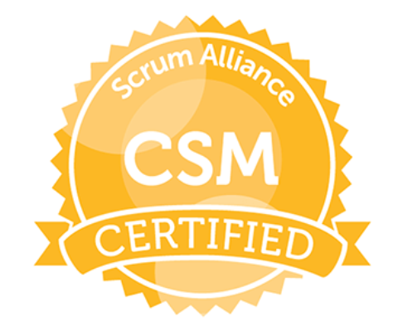

TWINKLE GUPTA
Tel. (+91)-750 322 9537 / 937 342 1801
E-Mail: twinkleg24@gmail.com Skype ID: twinkleg24

Aim to be associated with progressive and growth-oriented organization that gives scope to apply my talent and skills with hard work and determination, and to be part of the team that dynamically works towards the growth of the organization.

Synopsis

- Holding a Certified ScrumMaster® (CSM®) certification demonstrates knowledge and ability to support Scrum.
- Overall 2 years’ experience in Scrum Master and Agile Coach.
- Knowledgeable about software development life cycle (SDLC) that includes specifying and analysing requirements, release management.
- Expert in driving the adoption and enforcement of scrum rules, removing impediments with the help of Jira Board and fostering self-management.
- Interaction with PO and understand the requirement beforehand.
- Capable of delivering large scale software and web development
- M.B.A from Kurukshetra University and professional with almost 5 years of experience in the field of Accounts & finance and performing the role of scrum master for SAP Fico Application for Infosys.
- 2.5 years’ experience with Giftyounow.com (an e-Commerce Company) as a BDM - Finance & Sales and Agile coach.
- Effective communication skills, interpersonal skills, self-motivated, quick learner, team player.
- Proactive team builder and top performer in time-sensitive solutions with the proven ability to identify requirements acquire business processes and convert resources into working solutions.

Functional Skills

- Agile Principles, Certified ScrumMaster®
- Process Optimization
- People and Project management.
- Finance

Application Used

- Software: Jira, HPQC, MS Office (Word, Excel, Outlook, PowerPoint),
- Applications: SAP logon 720 and 750, Citrix, Siebel CRM, Cognos.

Career Scan and Projects Handled

June’18 – Till date with Infosys

Key Responsibilities:
- Adheres to Scrum as it is defined in the Scrum Guide
- Facilitates Scrum events and maintains Scrum artefacts.
- Works to remove team and organizational impediments with the help of creating dependencies in Jira.
- Interaction with PO (Product Owner) to understand the requirement and anticipating the impediment before sprint planning.
- Perform Sprint Retrospective and understand the fallout and strength to avoid or apply in upcoming sprints.

Oct’13 – Feb’17 with Giftyounow.com BDM - Finance & Sales

About Giftyounow.com
GiftYouNow.com is engaged in the domain of online shopping. As the name says their motto is to gift their customer with each delivery and feel them delighted. Its newly launched e-Commerce Company with headquarter in Lucknow and branch offices in all major cities of India.

Key Responsibilities: .

- Creation of G/L Masters, Cash Journals, House banks and Maintaining Field Status Variant and Posting Keys
- Defining Fiscal year variant, posting periods, Tolerance groups, Document types and number ranges, bank reconciliation, ledger posting, GL Account Document, Profit Centres, Cost centres
- Creation of Vendor Accounts Groups, Purchase Invoice Posting, Advance Payments, Creation of House Banks, Automatic Payment Program, Extended Withholding Tax.
- Defining Company Code, Business Area, Fiscal Year, Chart of Accounts, Posting Periods, Defining Document Type, Number Ranges, Tolerance Enter Customer invoice, Customer line item Display, post incoming payments.
- Billing process, Asset Creation, Depreciation.
- Sales process management - End to end management of the sale from initial contract, through to presentations, negotiation and implementation. Lead Generation – Identifying new business development opportunities

Scholastics

- M.B.A from Kurukshetra University in 2008 with 72% Marks in Finance (Minor: Marketing)
- M.Com from Kurukshetra University.
- B.Com from Kurukshetra University.

Personal Snippet

Address : K3-104, Kumar Purva, D.P Road, Pune -411028
Linguistic Abilities : English & Hindi.

