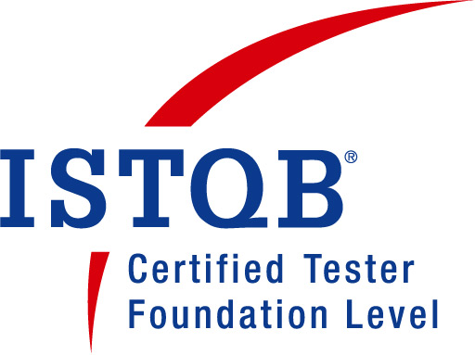
Anju Gupta
Mail to: gupta.anju192@gmail.com
Mobile: +91-9958564201

Career Objective :

To expertise software testing methodologies and seek challenging assignments in an organization which provides me avenues for learning and in turn leading to personal, professional and organizational growth.

Experience Overview :

- Total 4.0 years of experience in Software Testing i.e. Manual, Mobile & Web automation application.
- Well Versed with Bug Life Cycle.
- Experienced in Manual Testing includes GUI, Functional and Regression Testing.
- Good Knowledge on Email Production Marketing and Telecom domain.
- Good Exposure on Selenium.
- Well Versed with Window-based, Mobile & Web based Software’s.
- Good practical experience in various aspects of test writing, execution, desiging & planning throughtout the whole testing life cycle (STLC).
- Performs Metrics validation and assigning the task to the team members. Also, use to handle the team in absence of Team Lead.
- Good Exposure on QC. Experience in preparing Weekly status reports and Daily status reports.
- Ability to work under deadlines, worked as an active team member and willing to accept responsibilities.
- Good in communication, coordinate with team and skill improvement.

Professional Experience :

Name of the Company : Accenture Solutions Pvt.Ltd.
(working with one of the worlds number search engine as a client of Accenture)
Designation : Quality Analyst
Duration of Job : From 14th April 2017 – Till Date

Name of the Company : Tech Mahindra (On third-party payroll)
Designation : Software Engineer
Duration of Job : From 6th June 2016 – 25th Oct 2016

Name of the Company : Ericsson Global India Pvt. Ltd. (On third-party payroll)
Designation : QA Engineer
Duration of Job : From 1st April 2015 - 13th May 2016

Certification

- ISTQB Certified

Exposure :

Testing Skills : Manual Testing and Selenium
Languages : HTML, CSS
Databases : MS SQL, MS Access
Operating Systems : Windows Family, MAC OS
Bug Tracking Tools : HP-ALM-QC and JIRA
Other : Eclipse IDE, MS Office tools

Projects Undertaken

- Project Name : Cloud Platform
Client : Working with one of the worlds number search engine
Duration : April 2017 – Till date
Team Size : 11 Members

Project Description:

Responsible for testing and maintaining the quality of campaigns which Internet Giant send across while marketing their products. Our team sends across various monthly and quarterly reports through email campaigns to the customers by which they can analyse their performance.

Role: Working as a Quality Analyst

Responsibility:

- Work Order Calibration (Requirement Analysis)
- Preparation of Test Cases, Conducted Functional, UI.
- Providing all sorts of effort estimation for campaigns and their change requests.
- Involved in Client calls for Requirement analysis and status update.
- Testing of conditional logic implemented in the code.
- Experience in testing the mobile website on Android, Apple ipad, Iphone.
- Analysis of all possible pre and post production scenarios and identification of high risk and error prone areas.
- Interact closely with client, team members, active participation in Peer reviews and walkthrough and manage all aspect of QA processes and testing of the products, expedite bug-fixing process, Report and track product defect and priority lists with engineering and program management.
- Responsible for sending final sign-off to client.

- Project Name : AT&T Mobility & Retail
Client : AT&T
Duration : June 2016 – Oct 2016
Team Size : 15 Members

Project Description:

One point universal system (OPUS) is an application for AT&T sales representatives for ordering, billing and tracking process for customers. It is also available in Mobile version (OPUS-Mobile)

Role: Working as a Software Test Engineer

Responsibility:

- Testing on Mobile devices like IPads & Win8 Tablet and all latest payment/signature capture devices compatible with them.
- Analyzing Test documents, Test Planning, Test Cases writing, and Smoke & Sanity testing, test case execution and Defect Management.
- Analysis of Functional specifications and recommendations as a part of Functional & Regression Testing.
- Testing every part of the application including design, visual appearance, and functionalities at multi browser environment updating the test cases record.

3) Project Name : T-Mobile
Duration : 14 Months (1st April 2015 – 13th May 2016)
Team Size : 11 Members.

Project Description:

T-Mobile is the service provider which is used by the mobile subsidiaries of the telecommunication company.

Role: Worked as a Quality Analyst

Responsibility:
- Understanding Requirements
- Following the Test Plan
- Execution of Test Cases
- Bug Tracking and Reporting
- Test Report
- Retesting and Regression Testing
- Testing User Manuals

Academic Credentials :

- B.E. in Information Technology from RGPV, Bhopal (2014)
- 12th Miss Hill Hr. Sec. School, Gwalior (2010)
- 10th Carmel Convent Sr. Sec. School, Gwalior (2008)

Key Strength :

Positive Attitude, Proactive, Self-Driven, Innovative, Eagerness, Flexibility, Fast Learner, Team Spirit, Responsible and Keen to take Ownership.

Awards and Achievements :

- Awarded “Encore Award” for excellent performance.
- Got recognition for successfully certifying many functional projects.
- Awarded “Shining Star Award” from the Client side for excelling everyday.

Personal Profile :

Date of Birth : 29-09-1992
Language Known : English, Hindi
Mobile : +91-9958564201
Address of Communication: : 76, J&K Block,
Laxmi Nagar,
New Delhi- 110092
Willing to Relocate : Yes
Passport No. : L9924797

I here by declare that all the above mentioned facts are true to best of my knowledge and senses.

Date :-
Place :- New Delhi Anju Gupta

