CAREER OBJECTIVE:

Seeking a challenging assignment, where I can contribute my knowledge and skills for the growth and development of the organization.

EXPERIENCE SUMMARY:

* Good communication skills summed up with splendid knowledge in the area of HVAC.
* Self-motivated and ability to learn new concepts quickly for the organization.
* Good understanding of the cost and scheduling constraints present in the fast track projects.
* Determined and ability to face new challenges and new opportunities for good outcome of the organization.

**WORK EXPERIENCE:**

**Mechanical Engineer with 1 year 5 months experience in HVAC Design and Project**. Extensive knowledge and experience in HVAC systems design, drafting, installation & commissioning.

**CERTIFICATE:**

* HEAT VENTILATION & AIR CONDITIONING (From ACE MEP Institute Bangalore)

**STRENGTHS:**

* Ability to work in pressure situations.
* Good analytical and logical skills required for problem solving.
* Flexible and can Adapt to any change in needs.
* Quick learner, hard worker and a consistent team player.
* Willingness to learn and explore new things.

**JOB PROFILE:**

* **Heating/Cooling Load Calculation** following ASHRAE/ISHRAE handbook & software, building survey and preparation of riser diagram for multi – storey buildings
* **Selection of Indoor & Outdoor units** according to calculated CFM & TR
* **Selection of Diffuser**, grill and gauge of G.I sheet, calculation of no. of G.I sheets required, selection of AHU after static pressure calculation.
* **Calculation of Duct Size**, Design & drafting of all types of split A/C and preparation of duct layout with supply and return diffusers, Duct grill, Slot Diffusers with flexible connections for multi – storey buildings
* **Estimation** Tendering & preparation of BOQ
* **Completed** design and selection of extract fans, centrifugal blowers, axial flow fans, duct in – line fans
* **Installation, Testing & Commissioning of HVAC systems** (Air cooled) for residential, commercial & industrial buildings.

## CURRICULUM VITAE

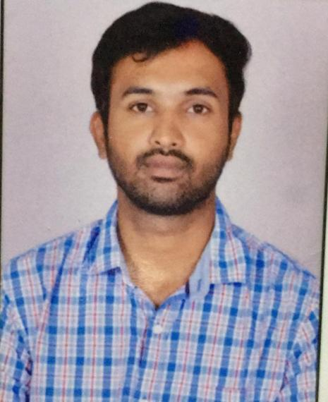

**SHADAB BAIG**

**(MECHANICAL ENGINEERING)**

**(HVAC Design & Project)**

**Mobile**: +91-9538508036

**E-mail:** [shadab047@gmail.com](mailto:shadab047@gmail.com)

**Passport No**: M8185763

ADDRESS:

S/o Sikandar Baig

#1020, 2nd main 2nd cross K T J Nagar Bahaar Manzil,

Davanagere

Pin code: 577002

**PERSONAL PROFILE**

Gender : Male

Date of Birth : 28/07/1993

Father's Name : Sikandar Baig

Nationality : Indian

Marital Status : Single

**EXPERIENCE:**

* **Applied Aircon Engineers** (Nov 2019 – Present)

Designation: Project Engineer (HVAC Design & Site Engineer)

Project Worked on:

1. RMZ MD’s Residency - (Fully VRF System) - Nov 19 - July 20
2. TCL Showroom - (DX Split AC) - July 20 - July 20
3. Villa’s (Adarsh Palm - Retreat) – (DX Split AC) - Aug 20 - Sep 20
4. RMZ Urban House - (Fully VRF System) - Nov 20 - Jan 21

Project Working on:

1. Commercial House - (DX Split AC) Jan 21 - Present
2. Nishara House - (Fully VRF System) Aug 20 - Present

**DECLARATION:**

My academic and involvement in several teams and organizations has improved my communication

Skills and has prepared me for a position to apply in your organization.

The enclosed resume is only a sampling of my capability and proven background. Ability to work in

a team environment can be evidenced in a personal meeting. I would appreciate in interviewing opportunity

at our earliest convenience. Thank you for your time and consideration.

Date: Yours truly,

Place: Davanagere **SHADAB BAIG**

|  |
| --- |
|  |