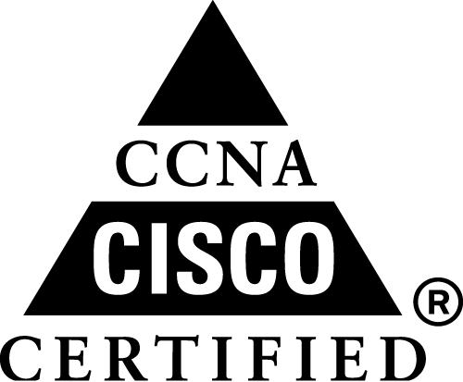 | 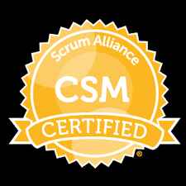 | 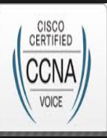 |  | 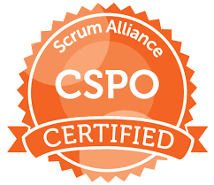 |  | 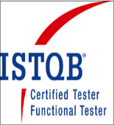
SANJAY KUMAR SAHU
Email: kumarsanjay.cse@gmail.com
Mobile: 9986990624
11 Years of experience in various roles such as Scrum Master, Tech/Program Lead, QA Engineer.
Career Objective:
Seeking a career in the field of Agile Product Development, Program Leadership, QA management, Program management, where I can contribute to meet the quality goal of the organization and my professional growth.
Professional Summary:
- Perform Scrum Master role and mentoring the team for Agile way of Product development.
- Working Exposure of SDLC, Agile Methodologies, Scrum Framework and SAFe Agile.
- Closely Involved in Product and Sprint Backlogs Enhancement
- Act as a change agent for Agile, Scrum and associated Practices.
- Experience in Customer Facing programs and Client Demo.
- Good exposure in tool such as JIRA, Rally, Collaborator, Confluence.
- Mentoring and Supporting the team members to adhere to Agile development values.
- Certified Scrum Master, Certified Scrum Product Owner and Certified SAFe Agilist (5.0).
- Performed as a QA Engineer/Lead and Program Lead for RCA/EDA for the Feature components.
- Expertise on Robot Framework, Selenium WebDriver, TestNG, Jenkins, Git, Core Java.
- Certified ISTQB (Foundation level) and ITILv3 foundational Certified Professional 2012.
- CCNA Voice certified in April 2014 and CCNA Routing and Switching in April 2011.

Current work experience at Nokia:
March 2017 to till date: as a Scrum Master/Technical Lead/ QA Engineer.
Responsibilities:
- Perform the role of Scrum Master and conduct the Scrum ceremonies.
- Prioritized User Stories and defined Acceptance Criteria based on customer requirements.
- Active participant of PI planning, Sprint planning, Backlog grooming, Velocity Optimization and other critical SAFe and Scrum framework processes.
- Leading the RCA/EDA program and responsible for delivery of Customer Acceptance Document.
April 2015 to Feb 2017 as QA Lead/Program Lead/Scrum Master
Responsibilities:
- Performed the role of Scrum Master for INT team
- QA Lead for for Integration team and Program Lead for cross functional RCA/EDA program
July 2013 to March 2015: as Senior Integration Tester:
Responsibilities:
- Managing Functional Automation Test cases for Continues Integration
- Handled Test automation and associate activities.

Previous Work Experience:
- At Cisco Systems, Bangalore (As a Client Place through Bodhtree Consulting Pvt. Ltd.) (July 2010 till June 2013) as Technical Lead/QA Lead/QA Engineer
- At Softsmith Pvt. Ltd, Bangalore (January 2010 to June 2010 as QA Engineer

Academic Qualification:
Bachelor of Engineering in Computer Science from CEC, Bilaspur (C.G) in year 2005 (73.44%)

Projects Details:
Project #1: SS
Role : QA Lead/Scrum Master/Program Lead in CI.
Project Description:
SS is a project which maintains and correlate FM and PM for NMS it is a tool which is responsible for maintaining and managing FM and PM
Roles and responsibilities:
- Perform role of Scrum Master.
- Program lead for RCA/EDA and Customer Acceptance Manual.
- Lead the Continuous Integration activities for the component QA team.
Project #2: NDSA
Role : QA Lead.
Duration : From December 2012 to June 2013.
Project Description: NDSA is single tool which does the security assessment and provide adequate recommendation to Organizations regarding Network security vulnerabilities
Roles and responsibilities:
- Prepare Master Test Plan and Prepare Test Scenarios.
- Prepared Test effort estimation and Test Case Preparation.
- Executed Functional, Regression Testing.
Project # 3: ASAM
Role : QA Lead /Test Engineer
Duration : From July 2010 to December 2012
Project Description: Migration Tool provides the ability to automate common, time-consuming tasks involved in the migration from Check Point/Juniper to ASA devices.
Roles and responsibilities:
- Prepare Alpha Test Plan and Test Scenarios
- Prepared Test effort estimation and Test case preparation
- Responsible for functional and Regression testing.
Project # 4: SPCG
Role : Test Engineer
Duration : From January 2010 to June 2010
Project Description:
SPCG, a state of art product from Softsmith is a web-based process management solution that helps IT organizations in process improvement across the SDLC and is based on the current IT industry standard
Roles and responsibilities:
- Prepared Test effort estimation and reviewing the BRD.
- Involved in preparation of Test Cases and Executed Functional, Regression Testing.

Personal Details:
- Father’s Name: R. S. Sahu
- Current Address: Nehru Nagar, Jakkur, Banaglore-64.
- Language Known: English, Hindi

I hereby declare that all the details provided above in my credential are true to the best of my knowledge and belief.
Sanjay Kumar Sahu

