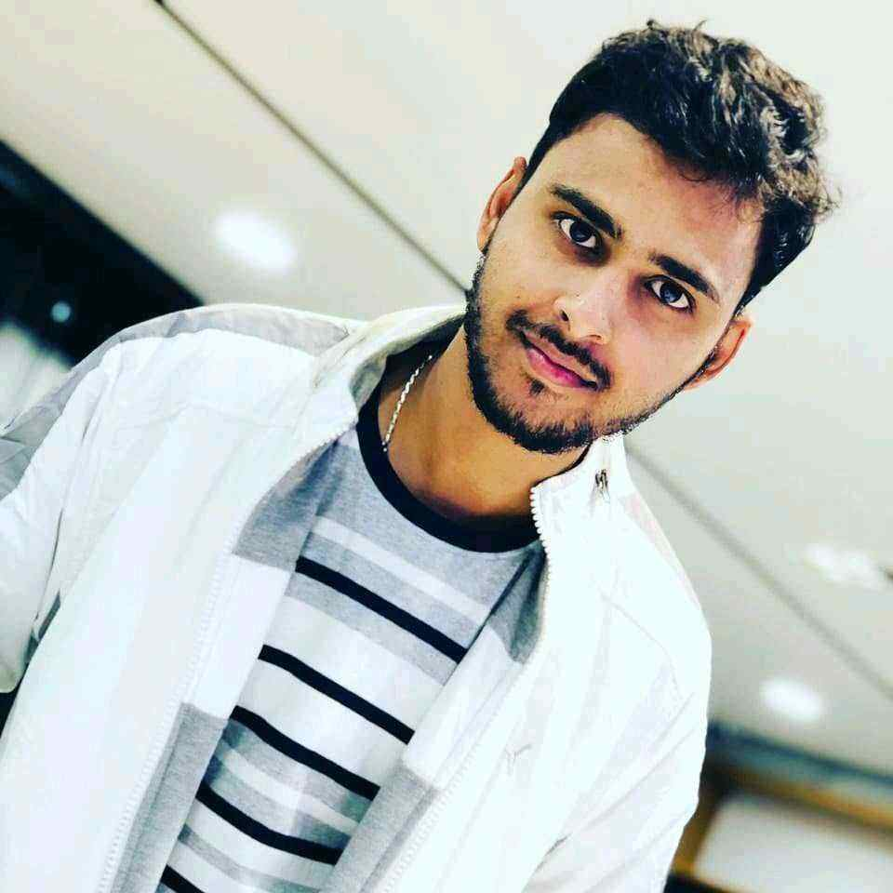 |  | EDUCATION
Delhi Public School, Jamshedpur
Class Xth (2001-2011) = 83%
Class XIIth (2011-2013) = 69%
SDM College of Engineering and Technology - Dharwad (06/2013 - 05/2017)
Grade: - 7.39/10
MUKESH KUMAR  - ML Software Engineer  Profile  A Skilled Software Developer having experience on Python development, Web Development Frameworks(Flask/Fast API/Django) along with implementation of Supervised & Unsupervised Machine learning Algorithms (Linear & Logistic regression, KNN-Algorithm, Random Forest, K-means, SVM , Bagging & Boosting Techniques) , NLP Model & Data visualization.  CONTACT  PHONE NUMBER:  +91-7019574739, 7795653735  EMAIL ADDRESS:  Sid.singh0612@gmail.com  LinkedIn: -  https://www.linkedin.com/in/mukesh-kumar-b8b8a6a6  Skype: -  sid.singh 0612  PROJECTS: -  1. CSAP Analytics (Cisco) (04/2018 – 10/2019)  - Worked on End to End Data Science Life-cycle project with Cisco and Developed Platform for CSAP Data Visualization.  - Developed ML Model on Different SR cases and Extract the Keyword from Different SR's by using NLP Techniques.  - Build Machine learning models by implementing different Supervised Algorithm to find the list of defect Classes occurring on product series.  2. Digital AI-Studio R&D Center (06/2017 – 04/2018)  - Developed End to End Chatbots on top of Python for Different use cases by implementing skills Such as text analytics, ML Models and by using External NLP API's such as IBM Watson, Google Dialogue Flow.  - Developed Microservice in Node.js which integrate Python Function or Python Modules to Express API. |  | WORK EXPERIENCE
Sr. Product Engineer
Harman India.
07/2020 – Present
- Worked on Product migration from SAS to Python which includes all ML Feature, Data streamline Process, API’s for Upstream and Downstream Applications.
- Designed and Developed Custom NLP Model to Segregate incoming User Ticket with confidence Score for IT Infrastructure and has given output to downstream application.
- Have Created Business Dashboard with different Metrics for Comparing SAS and Python procedure performance.

ML Software Engineer
Cargill India.
09/2019-07/2020
- Working on Creating transfer learning model to detect Object from different Cargill Business invoices.
- Worked on Creating Data Pipeline for NLP Model Rasa ML Model.
- Designed, implemented and monitored web pages and sites for continuous improvement.
- Coordinated with project management staff on database development timelines and project scope.

Application Development Specialist
Accenture R&D Lab.
02/2018-02/2020
- Designed and developed python models and libraries to create a platform and pipeline to run different analytics code.
- Worked on End to End Analytics Project Starting from EDA on Different Cisco SR Data Sets till Deploying Model in server through Pickle and Flask.
- Build Machine Learning Models (Linear Regression, Logistic Regression, Decision Tree Classifier) on Different Use Cases based on the Business Requirements.
- Create Rest API interface using Django and utilized MongoDB. Developed Contract Reading VA in Python with integration of IBM Discovery AI Services.
- Leverage Open Source tools and Libraries for Developing and Deploying ML based Solution.
- Developed Micro service in Node.js which integrate custom Python Modules while exposing to Express APIs.
- Design and develop a critical Ingestion pipeline to process millions of data.
 |  | TECHNICAL SKILLS
Skills: - Python Web Development, Machine Learning, Deep Learning, Computer Vision.

Library:- Pandas, Flask, Django, Open CV, scikit-learn, TensorFlow, Keras, NLTK, Spacy, PyTorch

Languages :- Python, Node.js, Java.
Version Control: - Git, bitbucket, Visual studio.
Operating Systems: - Windows, Linux, macOS.
Tools: - MS Excel, Anaconda, Jupyter-notebook, Android Studio.
Cloud: - Amazon EC2, S3 Bucket, GCP and Google Collab.
CERTIFICATIONS: -
Certified Data Scientist from University of California, San Diego (10/2018-10/2024)
IBM Certified Data Scientist (04/2019- Present)

