Pragmatic Delivery Excellence Professional with 14+ years of Experience in IT sector, Expertise in Scrum master, Testing and Project management.

Experience Summary

- Scrum master, with 3+ years of experience Serving as a liaison between product owner and development team to ensure requirements are delivered and key milestones are met
- Servant Leader in leading the distributed Agile teams and building the high teams that deliver high quality products at a sustainable pace; speed to market and exceed customer expectations
- Effective communication & presentation skills with strong academic orientation and adherence to time & quality commitments.
- Proven experience in leading test teams with facilitative approach and guidance for consistent performance improvement.
- Hands on experience in mentoring & coaching teams on Scrum framework.
- Flexible to adapt to any work environment and always been an active team player.
- Strong interpersonal skills thus maintaining exception rapport with the team.
- Facilitate Scrum events - viz. Sprint planning, Daily Standup, Sprint Review/Demo, Sprint
- Retrospective, Backlog grooming sessions.
- Helped team to be self-organized and motivated.
- Attend Scrum of Scrums(SoS) as needed. Helping the teams towards participating in constructive interactions/discussions with stakeholders.
- Knowledge of other approaches XP, Kanban, DevOps
- Knowledge of Agile techniques: User Stories,TDD, BDD, Continuous Integration, Pairing,
Automated Testing
- Established safe and open environment for teams to be self-organized and help each other.

COre Competencies

- Agile/Scrum/Waterfall methodologies
- Product Management
- Quality Assurance
- Client Relationship Management
- Team Building, Mentoring & Leadership
- Project Management
- Resource Management
- Delivery Management
- Vendor Management
- Communication /Negotiation Skills

CERTIfication
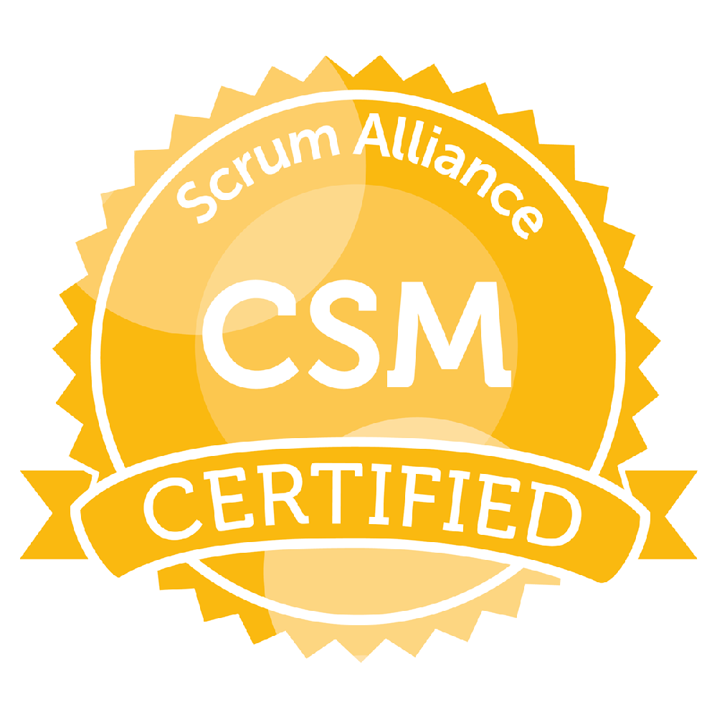 Agile Certified Scrum Master (CSM) from SCRUM ALLIANCER on July 2017 (ID: 000667794)

Technical SKILLS:

Languages & Scripting: JAVA, Java/Shell Script, SQL, Python
C. M. Tools: Git hub, CVS, SVN, Visual SourceSafe
Devops & Build: Jenkins, Docker, Ansible, Nagios,
RDBMS: Oracle 8i, 9i, 10G and SQL Server
Business Domains: Telecom, Travel, Customer Support applications etc.,
Project Management : JIRA, MS Project, Rally

Career Achievements

- Received Valuable team player & Pat on back awards in Techmahindra
- Received Best employee award for Orbitz project in Cognizant Technology solutions
- Implemented Best Practices to attain quality
- Enabled agile team to increase its throughout by 12% through use of swarming around features and other high collaboration approaches such as Paired programming
- Facilitated Test driven development on all projects increasing quality by 17%
- Brought down the Defect leakage to almost 5% from 30 % by implementing Six Sigma
- Succesfully delivered Agile projects within time
- Solely responsible for all the testing activities in test management
- Attained customer recognition in very low defect leakage and for improved testing efficiency

Employment history

Company | Designation | Duration
Techmahindra, Bangalore | Project Manager | Jan2010 to till date
Valuelabs, Hyderabad | Module Lead | July 2008 to July 2009
Cognizant Technology Solutions, Bangalore | Associate | May 2005 to August 2007

project experience

I | EMPLOYER | : | TECHMAHINDRA |  | Aug 2017 to Till date
I | Role |  | Scrum Master
I | Clients |  | British Telecommunication(BT)  DHL

- As an Agile Scrum master, Helping Product Owner(s) in defining user stories & also in maintaining a prioritized backlog.
- Facilitating sprint planning, daily scrum, sprint review demo, sprint retrospective and backlog grooming
- Ensuring that goals, scope, and product domain are understood by everyone on the Scrum Team as well as possible
- Encouraging team to maintain collaborative and cooperative approach with stakeholders.
- Working with Cross functional teams Dev Team, Product Owner and Multiple stakeholders.
- Generate and share burn down charts, velocity, defect density with stakeholders.
- Assist Program Manager in Risk Management and participate in quality reviews
- Manage escalation process & SLA and preparation for daily status calls
- Ongoing issues & Escalations(Tracker) Program Performance Review Planned Work Status
- Working on GO-LIVE activity to deploy the product in Production.

Technologies Used
- OSS/BSS, SQL, HP Quality Centre, BFG, BFG IMS

II | EMPLOYER | : | TECHMAHINDRA |  | Jan 2010 to Aug 2017
II | Role |  | Test Lead/Manager
II | Clients |  | British Telecommunication(BT), |  | Team size-20

Description:
CSDK is a program to provide consolidated way and producing standardized set of system and process for various contracts. The primary objective of the Contracts SDK program is to deliver efficiencies by migrating large MNC and UK contracts to a standard business operating model. The programme will achieve this by building a standard contract management solution that reduces people intensity, the occurrence of failure and ensures success during contract bid, transition and transformation. In CSDK, Expedio is a modular application that integrates and standardizes service management activity, which in turn improves and makes the support to core business, partners, customers and suppliers more efficient and effective.
Role:
- Functionality testing, System testing and Regression testing of the various Modules.
- Involved in Reviewing Test scenarios and Defect Reports.
- System study of the change request documents.
- Understanding the CR’s and Updating the Test Cases
- Defects were tracked, reviewed, analyzed and compared using Quality Centre
- Participating in the project status meetings, retrospective meetings
- Involved in giving UAT demos to the managers

III | EMPLOYER | : | VALUE LABS |  | July 2008 to Jul 2009
III | Role |  | Test Lead
III | Client |  | Tanla |  | Team size-6

Description
TCMS enables to create, edit, manage and finally publish in a number of formats various contents such as text, graphics, video etc, whilst being constrained by a centralized set of rules, process and workflows that ensure coherent and validated electronic content. This system also allows configuring billing/charging rules for the content uploaded. TCMS has content aggregators and content providers to host and deliver their content to mobile consumers. It provides flexibility for content providers and aggregators to organize and price their content across multiple storefronts.

Role:
- Functionality testing, System testing and Regression testing of the various Modules.
- Involved in Reviewing Test scenarios and Defect Reports.
- System study of the change request documents.
- Understanding the CR’s and Updating the Test Cases
- Defects were tracked, reviewed, analyzed and compared using Quality Centre

IV | EMPLOYER | : | COGNIZANT TECHNOLOGY SOLUTIONS |  | May 2005 to Aug 2007
IV | Role |  | Test Lead
IV | Client |  | TRAVELPORT ORBITZ |  | Team Size - 12

Description:
Orbitz is a leading online travel company offering leisure and business travelers a wide selection of low airfares, as well as deals on lodging, car rentals, cruises, vacation packages and other travel. The site was created to address consumers' need for a comprehensive display of fares and rates in a single location.

Role:
- Functionality testing, System testing and Regression testing of the various Modules.
- Involved in Reviewing Test scenarios and Defect Reports.
- System study of the change request documents.
- Understanding the CR’s and Updating the Test Cases
- Defects were tracked, reviewed, analysed and compared using Quality Centre

Academic Profile

- Bachelor of engineering (Computer Science) in Vijaya Nagar Engg College, Bellary,
GulbargaUniversity passed out in 2002.

(Lakshmi.Y.A)

