Brahma Reddy Narla  Mobile: +91-8688824447  Email: sivabrahmareddy6@gmail.com | 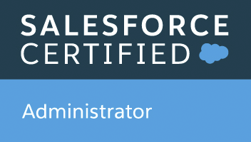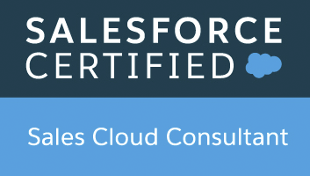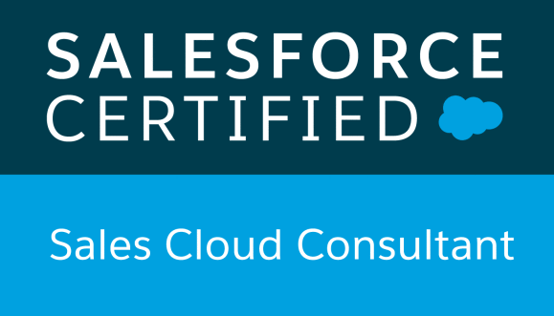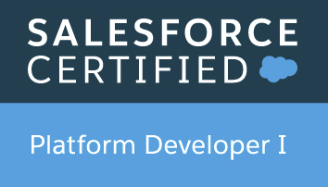  
Profile Summary  - 4+ years of experience on Salesforce.com Platform – CRM, Force.com, Apex Class, Apex Triggers, Batch Apex, Schedule Apex, Future Method, lightning, Aura Components, Visualforce, Rest Api, Workflows and Approvals, Test Classes, Transactional Security, Profiles, Permission Sets, Validation Rules, Reports and Dashboards, Sharing Settings, Deployment, Apex data loader, Workbench etc.  - Experience in end-to-end product development on Force.com platform. This involves development, test classes, bug fixes.  - Knowledge management and Shield platform encryption.  - Deployment experience using ANT and Change sets.  - Experience in Eclipse, JIRA, Bamboo tools and Bit Bucket repository and Vs code  - Experience on sales cloud implementation with modules like account, contact and opportunity etc.  - Experienced on requirement gathering, requirement analysis, providing estimation.  - Experienced in Agile methodology and Check Marx and SonarQube.  EDUCATION  Master Of computer Applications  LakireddyBaliReddy college of engineering, Mylavaram, Krishna (DIST)  CERTIFICATIONS  - IBM db2 Certified fundamentals.  - Salesforce certified administrator  - Salesforce certified Force.com Platform Developer 1  - Salesforce certified Sales cloud consultant  - Salesforce certified Service cloud consultant  - Salesforce certified Platform developer 11(MCQ)  - Flosum Certified Professional  - Copado Certified Administrator  - Copado Certified Developer  EXPERIENCE  Infosys Limited: Jan 2017 to till date.  PROJECTS  Project: # 1: Advisor Services  Role: Salesforce Developer and Administrator  Duration: March 2017- Till date  Client: Charles Schwab  Company: Infosys  The goal of this project is to design, develop and deploy a modern  CRM on Sales force to support for Advisors service. This new CRM platform is critical to support increased productivity and effectiveness of Firm’s front-line professionals and drive growth in assets and clients.  Responsibilities:  - Requirements Gathering, Analysis and Design.  - Development and Unit Testing  - Support System integration and User Acceptance testing  - Deployment and Post-Implementation Support  - Offshore/Onsite Coordination |  | SKILLS  Salesforce.com CRM  Sales Cloud  Lightning  Aura Component  Apex Programming  Managed Package  Custom Settings/Metadata  Visualforce  Rest Api  Json  Validation Rules  Workflows  Approvals  Process Builder  Security Modules  Reports and Dashboards  Other  HTML  Bootstrap  Tools  Visual Studio Code IDE  Apex Data Loader  Work Bench  Force.com IDE  Change Set  Bamboo  Bit bucket  JIRA  ANT

DECLARATION

I hereby declare that all the information given above is true to the best of my knowledge and belief.

Date:2nd Dec 2020
Place: Hyderabad Brahmareddy Narla

