MRIDUL GOSWAMI

+91-9583164063

@ [mridul.goswami999@gmail.com](mailto:goswami999@gmail.com)

Bengaluru

in https://www.linkedin.com/in/mridul-goswami

CAREER OBJECTIVES

To work in an environment where I can utilize my creative skills to grow with the organization.

LONG STORY SHORT

1995 2010 2012 2016 2020 2021 July 2022

Born Secondary

High

B.Tech AAIPVFX Pepper

Joining your

School

Secondary

School

ARENA ANIMATION INTERNATIONAL PROGRAM IN VISUAL FX

Media

company

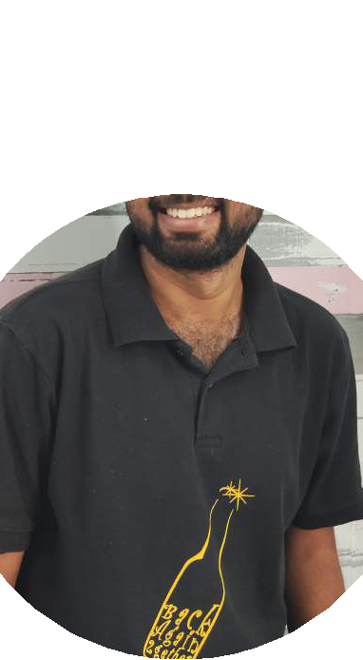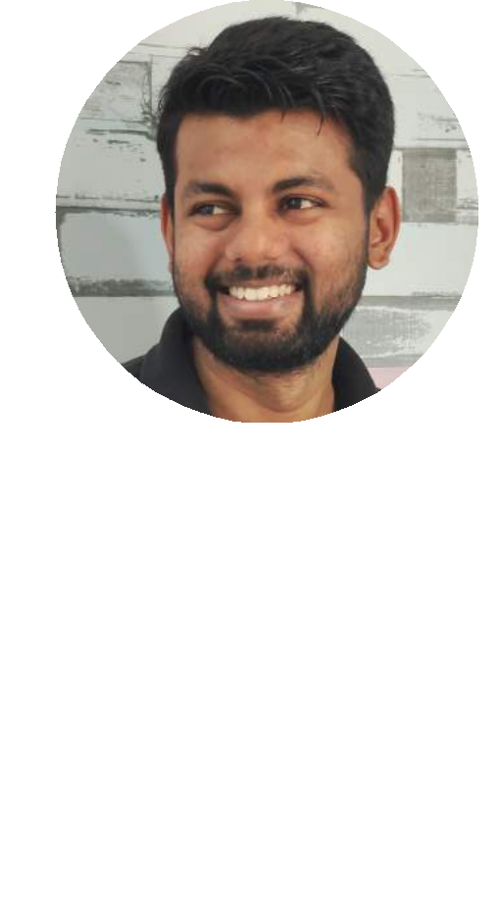

SOFTWARE SKILLS

NUKE MAYA AFTER EFFECTS

PREMIER ILLUSTRATOR PHOTOSHOP

WORK EXPERIENCE

Working since Feburary, 2021 in Pepper Media (a technology-driven digital media company which has collaborated with Sony Entertainment, ABP News etc.)

in Bengaluru

Part of Video Editing Team. Edit videos for YouTube policies and work under the proper telecast timing of the television shows

Video edit for social media platforms such as Facebook, Snapchat, and for pay television channels such as Sony Set Channel

(having 88mn + subscribers in YouTube)

INTERNSHIP

Internship in Digital Kora as Graphic Designer for 6 months

Volunteed for GAFX ( Gaming Aniamtion And Visual Fx) Confrence’ 19

ACCOMPLISHMENTS

Won 2nd prize in the “3D Arhitecture Visualization” category at

Creative Minds 2019 in Bangalore

Successfully completed 64 hours course in “N-Power Certified Routing Professional”

from APTECH Bhubaneswar in February, 2014

Secured “Excellent Performance Award” in Inter Center Quiz Competition on

IT Knowledge held by APTECH & Networking Academy in January, 2014

OTHER FREELANCING ACTIVITIES

Prepared video slide for Vidai & Student Connect in OEC (Orissa Engineering College) Designed Digital flex, registration card for OEC (Orissa Engineering College) fest Volunteed for GAFX (Gaming Animation and Visual FX ) Confrence’ 19

Volunteed for GAFX ( Gaming Aniamtion And Visual Fx) Confrence’ 19