Sanjay Parihar

📞 +91 8860687566
📧 sanjurtu@gmail.com

Profile

Knowledgeable network Engineer with over 7 years’ experience securing information and maintaining network performance. Highly trained and experienced in working independently to assess test and remedy network issues. Strong communication and troubleshooting skills.

Areas of Expertise

- Vast experience in Network Operations Centre functions
- Experience with Jenkins and Jira
- Good experience in Virtualization (VMware) and VPN
- Configuring and Maintaining Cisco Router and switches
- Routing & Switching STP, HSRP, VPC, OTV, VLAN, OSPF, EIGRP, BGP Design and Configuration
- Good Understanding of relationship between routers, switches, patch panels and connecting devices to the network
- Knowledge on tools like EM7, SolarWinds and WhatsUp Gold which are used to get the alerts from network devices.
- In-depth knowledge of network monitoring, LAN, WAN, SNMP and ICMP monitoring systems, network equipment, and network operation technique.

Skills Set

- Network administrator
- SDWAN
- Jenkins and Docker automation tool
- Virtualization (VMware)
- Net Scaler
- AWS cloud
- TCP/IP Protocol
- Active directory
- Troubleshooting
- Packet tracer
- NOC monitoring

Devices Hands-on

- Nexus switch series 2000, 5000, 6000, 7000, 9000
- Catalyst Switch Series 2900, 3500
- ISR router 4331

Professional Experience

Tech Lead (L2 Network Engineer) 25/1/2023- current
Cognizant Noida

- Managing and monitoring the operational activities of the client (Loblaw).
- Fix network issues including design, installation, configuration, maintenance, and security.
- Good understanding of SD-WAN and upgrade activities.
- Exposure to legacy network.
- Troubleshooting SDWAN and legacy WAN issues.
- Lead sessions to instruct engineers on the best practice around switching and routing.
- Do the health checks on the store’s routers and switches.

Network Engineer 03/12/2020 – 25/10/2022
Capgemini Gurugram

- Analyse, troubleshoot and resolve complex networking issue in data centres across the globe.
- Provide system analysis for the configuration, upgrade in the Nexus switches.
- Good understanding of switching protocols in Nexus like VPC, OTV, Fabric path etc.
- Worked in Nexus 2000/5000/6000/7000/9000 series switches within depth Tshoot.
- As a Network Engineer with LAN and WAN design experience focused on Cisco
- Responsible for Incident management and proactively escalate any issues that cannot be resolved within the established timeframes.

NOC Engineer 30/1/2019 – 27/11/2020
Incedo Gurugram

- Proactive monitoring such as network usage, temperatures, file system usage etc.
- Run Manual scripts through Jenkins.
- Manages network tuning, LAN, WAN, Server performance and designs strategies, and makes recommendations to improve network performance
- Responsible for Incident management and proactively escalate any issues that cannot be resolved within the established timeframes
- Worked in active directories, citrix and VMware.

Technical Support Engineer 21/8/2017- 2/9/2018
Prometric Gurugram

- Support the clients & provide resolution of procedural, process, information and technical problems for requests from testing centre administrators submitted by Inbound Calls, email, chat.
- Multitask and support customers on more than one channel, call & chat at the same time. Document & provide audit trail of all problems and resolutions.

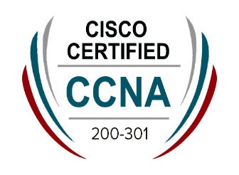
Certifications

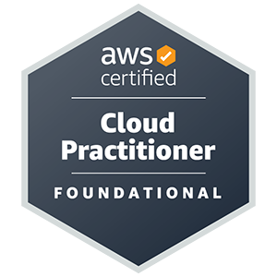
CCNA (Cisco certified network associate) AWS(Cloud Practitioner)

Education

Bachelor of Technology– Computer Science 2017
Graphic Era Hill University Bhimtal, Uttarakhand

Strengths

- Hard working
- Good listener
- Team Worker
- Adaptable
- Honest

Personal Details

- Date of Birth : 20th December 1994
- Languages Known : English and Hindi.

