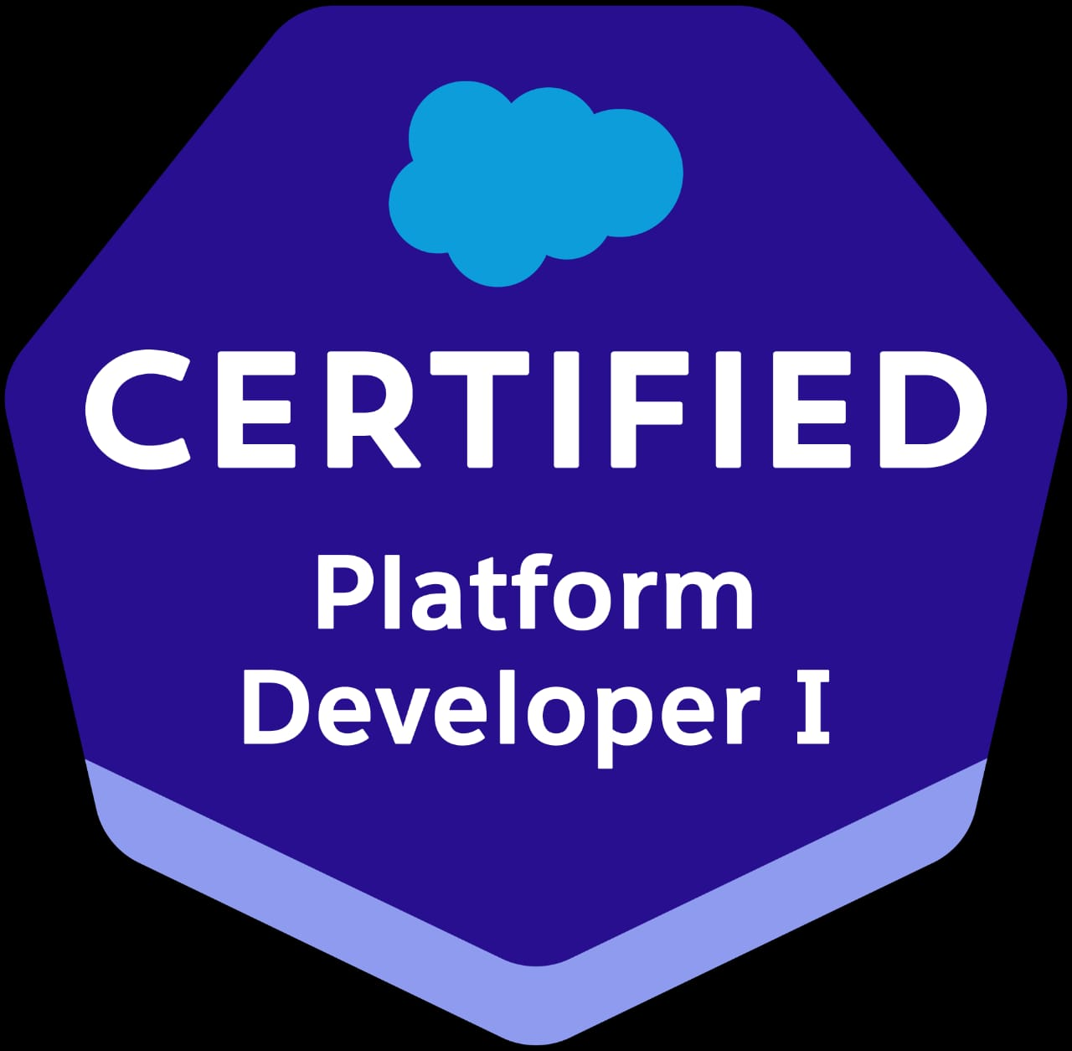

**Jagadeeswar Reddy Yeddula**

**Phone Number : +91 9059686659**

**Email ID : jagadeeswar16.sfdc@gmail.com**

**PROFESSIONAL SUMMARY:**

* **Having Totally 5 years of experience in the IT industry and having 5 years of Experience in Designing, Development, Testing and Implementation by using Salesforce CRM.**
* **Experience in working with Different Sandbox Environments and Production Environment.**
* **Proficiency in Salesforce Administrative tasks includes creating Profiles, Roles, Users, Page Layouts.**
* **Hands on Experience in Lightning Component Development and Lightning Experience.**
* **Developed Visualforce pages using the extension controllers, Apex Classes & Triggers to implement the business logic as per the requirements.**
* **Approvals, Workflows, Validation Rules, Reports, Dashboards, Actions, Tasks and Events.**
* **Proficient in using data migration tool like SalesForce Apex Data Loader.**
* **Experience in working with Salesforce CLI/SFDX and VS Code.**
* **Having Experience with REST API Services in Integration.**
* **Experience on deployment processes by using Change sets and BitBucket.**

**TECHNICAL SKILLSET:**

|  |  |
| --- | --- |
| **Salesforce** | Lightning Aura Components, Lightning Web Components, Apex Triggers, Apex Classes, Test Classes, Visual-force, Administration, SOQL |
| **Web technologies** | HTML, JavaScript ,CSS ,JXML |
| **Tools** | Apex Data loader, Force.com Migration Tool, Workbench and Salesforce CLI, VS Code, Salesforce Inspector,Bitbucket,JIRA |

**CERTIFICATION:**

**Salesforce Platform Developer I**

**EDUCATIONAL QUALIFICATION:**

* **B.Tech in Electronics and Communications Engineering from JNTU Anantapur.**

**PROFESSIONAL EXPERIENCE:**

* **Working as Salesforce Developer in Wipro from JANUARY 2023 to till now.**
* **Worked as Software Developer in iPark Info Technologies Pvt Ltd from JUNE 2018 to December 2022.**

**Client: Zurich JANUARY 2023 – Till Now**

**Projects: Zurich**

**Role: Salesforce Developer/Support**

**Organization: Wipro**

#### Description: Zurich is using Salesforce CRM to manage their products and services.

**Responsibilities:**

* Incident Management and Resolution in JIRA
* Change Order Management in Salesforce application
* Rest API Integration APIS health checks
* On boarding Service partners into the system with connected apps and users Creation
* Participating in client calls for the Business Application improvements
* Impact and analysis for the Application for the upcoming releases
* Code fixes in lower environments and deploy to Production using Bitbucket

**Client: MetLife JUNE 2020 – DECEMBER 2022**

**Projects: MetLife**

**Role: Salesforce Developer/Support**

**Organization: IPark Info Technologies Pvt Ltd**

#### Description: MetLife is using Salesforce CRM to manage their products and services.

**Responsibilities:**

* Incident Management and Resolution in Service Now Portal
* Change Order Management in Salesforce application
* Rest API Integration APIS health checks
* On boarding Service partners into the system with connected apps and users Creation
* Participating in client calls for the Business Application improvements
* Impact and analysis for the Application for the upcoming releases
* Code fixes in lower environments and deploy to Production using change sets

**Client: National Grid JUNE 2018 – MAY 2020**

**Projects: FFA**

**Role: Salesforce Developer/Support**

**Organization: iPark Info Technologies Pvt Ltd**

#### Description: FFA is the Field Force Application which was built on top of Lightning Aura components in Salesforce.

**Responsibilities:**

* Incident Management and Resolution in Service Now Portal
* Managing enhancements and change orders in Salesforce
* Participating in client calls for the Business Application improvements
* Impact and analysis for the Application for the upcoming releases
* Code fixes in lower environments and deploy to Production using change sets

**PERSONAL INFORMATION:**

**Name : Jagadeeswar Reddy**

**Gender : Male**

**Passport : Yes**

**Marital Status : Unmarried**

**Declaration**

**I hereby declare that the above information is correct and true to the best of my knowledge & belief.**

(**Jagadeeswar Reddy Yeddula)**