HARIOM UPADHYAY
B Naryanapura,Bangalore, Karnataka
Mobile: +919910269991
Email: hariomacet@gmail.com
Skype ID: hariom.upadhyay4
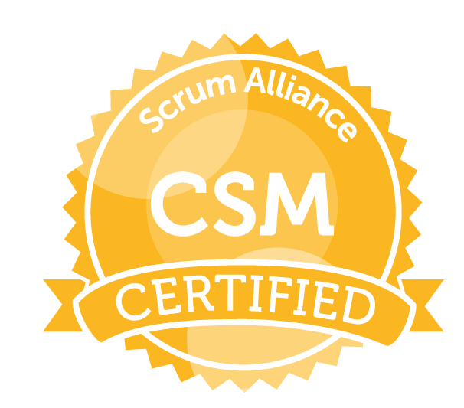

Career Objective

To emerge as a key player in a corporate environment where I can quench my thirst for knowledge in the domain of IT and perform a prominent role in attaining the goals of the organization.

Professional Summary

- I have 11.8 years of experience in complete software development life cycle
- Expertise in C#, JavaScript, API GATEWAY, Python, SQL, NoSQL, Lambda, Athena, Microservices, Agile Methodology, Docker, K8s, AWS DevOps tools
- Certified Scrum Master, SAFe for Teams, AZURE Developing Solutions, AWS Developer & Solutions Architect Associate.
- 3 years on-site (Malaysia) client exposure
- Domain Expertise in Manufacturing/Engineering, Healthcare, CRM, Finance
- Overall responsibility for the day-to-day operations of the project, reporting periodically to all the stakeholders, Project Planning and Tracking and Team building and on-site deployment

Work Experience/Projects

Currently Working as Enterprise Architect-Cloud in Boeing India Pvt Ltd from Oct 2021 to Present.

Worked as Software Engineer -AVP in Wells Fargo India Pvt Ltd from Dec 2020 to Oct 2021.

Worked as Sr. Application Developer in Boeing India from Jan 2018 to Nov 2020

Worked as System Analyst in UST GLOBAL, Malaysia from Aug 2015 to Jan 2018.

Worked as Associate Technology in NAGARRO Soft. PVT LTD, Gurgaon from APR 2014 to Aug 2015.

Worked as Software Engineer in OKS SPAN TECH PVT LTD, New Delhi from 9 Jan 2012 to 20 Jan 2014.

Worked as a Software Developer in knowledge IT Limited, New Delhi from 21 June 2010 to 31 Dec 2011
Project Summary:
- Title: Merchant Onboarding Digit Platform (MDOP)
Client: Wells Fargo USA
Environment: Microservices, C#, Asp.net core (3.1), Html 5, Angular10, Kendo UI, Responsive Design, GitHub, Splunk, Lambada, SQS, SNS, IAM, S3, API Gateway, EKS, Kubernetes, Docker, Container
Database: DynamoDB
Cloud: AWS
Role: Team Lead
Responsibility: Coding, Design, Unit Testing, Requirement Analysis & Team Handling

- Title: EHAD (Enterprise Hand-Carry Authorization)
Client: Boeing
Environment: Python, JavaScript, Cloud formation, Step functions, Athena, S3, Lambda, Microservices, API Gateway, EKS, Kuberenetes, Docker, container, K8s Administrator
Database: DynamoDB
Cloud: AWS
Role: Team Lead
Responsibility: Coding, Design, Unit Testing, Requirement Analysis & Team Handling

- Title: New Sponsorship (IP Application)
Client: Boeing
Environment: C#, Asp.Net Core, Web API Core, Bootstrap, Microservices, Html 5, Angular7, Responsive Design, Git, VS 2017
Database: SQL Server 2016
Cloud: PCF
Role: Team Lead
Responsibility: Coding, Design, Unit Testing, Requirement Analysis & Team Handling

- Title: Patient Companion Application
Client: Quintiles
Environment: C#, .Net, Web API, Bootstrap 3.0, Html 5, Angular 1/2, Responsive Design,
GIT, VS 2015,
Database: SQL Server 2012
Role: Team Lead
Responsibility: Coding, Design, Unit Testing, Requirement Analysis & Team Handling
- Title: Issue/Ticket Tracker Portal (Intel Malaysia)
Client: Intel
Environment: C#, MVC4, .Net, Web API, Entity Framework, Bootstrap 3.0, Html 5, Angular js, Responsive Design, Active Directory
Database: SQL Server 2012
Role: System Analysts
Responsibility: Coding, Design, Unit Testing and Requirement Analysis

- Title: Manager’s Dashboard Portal (Intel Malaysia)
Client: Intel
Environment: C#, .Net, Web API, Bootstrap 3.0, Html 5, Angular js, Responsive Design, Active Directory
Database: SQL Server 2012
Role: System Analysts
Responsibility: Coding, Design, Unit Testing and Requirement Analysis

- Title: Share Learning Speed (Intel Malaysia)
Client: Intel
Environment: C#, .Net, Web API, Angular js, Microsoft Enterprise Library, Active Directory (VS 13)
Database: SQL Server 2012
Role: System Analysts
Responsibility: Coding, Design, Unit Testing (Automated) and Requirement Analysis
- Title: UAL (United Aluminum Ltd)
Client: UAL
Module: Shipping
Environment: C#, Asp.net, JQuery, MVC4.0, Microsoft Enterprise Library (Visual Studio 2012)
Database: SQL Server 2008 R2
Role: Sr. Software Developer (Module Lead)
Responsibility: Coding, Design, Unit Testing and Requirement Analysis

- Title: BBIS (BLACKBAUD INFORMATION SYSTEM)
Client: BLACKBAUD (US)
Environment: Asp.Net, Vb.Net, JQuery, Active Directory (Visual Studio 2010)
Database: SQL Server 2008 R2.
Role: Software Developer
Responsibility: Coding, Design, Unit Testing

- Title: D & B Financial System
Client: D&B Australia
Environment: C#, Asp.Net, Entity Framework, Jquery (Visual Studio 2010)
Database: SQL Server 2008.
Role: Software Developer
Responsibility: Coding, Design
Reports: Excel

- Title: Corporate Governance Management (CGM-ERP)
Client: Nippon Steel Solutions Corporation
Environment: C#, Asp.Net, Java Scripts, Web services (Visual Studio 2008)
Database: SQL Server 2005.
Role: Software Developer
- Title: Hospital Management System
Environment: Vb.Net (Visual Studio 2008)
Database: SQL Server 2005.
Role: Software Developer
Responsibility: Coding, Design, Unit Testing
Reports: Crystal Report

Academia

- B. Tech (Computer Science & Engg.) From Aligarh College of Engg & Technology, Aligarh affiliated to UPTU with 68% of marks in 2010.

- 12th (Science) from UP Board with 71% of marks in 2006.

- 10th (Science) from UP Board with 62% of marks in 2004.

Software Skills

- Language: C#
- Cloud: PCF, AZURE, AWS
- DevOps: Docker Basic, Kubernetes, AZURE DevOps
- Web Technologies: HTML5, Asp.Net/Core, Ajax, JavaScript, LINQ, Entity framework, MVC,
- Data Bases: SQL Server 2005/8/12/16, MS-Access, NoSQL (Cosmos DB)
- Version Control: TFS, GIT
- Reports: Crystal Report, Excel, SSIS, SSRS
- Methodologies: OOAD, 3 Tier Arch, SOA
- Tools: Visual Studio 2005/8/10/12/13/15, JIRA, SQL SERVER 2005/8/14,

Extramural Activities

- Winner of Quiz –Contest at college Level in 2008
- Captain of Cricket-Team at School Level
- Client Appreciation Award in UST Global for 2016-17

Strength

- Extremely energetic, Self-motivated, Committed to excellence, Good communication & Interpersonal skill, Quick Learner.

Personal Dossier

Father’s Name : Mr.R.R. Upadhyay
Mother’s Name : Mrs.Shakuntala Upadhyay
Date of Birth : 14 February 1991
Sex : Male
Passport No. : L7507886
Permanent Address : H.No.321 Gopalapur-namajgadh, kadipur-sultanpur, Uttar Pradesh (228145) India Linguistic Abilities : English & Hindi

Hobby : Playing Cricket, Chess, Listening Music

Declaration

I hereby declare that the above furnished information is correct to the best of my knowledge & belief.

Place:Bangalore,India Hariom Upadhyay

