NATARAJAN PALANIAPPAN

**+91 7598162027**

Email:**natarajannatt31@gmail.com ·** LinkedIn Profile: **https://www.linkedin.com/in/natarajan-palaniappan-471740154/**

**Profile**

I am a hardworking individual who strives to achieve perfection in everything I do. 5+ years of experience as a Salesforce Lead Business Analyst. Worked closely with business leadership, key stakeholders, developers, and clients to identify, implement, and distribute Salesforce processes & system solutions to increase efficiency and reduce operational costs in a global Salesforce environment.

**Technical Skills**

* Salesforce Sales Cloud
* Salesforce Experience Cloud
* Salesforce Service Cloud
* Third party integration
* CRM Automations
* Data Migration
* Salesforce Lightning
* Linkedin
* Pardot
* Docusign
* Mailchimp
* Salesloft
* MS Office tools
* Admin Integrations

**Education**

August 2015-April 2019 **Sri Muthu Kumaran Institute of Technology, Chennai, Tamil Nadu, India**

B.E – Computer Science | First class Honours (73%)

**Work Experience**

05.2019 - Present **CUBE84 , Chennai, INDIA**

**Position:** Salesforce Lead Business Analyst 

01.2018 –04.2019 **CUBE84 , Chennai, INDIA**

**Position:** Intern Salesforce Business Analyst

Gathered and documented requirements for projects.

Experience in Designing, Implementing, Configuring, Customizing, Deploying and Administrating Salesforce.com CRM.

Handling Reports, Custom Report Type, Dashboards, and other analytics requests.

Manage daily administration tasks of user reported issues, new functionality, record types, page layouts,and other customizations as needed.

Hands on Experience in Creating Custom Objects, Custom fields, Page layouts, Custom Tabs, and various other components as per the client and application requirements.

Developing and managing Process flow (Lightning Process Builder), Validation Rules, Approval Process and Email Templates for Business to automate procedure.

Creating and maintaining Workflow Rules, Approval process, Escalation Rules and Lead/Case Assignment rules.

Hands on in Sales Cloud and Service Cloud.

**Certificates & Salesforce Super badges**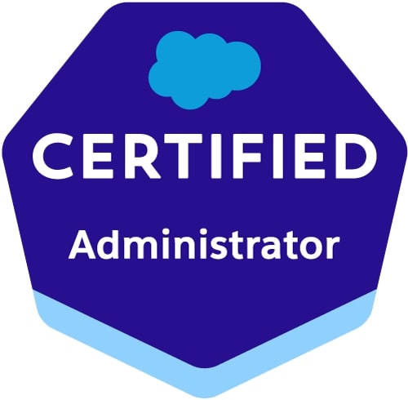

**Salesforce Certifications**

* Salesforce Certified System Admin (SCA)
* Business Analysis Foundation
* Managing Project Stakeholders

**LinkedIn Certification**

* Business Analysis Foundations
* Critical Thinking
* Business Analyst & Project Manager Collaboration
* Project Management Foundations – Requirement
* Project Management Foundations – Quality

**Salesforce Super badges**

* Business Administration Specialist
* Lightning Experience Reports & Dashboards Specialist
* Security Specialist

**Completed Projects & Project Role**

* **Moda Health Cloud -** Salesforce Experience cloud and Omnistudio Consultant
* **Class –** Salesforce Experience Cloud Project Manager / Solution Architect
* **Sonnet Technologies –** Zap Integration Consultant
* **Moodle (Sales Cloud, Community Cloud, Pardot, Service Cloud)** – Salesforce BA
* **Hawaiian Airlines (Experience Cloud and Service Cloud) -** Salesforce Consultant / Salesforce BA
* **Voot -** Salesforce BA / Pre Sales Consultant
* **Moda Health Cloud -** Salesforce Omnistudio Consultant / Admin
* **Keystone Partners (Community Cloud)** – Salesforce BA
* **Belay ( Community Cloud, Sales Cloud, Pardot, Mobile Publisher App)** – Salesforce BA
* **Freewill** **( Sales Cloud, Linkedin Navigator)** – Salesforce BA
* **Modzy (Sales Cloud, Experience Cloud,Service Cloud and Pardot) -** Salesforce BA
* **Olam (Pardot) -** Pardot Consultant
* **Northpoint Recovery** **(Health Cloud)** – Salesforce BA
* **SEBA (Community Cloud, Sales Cloud)** – Salesforce BA
* **Disney Music** **( Sales Cloud)** – Salesforce Admin / Salesforce BA
* **SUN Management (Sales Cloud)** – Salesforce Admin / Salesforce BA
* **Beacon Street Services (Experience Cloud) -** Experienced Cloud Consultant
* **Olli (Sales Cloud)** – Salesforce Admin / Salesforce BA
* **Meridian Institute (Sales Cloud)** - Salesforce Admin / Salesforce BA
* **AEA** - Mailchimp Admin / BA

**Achievements**

Account Growth Champion for growing the existing business and account

Star Performer of the Month in Project juggling and project Managing

Won “Best Contributor” award for my contribution in projects

Secured 2nd Rank in CSE department in Anna University Examination

Awarded 2nd Prize in Intermural football tournament

2022

2020

2019

**Languages**

English: Fluent (written and spoken)

Tamil (Indian): Fluent (spoken)

Hindi: Basic knowledge

Kannada: Fluent (spoken)

**Interests**

* Watching documentaries
* Playing games
* Watching Movies
* Travelling
* Learning New things