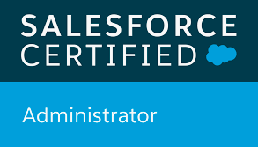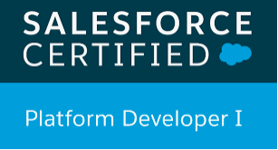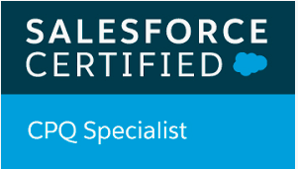

**SHALINI SONI**

Contact:91-7619390702 Email:sonishalini51@gmail.com

--------------------------------------------------------------------------------------------------------------------------------------------------**PROFESSIONAL SUMMARY**

A Salesforce CPQ Developer with 3.8 years of experience in developing solutions/applications both from a development and administration perspective.

**Primary Skills:**

* Salesforce CPQ
* Salesforce Administration
* Salesforce Customization using (VisualForce, Triggers, Apex Class)
* Process automation using Workflows, Process builders, Flows
* Lightning Aura Components
* SOQL and SOSL
* Apttus CPQ

**Other Skills:** Oops Concepts, Core Java, SQL, Basic Javascript

**Certifications:**

* Salesforce CPQ Specialist
* Salesforce Administrator
* Platform developer 1

**Experience 1:**

|  |  |
| --- | --- |
| Employer | Tata Consultancy Services |
| Project Name | APTTUS NXT GEN CPQ PROJECT |
| Technology | Salesforce Administration, Apex, Visualforce, Apttus CPQ Configurations, SOQL & SOSL |
| Role & Responsibility | 1. Customization of Sales Force application as per the needs of global Salesforce application users 2. Development and implementation using Triggers, Visual force pages, Workflows, Approvals, Objects and APEX classes. 3. Bug fixing and production support. |
| Project Description | Apttus NXT Gen CPQ application is a cloud application for sales representatives in GE Healthcare which allow sales representatives to quickly configure products, determine accurate pricing and generate quotes. This is also use to manage Accounts, Opportunities, Leads, Contacts, Users and their profiles. Apttus NXT GEN CPQ application is implemented to consolidate sales management for all regions( ex  USA , CANADA, CHINA, JAPAN, APAC ) |

**Experience 2:**

|  |  |
| --- | --- |
| Current Employer | Cognizant Technology Solutions |
| Project Name | Teneo Salesforce CPQ Project |
| Technology | Salesforce CPQ, Price Rules Product Rules, Product Creation, Guided Selling, Salesforce Customization and Administration |
| Role & Responsibility | 1. Customization of Sales Force application as per the needs of global Salesforce CPQ application users 2. Product creation and Migration 3. Price rules and Product rules 4. Bug fixing and production support. |
| Project Description | Salesforce Cpq Application is a simplest cloud application for Sales reps to deal with various business/users from different locales. It provides extensive methods of pricing and discounting various type of products. It gives flexibility to contract and renew a deal. |

**Education:**

* B.E. in IT (RGPV bhopal) in 2016 with 79%
* 10th Shree Ram Krishna Ashram Higher Secondary School Jabalpur in 2010 with 85%
* 12th Shree Ram Krishna Ashram Higher Secondary School Jabalpur in 2012 with 87.5%

**Personal Details:**

Date of Birth :06/09/1994

Father’s Name :Mr. Rajesh Kumar Soni

Language Known :Hindi, English

Address :401, Shree Karni kunj Apartments, Spice garden layout, Bangalore.

Passport Number :N8578650