**NIKU SINGH**

Email: [nikusingh79@gmail.com | Phone](mailto:nikusingh79@gmail.com%20|%20Phone): 9663931355

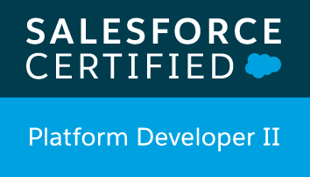 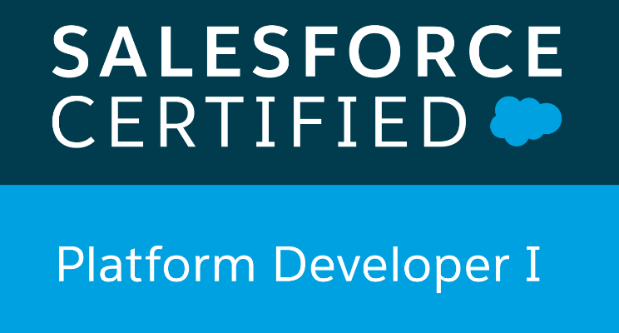 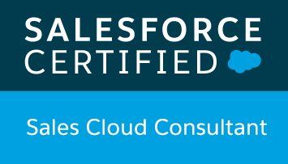 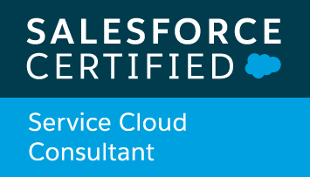 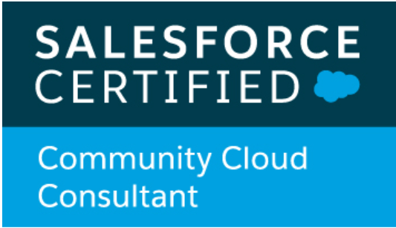 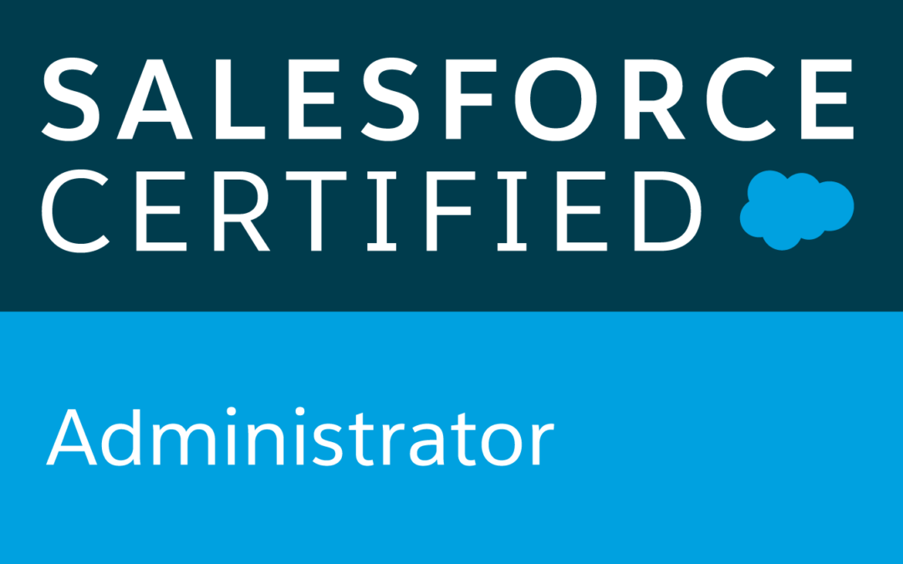

**Profile**

Certified Salesforce Developer with 5+ years of Salesforce expertise. Currently seeking opportunities to build a sustainable career in a growth-oriented and professional environment. A keen willingness to learn and a strong focus to deliver on my commitments with excellent quality.

**Certifications**

* Salesforce Platform Developer 2 (PD2)
* Salesforce Platform Developer 1 (PD1)
* Sales Cloud Consultant
* Service Cloud Consultant
* Community Cloud Consultant
* Salesforce Administrator (ADM 201)

**Professional Experience**

***Module Lead*,** Mindtree Limited | **Catalina** (Jan 2020 - Present)

* With a client facing role, worked towards look and feel of Catalina consumer site using VisualForce page from where guest users raise incidents.
* Proactively learnt and worked on Dell Boomi which is a new tool for me, but major deliverable for the project.
* With strong resolution skills, I improved the code for users from different locales\time zone, who were not able to send contract to CDT.
* Researched on the impacts and suggested ideas and workarounds regarding the modified accessibility of guest user licenses as part of new Salesforce release.
* Programmed complex logics with Apex Classes, Apex Triggers, Standard Controllers, Custom Controllers, Controller Extensions and Test Classes.
* Created Workflow Rules, Tasks, Email Alerts, and Components to suit to the needs of the application.
* To improve product visibility and market performance, configured reports and dashboards.
* Developed Process Builders and workflows according to business requirements.
* Created users, roles, public groups and implemented role hierarchies, sharing rules and record level permissions to provide shared access among different users.
* Carried out deployments through change sets and gear sets.
* Other than implementing the tasks provided, I also analyse the requirement as the end user, and suggest amendments/ideas which would be user friendly.
* Trained the new resources and made sure the quality deliverables are on time through agile methodology.

***Senior Software Engineer****,* Mindtree Limited | **Lincoln Financial Group** (Dec 2015-Jan 2020)

* Played a key role in the Salesforce.com System Integration with external applications and systems using Apex Web services and Apex Callouts with both REST API and SOAP API.
* As the implementation of the Shield Encryption in instances of  LFD, CM, AR, RPS instances was successfully done, the team got the opportunity to work on GP instance as well, which was led by me.
* Updated Batch jobs to prevent high number of Participant records being downloaded from RPS to ETL.
* Analysed the requirements, designed and developed the modules in Salesforce.com. Created and deployed several Reports using salesforce.com platform.
* Worked on CRM Groups and Queues orientation and uploading in Production.
* I proactively worked on Lightning readiness and IVR analysis which were major deliverables for the project.
* Customized different page layouts and assigned them for different profile users.
* Responsible for designing various Pages in Visualforce for functional needs and developing custom applications and solutions leveraging the SFDC Force.com Platform of Apex and Visualforce.
* Involved in unit testing and Test Coverage for Triggers.
* Developed the Batch processes using Apex classes to automate the process.
* Excellent and effective inter –personal and communication skills and the ability to interact professionally with a diverse group of client and staff.
* Lead the team for configuring Shield Platform Encryption in the Salesforce Instance.
* Configured integration to third party systems using connected apps to send record data through SSO.

***Software Engineer*,** Mindtree Limited | **AIG Phoenix (CCUW)** (Feb 2015 – Dec 2015)

* Responsible for analysis of the various Implementation specs provided for configuration.
* Debugging of java codes for PTM (Product Test Manager) test cases.
* Configured the rules in Product Authority. Manual configuration of the components and Content Show/Hide, Validation and Calculation rules.
* Played a major role in coordination with the team for competition of deliverables and resolution of issues encountered during configuration activities.

***Software Developer,*** Discoverture Solutions | ***MSIG*** (Dec 2014 – Feb 2015)

* Configured the IFBC (Inforce Business Configurator), rules and customized the screens in FS PRO for creating insurance applications.
* Analyzed the various Implementation specs provided for configuration and implemented rules and forms.

**Skills**

* **Salesforce** : CRM functionality, SFDC Customization, CPQ, Workflows, Triggers, Scheduled Apex, Batch Apex, Custom labels and settings, Test classes, Data migration, Security Access, SOQL,SOSL, Aura Components,LWC
* **Programming Languages**: Apex, Visualforce Java, HTML,CSS, Javascript.
* **Operating Systems**: Windows XP/ Windows 7, Linux.
* **Tools**: Dell Boomi, Gearset, Eclipse Force.com IDE, Apex Data Loader, Visual Studio Code, SAP Camillion, FS PRO, FS QUO, Camilion Debug Console, Xpath tester
* **Methodologies**: Scrum and Agile.
* Others: Performance Management, Defect Analysis.

**Awards**

* **Winner** – Salesforce Hackathon 2020.
* Salesforce Rockstar Award 2018-2019
* Mindtree Outstanding Performance award FY17.
* Mindtree Pillar Award.
* Mindtree ‘A team’ award FY17.
* Mindtree Accountable award FY15.

**Education**

Gandhi Institute of Engineering and Technology, Gunupur, India (2010-2014)

Bachelor of Technology in Computer Science, CGPA – 7.5/10