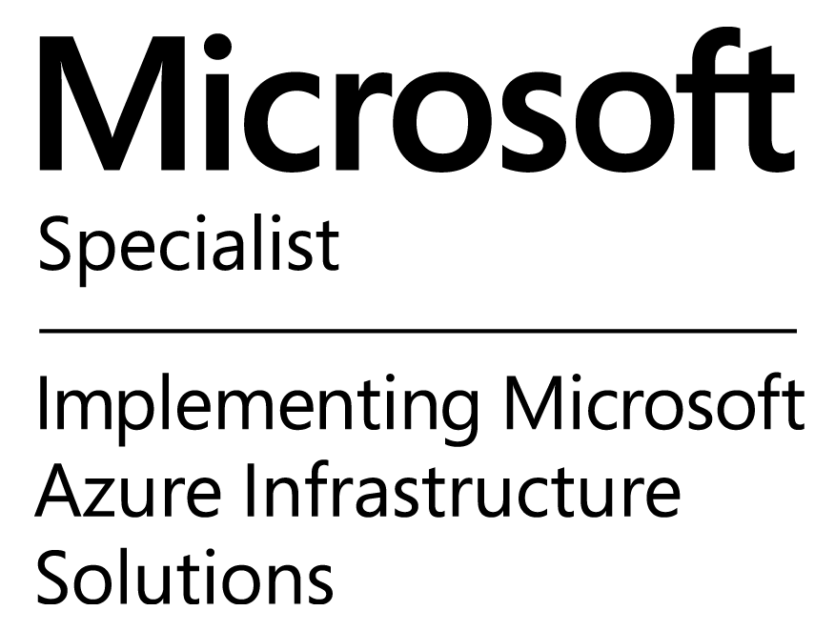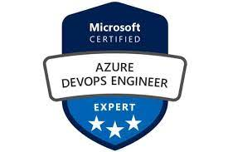
Phone: +91 7981206632 Deepthi Kolli
Email : kollideepthi17@outlook.com
___________________________________________________________________________________

Career Summary

- Total 11 + years of experience in Microsoft Azure along with Azure Devops, AKS, SQL Server & Power BI.
- 5+ years in depth experience in MS SQL Server 2012/2008 R2/2005/2000 Versions, Administration in enterprise production environment including server installation, configuration, upgrade, maintenance, performance tuning, optimization, backup/restore, recovery, migration, monitoring and troubleshooting.
- Deploy and configure web apps and mobile apps in Azure
- As per the requirement, worked on creation of Various Dashboards, Reports, using Datasets in PowerBI.
- Published the PowerBI Dashboards in SharePoint pages and shared to the end users.
- Configuring Cloud VM, Provisioning Storage, establishing Point to Site Connectivity, Traffic Manager, Load balancer, SQL Azure, Backup & Disaster Recovery Services.
- Provide software build support & ongoing assistance with build activities to ensure timely delivery of testing, production software builds.
- Implement and manage virtual networking within Azure and connect to on-premises environments, configure Express Route, Virtual Network, VPN Gateways, DNS and Load Balancers
- Troubleshooting and resolving complex technical issues including performance tuning stored
- Define securing, monitoring, auditing, high availability, and disaster recovery strategy for Azure resource management
- Plan, create, configure, manage, and monitor Azure virtual machines to optimize availability and reliability
- Implemented web App, Azure health bot , SQL Database , ADF, Email template, Power bi , Logic APP , deployments through Azure Devops .
- Creation of the CI CD pipelines by using Azure DevOps and deploying into Azure Web Apps
- Creating Build definition by using MS Build for automated process.
- Co-ordinate with the development team in case of build failures.
- Deployment of enterprise-scale Azure solutions using Azure Container
- To achieve Continuous Delivery goal on high scalable environment, used Docker coupled with load-balancing tool Nginx
- Virtualized the servers using Docker for the test environments and dev-environments needs, also configuration automation using Docker containers
- Building/Maintaining Docker container clusters managed by Kubernetes, Linux, Bash, GIT, Docker on Azure
- Plan, manage, backup, and monitor Azure storage solutions
- Create, edit, and delete data factories and child resources including datasets, linked services, pipelines, triggers, and integration runtimes.
- Deploy Resource Manager templates
- Manage App Insights alerts for a data factory.

.

Technical skills
- Databases : MS SQL Server 2005/2008/2012
- Primary Skills: : Microsoft Azure (Cloud), Azure Devops
- Secondary Skills : Knowledge on GCP, Docker, AKS, Share Point Online, O365,Power Bi

Academics

- M.Tech in Information Technology, Chennai
- B. Tech in Computer Science and Engineering, Vijayawada
- 10+2 from Board of Intermediate, Vijayawada.
- S.S.C from State Board, Guntur.

Professional Experience

Winwire Technologies● Technical Lead● September 2019 -till date

Project Name: Viewpoint Migration ~ Duration: September 2019-October 2020

Project Name : Viewpoint, USA
Client : Viewpoint
Duration : September 2019 to October 2020
Environment : AZURE IAAS, PAAS

As Part of Global operations team, we are responsible to migrate the on-premises VMware infrastructure to Azure cloud and provide operations support.

Responsibilities:
- Migrated 2300 servers from on premises to Azure Cloud including GCP servers
- Understand security best practices, policies, and standards to design highly secure cloud architectures for internal and external cloud solutions.
- Administration, Configuration, support, Design for Microsoft Azure.
- Migrated the servers from on-premises and Google cloud to Azure.
- Administration, Configuration, support, Design for Microsoft Azure.
- Migrated the servers from on-premises and Google cloud to Azure.
- Preparing Google cloud environment for migration.
- Strong experience in implementing, monitoring, and maintaining Microsoft Azure solutions, including major services related to Compute, Storage, Network, and Security.
- Assist with upgrading, installing, configuring, and monitoring solutions in Azure for Windows and Linux servers.
- Syncing of Windows AD objects to Azure AD through Azure AD Connect.
- Managing and implementing Role-based access control (RBAC) and Policies.
- Configuring Azure VNet, NSG, Load balancer, FrontDoor, etc
- Created the Network Security Groups (NSGs) to allow the ports.
- Configure Azure Virtual Machines for High Availability Solutions

Project Name: Gilead RSVP ~ Duration : October 2020-till date

Project Name : Gilead RSVP Screening
Client : Gilead Science
Duration : October 2020 to till date
Environment : AZURE Devops, Azure IAAS, PAAS, ADF, Power Bi Reports

Gilead Sciences, Inc. is a biopharmaceutical company, which engages in the research, development, and commercialization of medicines in areas of unmet medical need. Developed chatbot for company employees for self-screening in current covid situation which directs employee whether to attend office or not. Also captures vaccine cards of employees along with vaccine management admin page. Supports web and Teams channel.

Responsibilities:
- Deploying Applications and Virtual Machines through Azure DevOps and creating CI/CD pipeline for the same
- Responsible for Servers Health Checks and performance monitoring.
- Performing assessment and estimating cost analysis.
- Creating, Publishing and Assigning Azure Blueprints
- Implemented web App, Azure health bot , SQL Database , ADF, Email template, Power bi , Logic APP , deployments through Azure Devops .
- Integrating ADF with Data store service like Azur SQL Database and Azure SQL Data warehouse
- Deployment of Kubernetes cluster and Implementing Identity and Access management for container cluster
- Experience in deploying scenarios, Custom Strings in Azure Health Bot
- Experience in Microsoft Azure Storage Explorer .
- Deploying Azure Functions and secure configuration with Azure key Vault
- Publishing dataset and reports to power bi workspaces as per the business requirements
- Working experience in creating and monitoring Azure based infrastructure applications
- Created storage accounts and sharing SAS Encryption key to Client

Suneratech ● Associate Lead ● September 2018 – September 2019

Project Name: DAI ~ Duration: September 2018 -September 2019

Project Name : Development Alternative Incorporation DAI, Washington, USA
Client : DAI
Duration : September 2018 till date
Environment : AZURE IAAS, PAAS

DAI is a company from USA Who does social project works across different continents in challenging environments racked by political and military conflict with the help of USAID.
DAI maintains progress of their work by setting up servers which are at different geographical locations for the project needs. As of today, DAI has 100+ production servers situated across different countries and they are using Dynacom a reporting tool on top of Azure Server for FAS activities.

Responsibilities:
- Lead implementation of Office 365 and Azure Active Directory for single sign on, authentication, authorization and Azure Role-based Access Control (RBAC).
- Installed, configured, administered, monitored Azure, IAAS and PAAS, Azure AD.
- Used Windows Azure portal to manage Virtual Network and Traffic Manager
- Created, managed, monitored VM using Windows Azure portal admin
- Created, managed, monitored Web site using Windows Azure portal admin
- Used Azure BLOB to access required files and Azure Storage Queues to communicate between related processes.
- Designed and developed standalone data migration applications to retrieve and populate data from Azure Table / BLOB storage to on premise SQL Server instances.
- Smoothly created pre-production environments and manage the portion of traffic going to them. Debug in the cloud when needed and roll back if issues are found.
- Azure Network Configuration - Created resource groups using resource manager which allow to see cost/billing and monitoring information for resources within a resource group and manage access to those resources as a set for individual customer.
- Attend ongoing client meetings to introduce and answer Azure PAAS and IAAS questions as they arise, covering important application migration considerations and options.
- Associated routes with VNets via the route table per relationship constraints.
- Managed IP Forwarding for VMs and role instances acting as virtual appliances.

LNT TECHNOLOGY SERVICES ● Cloud Engineer ● March 2018 -September 2018
Project Name: Exxon Mobile ~ Duration: March 2018 -September 2018

ExxonMobil is the world’s largest publicly traded international oil and gas company. We hold an industry-leading inventory of global oil and gas resources. ExxonMobil is one of the world’s largest integrated refiners, marketers of petroleum products and chemical manufacturers.

Project Name : Development Alternative Incorporation DAI, Washington, USA
Client : DAI
Duration : September 2018 till date
Environment : AZURE IAAS,

- Supporting technical and infrastructure-related activities
- Facilitating proactive measures to ensure systems availability
- Maintenance of all production, DR, and UAT instances
- Monitoring of production systems from availability/performance/stability point of view
- Participate in incident management remediation and work to resolve ongoing related issues/crisis
- Contribute to and maintain systems standards as they relate to configuration management, hardening, and security
- Maintains data environment and monitors systems to ensure data integrity & availability
- Handle and maintain the confidentiality, integrity, and availability of sensitive information
- Maintain a clean, automated, up-to-date systems inventory
- Develop concise, detailed documentation for new and existing environments
- Leveraging key technical resources to architect scalable solutions, using industry best practice
- Maintain SSL certificate renewals

Ameri100(formerly Bell soft India) ● Consultant - DBA ● September 2016 -May 2017

Project Name: Newell Rubbermaid Support project~ Duration: September 2016 -May 2017

Project Name : Newell Rubbermaid Support
Client : Newell Rubbermaid
Duration : September 2016 till date
Environment : Sql Server 2008 / R2 / 2012, 2016, SQL AZURE, Power BI, SharePoint Online, O365

Newell Rubbermaid is a leading global consumer goods company with a strong portfolio of well-known brands. This has grown over the decades, often by acquiring brands built by entrepreneurs like Edgar Newell that we are now privileged to offer to consumers around the world. I am responsible for interacting with various customers and analyzing their SQL server environments and making suggestions, Supporting and implementing the same for better performance. The project also involved setting up new SQL environments resolving SQL issues for various customers.

Responsibilities:
- Provide 24/7 production support as well on call support for SQL Server Databases.
- Installing and Configuring TSM SQL Backups
- Creating Network security groups (NSG) to control inbound and outbound traffic.
- Administration and Implementation of Azure Backup Vault for VM Level Backups and File and Folder Backups.
- Provided high availability for IaaS VMs and PaaS role instances for access from other services in the VNet with Azure Internal Load Balancer.
- Implementation and Migration on Premise Virtual Machines using Azure Site Recovery and Double Take Move.
- Provide resolution to assigned tickets as per the defined priority, to maintain the SLA.
- Using TSM Data protection for Scheduling Backups
- Implementation of SQL Logins, Roles and Authentication Modes as a part of Security Policies for various categories of users.
- Upgraded/Migrated SQL Server 2005/2008 databases to SQL Server 2012/2014 databases
- Working experience on ARM templates, Powershell scripting.
- Working experience on Azure Environment including provisioning and architecting workloads
- Delivering transformed data from Cloud to On-Premises
- Regularly monitor and identify blocking issues.
- Worked on User Management in Office 365.
- Played Password administrator role in Office 365.
- Monitored the Service health of O365.
- Developed reports/dashboards using Power Bi with Multiple Visualizations
- Worked on Gateway issues in Power Bi Service
- Manage the User Signup and maintain the quality of Power Bi service
- Worked on Dataset refresh issues
- Worked on various SharePoint Out of the box features Like lists, libraries, permissions, calendar, tasks, workflows.

Veda HR Consultancy ● Consultant - DBA ● October 2014 till date

Project Name: Win2K3 EOS project ~ Duration: October 2014 till sep 2016

Project Name : Win2K3 EOS
Client : Microsoft
Duration : October 2014 till date
Environment : Sql Server 2008 / R2 / 2012, Microsoft Azure, SQL Azure

Working as a Consultant – DBA in Veda HR Consultancy being an integral part of the Customer services and solution practice, I am responsible for managing sql server environment for global customer, managing and supporting SQL databases and applications. Performing assessment of the legacy SQL server to migrate it to latest version. Also, migrating all pre-prod environment to Cloud.

Responsibilities:
- Assessment of legacy system
- Preparation of an assessment report
- Provide solution for assessment
- Worked closely with application team and other stake holder before moving application to cloud.
- Deployment on Azure
- Planning on how to move application to cloud
- Implementation of SQL server 2012\2014 migration and upgrades.
- Implementation of SQL server Always on High Availability.
- Different versions of SQL Server installation
- Creating databases and managing databases
- Migration from on premise to cloud
- Establishing point to site connectivity
- Provisioning Virtual Machines and storage accounts
- Usage of various data services like Azure HDFS, Azure SQL, Backup,
- Security management
- Assigning roles and permissions
- Configuring high availability solutions like Log shipping and Database Mirroring
- Rebuilding the indexes at regular intervals for better performance
- Monitor SQL Server services status, Jobs, SQL Server Logs, Dead locks/Blocking.

OSI Consulting ● SQL DBA ● Jan-2012 till Sep-2014

Project Name: Cardinal Health ~ Duration: Jan-2012 till Sep-2014

Project

Project Name : Cardinal Health
Client : Cardinal Health
Duration : Jan’ 12 to Sep 2014
Environment : SSIS,SSRS Sql Server 2008

Description:

Cardinal Health is a $9 billion global manufacturer and distributor of medical and surgical supplies and technologies dedicated to making healthcare safer and more productive. Its customers are located on five continents and include hospitals, medical centers, retail and mail-order pharmacies, clinics, physicians, pharmacists and other healthcare providers. It has multiple operational systems where transactions are created and managed currently. MBT program scope is to minimize the number of systems in the landscape and move all the operations to SAP ECC platform. To support business requirements, transactional data from current operational system in part/full needs to be migrated to the new platform.

Roles &Responsibilities:

- Design and Implemented SSIS jobs to transfer the data from source to staging area adding the technical fields and finally loading the data into Target Systems.
- Deploying, Scheduling and Monitoring SSIS Packages.
- Making a job scheduling and database maintenance plan for database backup daily and weekly with SQL-Server 2008.
- Migrating databases from one server to another server and fixing the orphaned users
- Rebuilding the indexes at regular intervals for better performance
- Monitor SQL Server services status, Jobs, SQL Server Logs, Dead locks/Blocking.
- Monitoring of Disk space where physical databases are stored.
- Detach and Attach Databases.
- Database Backup Verification (Daily/Weekly/Monthly).
- Creating and Monitoring SQL Server agent jobs and troubleshooting as required.
- Monitoring, Troubleshooting and Administering Log shipping.
- Building disaster recovery systems by mirroring.
- Monitoring SQL Server Performance using profiler to find performance and locks and blockings.

Infosys Technologies ● SQL Data Admin ● Oct-2010 till Dec-2011

Project Name: Siebel Ecosystems ~ Duration: Oct-2010 till Dec-2011

Project

Project Name : Siebel Ecosystems
Client : Microsoft IT India, Hyderabad
Duration : Oct’ 10 to Dec’ 11
Platform : Windows 2003 Server R3
Environment : MSSQL Server 2005/2008, Microsoft CRM, MSE & ITSM (Ticketing tool)
Applications : GSX 5.3, GSXO, PSX 2.0, CRMAdhoc, CRMPublish, DET, DMT.

Description:

The Microsoft Global Sales Experience (GSX) is the new, role-based CRM solution designed by Microsoft for Microsoft sales people. GSX is integrated, simple and effective. With GSX the user can spend more time with customers (due to improved performance and simplified UI), work online and offline within Outlook, and showcase 100% Microsoft technologies.

Siebel Sales is CRM (Customer Relationship Management) tool that is the heart of the RxD Application Portfolio that acts as a central repository of all data related to the business. Partner Sales Experience (PSX) is a pipeline management tool for Partners to share opportunities with Microsoft. The goal of PSX is to simplify how Microsoft and Partners work together on opportunities. PSX delivers an innovative, agile Partner pipeline management experience, built entirely on Microsoft technologies and best practices and to replace existing PSM System

Roles & Responsibilities:
- Customizing and Implementing Microsoft CRM for various modules like sales, service and marketing.
- Installation, configuration and maintenance of MS SQL Server.
- Service packs and patch management.
- Checking the status of Backup troubleshooting the failed backups and Restoration of databases.
- Ensuring data consistency in the database through DBCC commands.
- Adding users in the database and granting permissions.
- Scheduling jobs in SQL Server.
- Recovery of the database during crash or data Loss.
- Daily Log checking for errors on Production Server.
- Monitoring MS SQL Server log shipping.
- Monitoring free space of database.
- Resolving issues of customer.
- Providing connectivity and troubleshooting of connectivity problems.

personal details

Father’s Name : Mr. NageshwararRao
Passport: Valid up to September 20, 2025

(Deepthi.Kolli)

