Mallemoggala Saikrishna



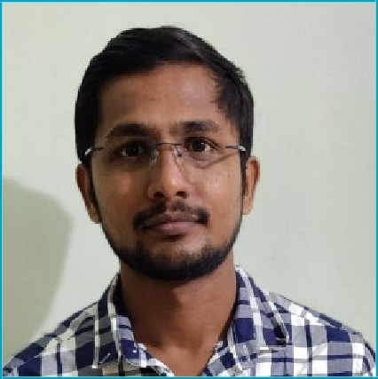

 Madhira,India,507203 +91-9866895155

 [msaikrishna196@gmail.com](mailto:msaikrishna196@gmail.com)

# PROFESSIONAL SUMMARY

Dedicated Network Engineer with 3 years of hands-on experience in implementation, configuration, troubleshooting, resolving hardware,Software and security related issues, reducing downtime, improving network speeds, and reducing costs.

# TOOLS

Ticketing tools : Hpsm , ITSM , Service NOW

Application Monitoring Tools: TeMIP , Solarwinds , NNM1&2 , Riverbed .

# ADDITIONAL INFORMATION

* Date of Birth : 30th April 1996 Father's name : Poorna Chandra Rao

Sex : Male

Marital Status : Single Address : #1-227/1 , Banjara Colony , Khammam ,

Madhira , Telangana - 507203.

# EXPERIENCE May 2023 –Till Date NOC L2 Milestone Technologies | Hyderabad , India >Hands on experience on Trouble shooting of PA SD-WAN PA3260 , 440 , PA 200 , Implementing the NAT/PAT Policies ,MPLS to DIA migration , SDWAN Migration , identifying the Threat Vulnerabilities through Change management > Worked on Cisco WLC , Cisco ISE ,AP Trouble shooting , Creating new SSID’s , Whitelisting the mac address , wifi slowness issue . > Worked on WAN link issues , latency , packet loss , Utilizations and coordinating with the ISP’s . >Managed the Incident management process to strengthened Project .

November 2022 - May 2023

**Network Engineer Quality Kiosk Technologies** | Hyderabad, India

* Performed monitoring, troubleshooting for excellent traffic filtering by using SolarWinds , Riverbed , Panaroma , Infoblox ,Smart Console .
* Managing / Monitoring Firewalls (Palo Alto , Fortinet , Azure etc..) network services .
* Performing activities related to standard Change management and preparing change process and procedures .
* Preparing the EOD & BOD reports to analyses the traffic to improve the network performance.

April 2021 - November 2022

**Managed service desk engineer NTT INDIA GDC PVT LTD** | Bengaluru, India

* Hands-on experience on Routers (2900,4300,1100) and Switches(3600,9300)& Cisco, Versa , Lavelle SD WAN devices.
* Perform Basic level Trouble shooting on Router , switch , Wireless Access points, RF guns
* Investigating the IP routing related issues on Datacenter , Logistics Resolving IP Phone (Cisco, Uniden) related problems, like LAN port related issues, MAC address mismatch, new IP phone configuration into the network

**Network Engineer Velocis Systems pvt ltd** | Hyderabad, India  
January 2021 – April 2021

* Worked on LAN / WAN related issues, Creating Vlans , Enabling the BPDU Guards on the switches , Checking the firewall related and server related issues (Zscaler, Citrix server, Windows server ) and assigning those issues to L2 and L3 level teams for investigating . Logging case with isp and Following up .

**L1/L2 Service desk Engineer Prompt Personnel** | Hyderabad, India

September 2019 - January 2021

* Worked on BGP related issues , Internet Tunnel down issues etc and logging the case with ISP like sify ,Tikona , Tcl ,Vodafone , Airtel , Telstra etc .
* Checking the latency, internet slow browsing, RSSI value for the enterprise network
* Worked on VPN , Printer Connectivity issues Diagnosis the issue and take necessary action assign the issue to Right assignment group Taking up initiatives and providing innovative ideas for the best quality.



# EDUCATION

2016

**Bachelor of Technology** | Electronics and Communication Engineering

Anurag Engineering College, Hyderabad, TG GPA: 70.65

2012

**Intermediate** | MPC

Sri Chaitanya Junior College, Vijayawada, AP GPA: 86.2

2010

**Secondary School Certificate** Triveni Talent School, Khammam, TG GPA : 86

# LANGUAGES

English, Telugu .

# CERTIFICATIONS

* + CISCO Certified CCNA 200-301