**Unnikrishnan. K** 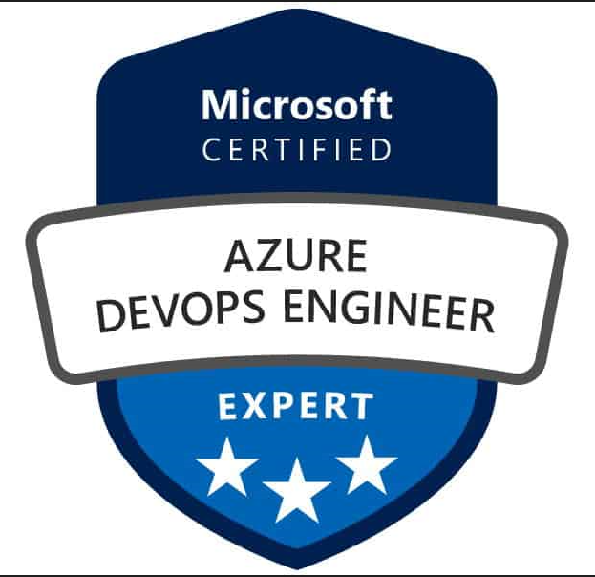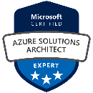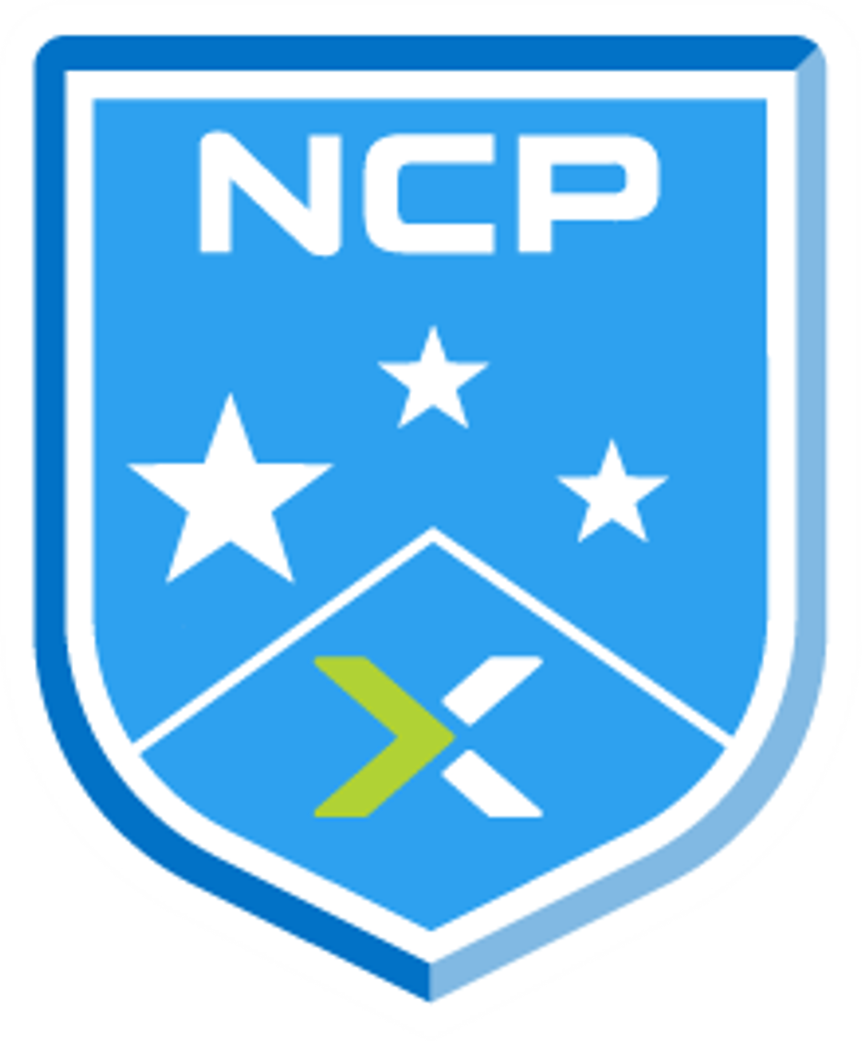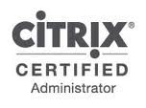  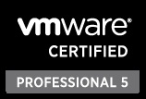

**Mobile: +91 9036747105 e-Mail:** [**unnikrishnank.in@gmail.com**](mailto:unnikrishnank.in@gmail.com)

**Profile Summary**

* 16+ years of experience in IT professional, Infrastructure & Cloud Architect, Ansible, Azure, DevOps & SRE Engineer.
* Develops and maintains strong working relationship with peers across the organization to create and market architectural products and service.
* Assist with development and implementation of DevOps SRE solutions for large scale distributed web applications across multiple tiers and data centers.
* Good exposure of Agile development methodology in designing and implementation of Continuous Integration and Delivery (CI/CD) methodology.
* Experience in Azure IaaS- Virtual Machines, VM Scale Sets, Load Balancer, Traffice Manager, Virtual Networks, SQL, Reource Groups and Cloud Services,
* Experience in Azure Platform Development, Deployment Concepts, hosted Cloud Services, platform services and close interface with Windows Azure Multi-factor Authentications.
* Hands on experience in writing Azure Resource Manager (ARM) to deploy, update and delete multiple resources in Azure and migrate the on-premises resources to Azure with Azure Site Recovery (ASR) and Azure Backups.
* Extensive involvement in Azure Backup, Azure Policies, Azure Key Vault, Azure Monitoring, Azure Sentinel, Salt Stack and Tagging.
* Extensive experience in migrating on-premises application to Azure and configured VNETs and Subnets as per the project requirement and performed PowerShell scripting & Pipelines to do patching, Imaging, and Deployment in Azure.
* Expertise in Infrastructure as code using Ansible & Ansible Tower.
* Write Playbooks to maintain configurations according to client requirements.
* Writing Modules to automate infrastructure using Ansible.
* Basic understanding of Terraform.
* Creating CI/CD pipelines by integrating Git, Azure DevOps, Jenkins, Maven.
* Involved Setup and configuration of Tomcat, creating multiple instances of Tomcat.
* Responsible for taking the source code and compiling using MAVEN and package it in its distributable formats such as JAR, WAR.
* Extensively worked on Jenkins to implement End to End automation with all build and deployments.
* Installed and Managed Jenkins for CI and Sharing Artifacts respectively within the company
* Associating with Build & Release team to setup Jenkins’s server & nodes for distributing the Jenkins jobs.
* Worked on creating the Docker containers for managing the application life cycle.
* Developing Docker images to support Development and Testing Teams and their pipelines.
* Developing scripts for build, deployment, maintenance, and related tasks using Jenkins, Docker, Maven
* Participated in all stages of Software Development Life -Cycle including architecture, design, implementation, and unit testing.
* Plan, design, implement and support Azure, Office 365, and On-Premises solutions.
* Experience with migrating and maintaining VDI workloads in Citrix & Azure Cloud.
* Implemented IBM Cloud Private POC environment for migrating & testing application from legacy infra.
* Hands-on experience in Design Solution, Administration & Maintenance of Enterprise level on Citrix Apps and Desktop, PVS, UPM, FSlogix on Virtual Infrastructure and Cloud environments.
* Plays a principal role in the development and implementation of Cloud workflow automation processes and procedures.
* Experience with syslog-ng, Splunk, ELK or similar log monitoring and analytics solutions
* Strong ability to troubleshoot any issues generated while building, deploying and in production support.

**Technical Skills**

|  |  |
| --- | --- |
| **Web/Application server** | Tomcat, IBM WAS, JBoss, WebLogic |
| **DevOps Tools** | Azure Pipeline, Ansible, Ansible Tower, Docker, Terraform (IaC), Jenkins, GitHub |
| **Cloud Platforms** | Azure Cloud/DevOps, VMware Cloud, IBM Cloud, Citrix Cloud & AVD |
| **Databases** | Oracle, SQL |
| **Operating Systems** | RHEL 7.x, CentOS 7.x, Windows Client OS/ Server 2k8r2/2k12r2/2k16/2k19 |
| **Monitoring tools** | Azure Service Health, Azure Monitoring, Azure Sentinel,  Splunk, AppDynamics, Data Dog, Dynatrace, ELK, Azure Sentinel |
| **Tool** | WinSCP, FileZilla, Postman, VS Code and ATOM |
| **Virtualization** | Citrix Apps & Desktop, Citrix PVS, VMware ESXi & Hyper-V |
| **Bug Tracking Tool** | JIRA, Remedy, ServiceNow, IBM Clear Quest |
| **Scripting** | PowerShell, Bash/Shell/Python Scripting |

**Professional Experience**

* Working as **Infrastructure/Cloud Architect (IaC)** in Kyndryl Solution Pvt.Ltd from Sep` 2021 to till date.
* Worked as **Infrastructure/Cloud Architect (IaC)** **in** IBM India Pvt.Ltd from May’2015 to Aug`2021.
* Worked as **Systems Engineer** in Tesco HSC, from Jan`2014 to May`2015.
* Worked as **Sr. System Administrator** in Maintec Technologies Pvt.Ltd from Mar`2012 to Jan`2014.
* Worked as **Associate IT Support Executive** in Arisglobal Software Pvt.Ltd from Apr`2009 to Mar`2012
* Worked as **Desktop L2 Engineer** in Wipro Infotech from Apr’2008 to Mar`2009
* Worked as **Technical Advisor** in Infomatics Solutions from Aug’2006 to Mar’2008.

**Certification Obtained**

* Microsoft Certified System Engineer (MCSE) with Security
* Cisco Certified Network Associate Training Completed.
* VCP 5.1 certified Professional
* Citrix Certified Administrator (7.6)
* Certified IT Specialist from IBM. (Globally respected Open certificate)
* Nutanix Certified Professional (NCP) 5.5
* Microsoft Certified Azure Administrator Associate
* Microsoft Certified Azure Solution Architect (AZ-303 & AZ-304)
* Configuring and Operating Microsoft Azure Virtual Desktop (AZ-140)
* Microsoft Certified Azure DevOps Engineer (AZ-400)

**Certification Digital Badges Obtained**

* Site Reliability Engineer Bootcamp
* IBM Architectural Thinking
* IBM Team Solution Design
* IBM Cloud Essential
* IBM Mentor
* IBM Technical Specialist Profession Certification
* IBM Automation Practitioner
* IBM Cloud Private - Foundation Technology
* IBM Services Platform with Watson
* IBM GTS Specialist Project
* IBM Recognized Teacher/ Educator
* Industrial Products Industry Foundations
* Enterprise Design Thinking Practitioner
* Enterprise Transformation Advisor- L4
* GTS Architect Foundations

**Academic Details**

* B. Tech-Computer Science course completed from Singhania University with 69% in Dec 2019.
* Diploma in Computers, Govt.Polytechnic College. Palakkad, Kerala with 59% in Nov 2006
* S.S.L.C, Kerala State Education department, St. Sebastian`s High School Palakkad, Kerala with 67% in 2003

**Personal Details**

**Permanent Address :** Lakshmi Nivas, Kunthanipotta, Sivaparvathypuram, Pudussery P.O. Palakkad,

Kerala-678623

**Present Address :** 20001, Wing 20, Sobha Dream Acres, Panathur main Rd, Balagere, Varthur

Bangalore -560087

**Date of Birth :** 30th APL’ 1988

**Passport :** R0966808 Valid till 18th June`27

**Languages Known :** English, Malayalam, Tamil, Hindi, and Kannada.