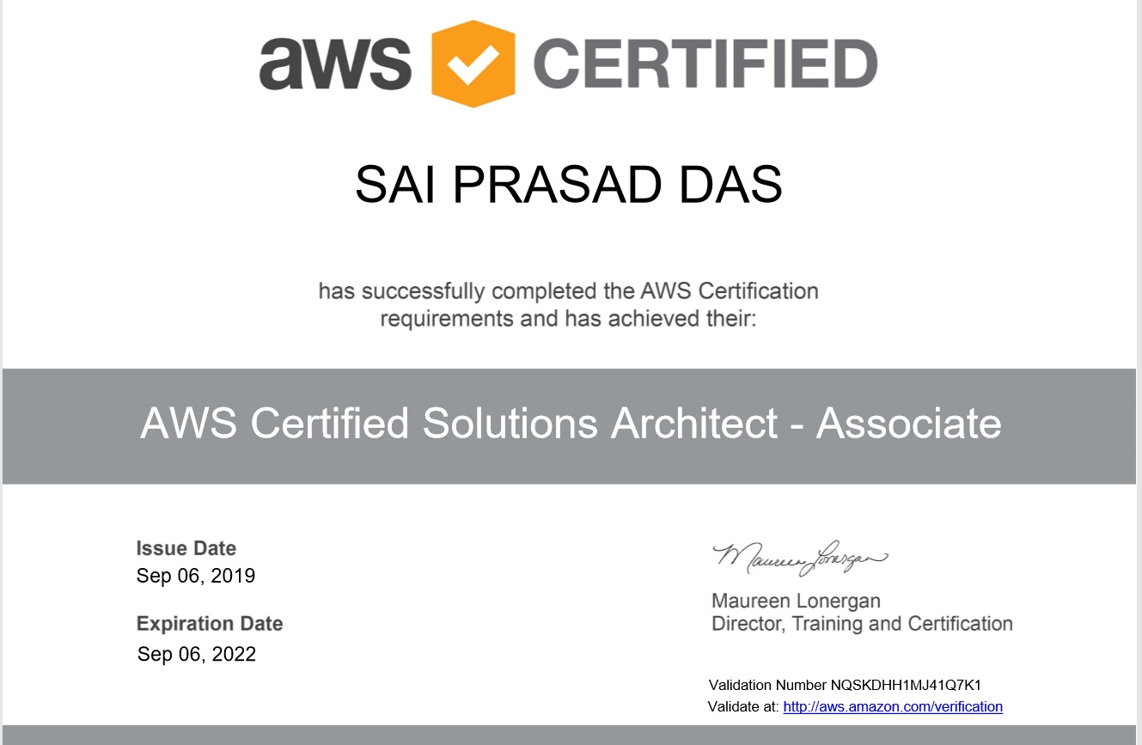

**Sai Prasad Das**

**DevOps Engineer**

**Email**: saiprasad.info1@gmail.com

**Phone**: +91 9686946845

**Location**: Bangalore

###### **Career Objectives**:

To work on challenging assignments in a progressive organization that would leverage my technical experience to the fullest potential and align my growth with the growth of the organization.

###### **Professional Skills**:

**Amazon Web Services:**

* Deploying and Scaling high traffic web application services on **EC2** instances using **Cloud** **Watch**, **Auto** **Scaling** and **Load** **Balancing**.
* Experience in creating cost effective cloud deployment solutions on **AWS**.
* Experience in designing cloud security **VPC**, **VPC** **peering, VPN** and **MFA**.
* Experience in working on AWS and its services like **AWS IAM, VPC, EC2, ECS, EBS, RDS, S3, Lambda, ELB, Auto Scaling, Route 53, Cloud Front, Cloud Watch, Cloud Trail, SQS**, and **SNS** and experienced in Cloud automation using AWS Cloud Formation templates to create custom sized **VPC, subnets, NAT, EC2 instances, ELB** and **Security groups**.
* Exp on **SES, S3, CloudTrail, SNS**.
* Mounting S3 bucket to Ec2 instance.
* Creating **IAM user, role and policy.**

**DevOps:**

• Create and maintain fully **automated CI/CD pipelines** for code deployment using **Bitbucket, Jenkins and Kubernetes.**  
• Built and deployed **Docker containers** to break up the monolithic app into microservices, improving developer workflow, increasing scalability, and optimizing speed.  
• Strong experience on DevOps essential tools like  **Ansible, Docker, Kubernetes, GIT, Jenkins, Maven** and migrated VMWAREVMs to AWS and Managed Services like **EC2, S3, Route53, ELB, EBS.**• Strong experience in AWS, creating, importing and launching volumes, **EC2, RDS, Lambda, security groups, auto-scaling, load balancers (ELBs), NACL** in the defined **VPC** to design cost-effective, fault tolerant and highly available systems.  
• Experience maintaining CI environments with build automation tools like Jenkins extensively used Jenkins to streamline **CI/CD process**, automated Master-Slave configurations using temporary slaves.  
• Created infrastructure in a coded manner (infrastructure as code) using **Ansible**for configuration management of virtual environments, and Vagrant for a virtual machine and  
resource control.  
• Deployment of Cloud service including **Jenkins** and **Nexus** on **Docker**.  
• Virtualized the servers using **Docker** for the test environments and dev-environments needs, also  
configuration automation using **Docker** containers.  
• Experience in creating **Docker Containers** leveraging existing Linux **Containers and AMI** in  
addition to creating **Docker Containers** from scratch.

###### **Education Qualification:**

**B .Tech in Electronics Communication Engineering from BPUT**, Odisha.

###### **Certifications:**

* **AWS Certified Solution Architect Associate**

###### **Career Profile:**

Total **5+ Years** of relevant working experience in this field**.**

* **1 years and 4 months of** current working experience in **AgilizTech Software Services Pvt LTD.**
* **8 months** of working experience in **DXC Technology**.
* **3 Years 3 months** of working experience in **Digi Kraft Software Private Limited.**

###### **Projects / Assignments**

The details of the various projects / assignments that I have handled are listed here, in chronological order:

|  |  |
| --- | --- |
| **Project No-1** | Multiple Clients (AgilizTech Software Service Pvt LTD) |
| **Period** | MAR 2019-till date |
| **Roles and responsibilities** | **DevOps**   * AWS infra creation manually and through automation using Terraform. * Participate in deep architectural discussions to ensure solutions are designed for successful deployment in the cloud. * Involved in building end to end cloud Platform in AWS as per client need. * Architect, design and implement solutions with AWS Virtual Private Cloud (VPC), Elastic Compute Cloud (EC2), Elastic Load Balancer (ELB), Auto Scaling, RDS, S3, CloudWatch and other AWS products. * Deploying/ Managing/Monitoring/ overall cloud environment on AWS (EC2, ECS, ELB, S3, VPC, Lambda, RDS, DynamoDB, etc.). * Create/Managing buckets on S3 . * Create/Managing Users, Groups, Policies, and Roles on IAM. * Creating AWS VPC, EC2 Instances, ALB, ASG etc. by using Terraform. * Have automated our Test Environment with end to end features with Terraform. * Validating and implementing Continuous Integration tools for deployment. * Maintenance of all the Applications * Creating fully automated CI build and deployment infrastructure and processes for multiple projects. * Working closely with Architecture, Development, Test, Security and IT Services teams. * Installing, configuring and maintaining Continuous Integration, Automation and Configuration Management tools. * Implementing and developing solutions enabling Development and Operations teams to build, deploy, monitor and test applications and environments * Implementing monitoring and reporting solutions across a range of environments and platforms * Mainly Concentrating:EC2 (Elastic load balance) Auto scaling,EBS,VPC,S3,IAM. * Utilized Cloud Watch to monitor resources such as EC2,CPU Utilization, Amazon RDS DB services, EBS Volumes, to set alarms for notification or automated actions and to monitor logs for better understanding and operation of system. * Monitored and worked on alerts on various issues such as server availability, Disk issues, CPU Utilization, Processes etc. * Manage and created user accounts, shared folders, Printing services, providing day to day user support, Log management, reporting, applying group policy restrictions etc. * Provide highly durable and available data by using S3 data store. * Using Cloud watch to monitor Traffic behaviour and reacting accordingly * Providing access to the jump and stage instances through scripts. * Performing Server Hardening and automating the process using Ansible. * Develoing playbooks for configuration and deployment tasks. * Writing Ansible roles to create reuse playbooks * Automating many sysops tasks like memory check, cpu usage, hard disk usage through Ansible Tower |

|  |  |
| --- | --- |
| **Project No-2** | XPO Logistics (DXC Technology) |
| **Period** | JUL18-FEB19 (8Months) |
| **Roles and responsibilities** | **DevOps**   * Managing the team in off-shore. * Providing access to the jump and stage instances through scripts. * Monitored and worked on alerts on various issues such as server availability, Disk issues, CPU Utilization, Processes etc. * Mainly Concentrating:EC2 (Elastic load balance) Auto scaling,EBS,VPC,S3,IAM. * Deploying and Scaling high traffic web application services on **EC2** instances using **Cloud** **Watch**, **Auto** **Scaling** and **Load** **Balancing**. * Experience in creating cost effective cloud deployment solutions on **AWS**. * Experience in designing cloud security **VPC**, **VPC** **peering, VPN** and **MFA**. * Exp on **SES, S3, CloudTrail, SNS**. * Mounting S3 bucket to Ec2 instance. * Creating **IAM user, role and policy.** |

|  |  |
| --- | --- |
| **Project No-3** | Digikraft Technologies Private Limited |
| **Period** | APR15-JUN18 (3 Year 3 Months) |
| **Roles and responsibilities** | **Linux Admin**   * Checking Disk Space Clearing log & checking health status * Managing file system & partition * Adding new LVM, adding new user & group * Taking Backup restoring in dump server. * Working with end users to get applications installed and managing user expectations of how the system will perform * Troubleshooting P1/P2 * Job Automation through cron * Manage installed services * NFS * User security with sudo * Working on creating Postgres/Mysql/Oracle Database * Creating Database role & user |

**Declaration**

I do hereby declare that the statements made above are true, complete and correct to the best of my knowledge and belief.

Bangalore **Sai Prasad Das**

