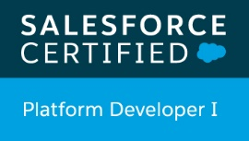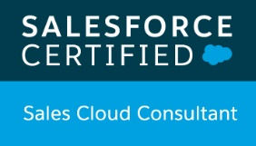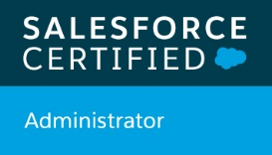

**ALAGHUNIDHI E**

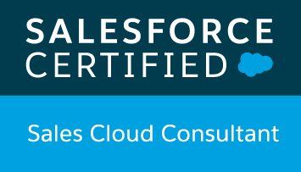

E

-

Mail: Alaghunidhi@gmail.com

Mobile

: +91 9791705210

**Professional Summary:**

* 2 years of experience in Salesforce Development.
* Certified Salesforce Developer, Administrator and Sales Cloud Consultant.
* Domain Experience in AIIT & Life Science Industry (Pharma).
* Strong technical skills in Salesforce, ServiceMax, Apttus CPQ.
* Involved in various stages of Software Development Life Cycle including analyzing requirement, development, Enhancement, testing.
* Experience working across various SFDC Implementations covering Sales Could, Service Cloud and App-exchange applications.
* Good work experience on Custom Objects, Custom Fields, Custom Tabs, Validation Rules, Page Layouts, Record Types, Relationships, Workflow Rules, Email Templates and Approval Process.
* Good work experience on Apex Class, Apex Trigger, Visualforce pages and SOQL.
* Good Work experience on Managing Users, Security and Data Access which involves Profiles, Roles, Permission Sets, OWD Settings, Field Level Security.
* Good Work Experience in using Data migration tools like Apex Data Loader, Workbench and Eclipse Force.com IDE.
* Good knowledge on Reports and Dashboard and retrieving metadata from system for deployment using ANT Tool.
* Preparation of Test Data, Test Scenarios and Scripts.
* Involved in Unit testing, System Integration testing and UAT.
* Skills with multi-tasking talents and comfortable working in a team environment with tight schedules and meet deadlines.
* Commitment to the highest level of professional and personal excellence.

**Technical Skills:**

**In Salesforce:**

|  |  |
| --- | --- |
| • | Apex classes and Apex Triggers |
| • | Visualforce pages, SOQL and Test classes |
| • | Apttus CPQ, Servicemax |
| • | Workflow rules |
| • | Profiles, Roles and Permission sets |
| • | Record Types and Page Layouts |
| • | Reports and Dashboards |
| **Tools:** |  |
| • | Developer Console and Data Loader |
| • | ANT for deployment |
| • | Workbench |
| • | Force.com IDE |
|  |  |

**Certifications:**

* Salesforce Certification for Admin (**Salesforce** **ADM 201**).
* Salesforce Certification for Platform Developer-I (**Salesforce** **Dev 450**).
* Salesforce Certified Sales Cloud Consultant

**Professional Experience:**

**Project 3**

**Client :** ABB, Switzerland

**Project Duration :** Nov 2016 to till date

**Role :** Salesforce Developer - CQM

**Environment:**

Apttus CPQ, Sales Cloud, Apex Classes, Apex Trigger, Visulaforce Pages, Workflow, Email Templates, Custom Object and Fields, ANT Tool.

**Responsibilities:**

* Responsibilities for understanding the requirements related to Quotation and Agreement object in Configure prince and quote functionality.
* Created Page Layouts to organize fields, Custom links, Related lists and other components on a record detail and edit pages.
* Authored Visualforce page with extension for representing the process flow of quotation and Agreement.
* Designing and creating objects for master data and loading data into it.
* Created Workflow for generating emails, creating task, field update under various criteria.
* Created Email Templates for time based workflow.
* Authored Apex Classes and Triggers to meet the requirements.
* Worked on formula fields to show the button images using static resource under various conditions and validation rule for maintaining data accuracy.
* Troubleshooting and fixing the issue raised in UAT and Production**.**
* Worked in client location to fix hyper care defects.
* Good Work experience on Custom Setting and Custom Labels.
* Involved in Data Migration activities using Apex Data Loader, Workbench and Retrieving metadata packages using ANT Tool.

**Project 2**

**Client :** Roche, Switzerland

**Project Duration :** June 2016 to Oct 2016

**Role :** Salesforce Developer/Administrator

**Environment:**

Salesforce.com, Service Console, Users, Sharing Settings, Public Groups, Apex Test Classes, Reports and Dashboards

**Responsibilities:**

* Salesforce Developer and Administrator for 200 users across 3 different countries.
* Creating Role based and Criteria based Sharing Rules, OWD, Public Groups to match the needs of the organization.
* ModifyingProfiles and Permission Sets as per the requirement and assigning it to the users.
* Creating Workflow for creating task and field update.
* Analyzing the functional requirements and deriving Test Scenarios and Scripts for the same.
* Performing System Integration testing and reporting bugs and tracking the bug till closure.
* Test Data preparation for UAT and coordinating with users in addressing the issues.
* Preparation of Test Reports after the completion of SIT and UAT respectively.

**Project 1**

**Client :** Schneider Electric, France

**Project Duration :** July 2015 to May 2016

**Role :** Salesforce Developer

**Environment:**

ServiceMax, Custom Objects and Fields, Profiles, Apex Class, Apex Trigger, Page Layout

**Responsibilities:**

* Performed detailed analysis of business and technical requirement and designed the solution by customizing various standard objects of Salesforce.com and objects related to service like Case, Contracts and Work Order.
* Created Page Layouts to organize fields, Custom links, Related lists and other components on a record detail and edit pages.
* Maintained data cleanliness and accuracy by adding almost 50 custom validation rules, Custom Formulae.
* Worked on Security and Data Access which involves modifying Profiles and Permission Sets.
* Have done demonstration on Dispatching Work Orders to Field Service Representatives and Service/Maintenance Contracts on ServiceMax.
* Authored Apex Classes and Apex Triggers for various functional needs in the application.
* Perform Data Migration Activities

**Academic Details:**

|  |  |  |  |
| --- | --- | --- | --- |
| **Name Of Examination** | **Institution Studied** | **Year Of** **Passing** | **Aggregate** |
| B.E (Mech) | Sri Sivasubramania Nadar College of Engineering, Chennai, TN. | 2015 | 72.5% |
| HSC | SRV Boys Higher Secondary School, Rasipuram, TN. | 2011 | 94.5% |
| SSLC | KSMS Higher Secondary school, Thanjavur, TN. | 2009 | 90% |

**Declaration:**

I hereby declare that the above furnished details are true to my knowledge.

**Date:**

**Place:**  Alaghunidhi.E