**Satish** 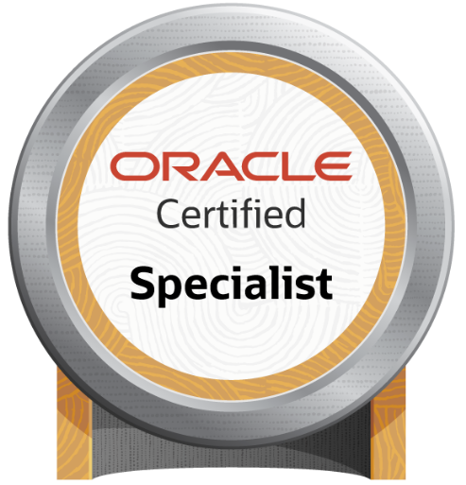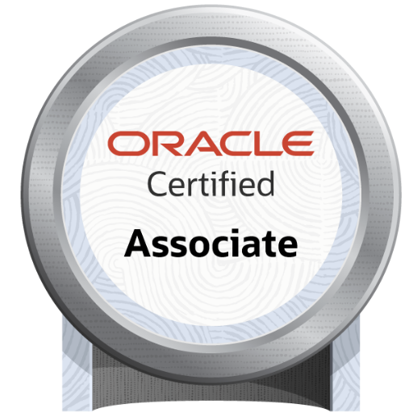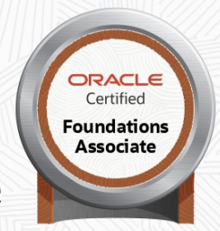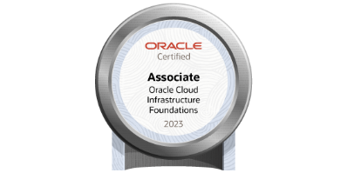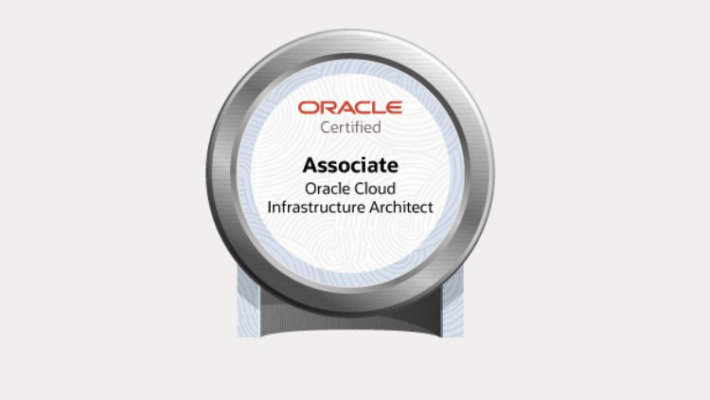

Senior Principal Consultant

Mobile: **+91-9985199912**

E-mail: **satish2904@gmail.com**

## **Summary**

* 15.9 years of experience in E-Business Suite (11i, R12.1.x, R12.2.x) Implementation, Upgrade and Production support
* Good experience in migrating EBS On-Prem to OCI
* Experience in **Lift and Shift On-Premises EBS to OCI**.
* Experience in configuring **EBS Asserter** and integrating to OCI EBS environment.
* Experience in Provisioning servers with Compute instance, DBCS (VMDB).
* Experience in **EBS Cloud Manager.**
* Hands on experience in Database and applications installation, patching, cloning and upgrade.
* Experience in using Zero Downtime Migration technologies and methods.
* UpgradedEBS **R12.2.3 to EBS 12.2.7,12.2.9/10**
* UpgradedEBS 11.5.10.2 to **R12.1.x and R12.2.x.**
* Implemented Best practices for monitoring, code migration, Backup and Recovery
* Experience in administering RAC environments.
* Installed and maintained Application Management Pack (AMP), configured PCP.
* Expert knowledge in patching and using AD utilities.
* Migrated EBS **11.5.10.2** from **HP-UX to SUSE Linux**
* Installed and configured the APPLOAD tool with EBS R12***(12.1.3 and 12.2.3)***
* Thorough knowledge in trouble shooting and performance tuning of Application Tier
* Good knowledge on working with RMAN.
* Sound knowledge of third-party tools like Kintana, OnGuard, VSS, Stat-Application Change Management etc.
* Created users, assigned responsibilities and roles, and resolved login issues.
* Good knowledge on Concurrent manager Tuning
* Configured Workflow in EBS
* Very good understanding in shell scripting and automated RMAN with new shell scripts
* Systematized meetings for expected deliverables, status, future suggestions and implementations with clients
* Good communication, analytical, computational and teaming skills.
* Very Good interpersonal skills with demonstrated ability of customer satisfaction.

#### **Skills Summary**

|  |
| --- |
| Expertise |
| * Technical Skills: * Applications: R12.1.X, R12.2.X, WebLogic Admin, OBIEE, Demantra, APEX, SOA EBS integration, Enterprise Command centers (ECC) * Databases:  Oracle 10g, 11g, 12c and 19c * Installation and configuration   EBS R12.1.3, R12.2.3, R12.2.6, WebLogic 12c with OBIEE, Demantra, SOA, APEX with versions 20.2,4,5 and Oracle Forms & Reports 12.2.1.4. OCI Backup module, ZDM   * Upgrades   EBS 11.5.10.2 to R12.1.x and R12.1.3 to R12.2.x  Database: 11.2.0.4 to 12c and 19c  Cloning, Refreshing Databases, Patching, Backup and Recovery, Performance Tuning and Troubleshooting issues on both Oracle Applications (EBS, FMW) and Oracle Databases   * Operating Systems: RHEL, OEL 5,6,7 & 8.2, HP-UX, Solaris, IBM AIX * Hardware: ZFS storage * Software: Oracle E-business suite (EBS) – R12 (12.1.X, 12.2.X) and 11.5.10   Oracle 9i,10g, 11g, 12c and 19c  Weblogic and SOA Administration, OBIEE, Demantra, APEX, Oracle Forms & Reports (Non EBS)   * Cloud Computing: OCI * Tools: Sqldeveloper, Putty, VNC Server, WINSCP |

#### **Relevant Experience**

|  |  |  |  |
| --- | --- | --- | --- |
| Infolob Solutions India Pvt Ltd | |  | Jan 2023 – Till Date |
| Role | Senior Principal Consultant (CE) | | |
| Responsibilities | * Responsible for all timeline deliverables and POCs. * Handling customer calls, Status calls, Deliverable calls. * Responsible for proposed Workplan Deliverables to Client. * Responsible for On premises EBS migrating to OCI. * Cloning of Databases and E-Business Suite 11i, R12.1.x and R12.2.x * Migrate and/or Upgrade EBS (Database/Applications). * Responsible for all Prod and Non-Prod Applications, Database services availability and access. | | |
| **Clients**  Cholamandalam | **OCI migration**  Migrated On-prem Database (12.1.0.2) and EBS applications (R12.2.7) to OCI  Co-ordinated and worked with the client partner to make EBS environment As-Is after migrating to OCI.  Provided Runbook to the partner for the PROD Go-Live and DEV, SIT, UAT was successfully migrated to OCI | | |
| US Bricks | DR was built in OCI with DB 11.2.0.4 (Standby) and Applications EBS R12.2.6 with rsync, delivered to client. | | |
| Oman Airports | Migrated On-prem Database (19.13.0.0) and EBS applications (R12.2.10) to OCI  Configured EBS Asserter to OCI EBS R12.2.10 applications environment. | | |

|  |  |  |  |
| --- | --- | --- | --- |
| Oracle India Pvt Ltd | |  | Nov 2021 – Jan-2023 |
| Role | Senior Cloud Engineer (CE CoE JPAC) | | |
| Responsibilities | * Responsible for all timeline deliverables and POCs. * Handling customer calls, Status calls and Deliverable calls. * Responsible for proposed Workplan Deliverables to Client. * Responsible for On premises EBS migrating to OCI. * Cloning of Databases and E-Business Suite 11i, R12.1.x and R12.2.x * Migrate and/or Upgrade EBS (Database/Applications). * Responsible for all Prod and Non-Prod Applications, Database services availability and access. | | |
| **Clients**  Central Coast Council | **OCI migration**  Migrated On-prem Database (11.2.0.4) and EBS applications (R12.1.3) to OCI  Co-ordinated and worked with the client partner to make EBS environment As-Is after migrating to OCI.  Provided Runbook to the partner for the PROD Go-Live and PROD was successfully migrated to OCI | | |
| IDP Education Limited | **OCI migration**  Migrated and upgraded On-prem EBS database environment from 12c to 19c (19.17) to OCI Oracle Database Cloud service (DBCS) and Configured EBS applications. | | |
| TMEIC | **OCI migration**  Migration project from On-prem Database (12.1.0.2) EBS (12.1.3) to OCI and upgrade Database to 19c EBS 12.2.10  Conducted and driven the status calls with client and partner to meet the deliverables.  Implemented best practices to reduce the downtime and made PROD Go-Live successful. | | |
| New Zealand Health Partnerships | **OCI migration**  Migrated As-Is from Onprem to OCI  EBS R12.2.9, Database 19c | | |
| PSA | **OCI migration**  Migrated from On-prem Database (12.1.0.2) EBS (12.2.4) As-Is to OCI  Co-ordinated and worked with the client partner to make EBS environment As-Is migration to OCI. | | |
| Suneratech | |  | Jul2021 – Nov 2021 |
| Role | Senior Manager | | |
| Responsibilities | * Handling customer calls, Status calls, Deliverable calls and team management. * Prod migrations etc. * Cloning of Databases and E-Business Suite 11i, R12.1.x and R12.2.x * Upgrade Database 19c * Responsible for all timeline deliverables and POCs. * Responsible for all Prod and Non-Prod Applications, Database services availability and access. | | |

|  |  |  |  |
| --- | --- | --- | --- |
| Centroid | |  | Jan2015 – Jul2021 |
| Role | Lead Consultant | | |
| Responsibilities | * Handling Customer calls, Status calls, Customer Deliverables and team management. * Applying patches on 11i, R12.1.x and R12.2.x multi-node instances * Monitoring daily alerts from DB and Applications and addressing them such as blocking, inactive sessions etc. * Prod migrations etc. * Cloning of Databases and E-Business Suite 11i and R12 * Maintain Applications and databases on operating systems such as Linux, IBM AIX * Installed and configured Oracle Forms and Reports 12.2.1.4 * Installed and configured OBIEE 11g and 12c * Upgraded EBS 12.1.3 to 12.2.3, 12.2.3 to 12.2.7 * Install and configure Oracle products as per the requirement (WLS 10.3.6, OBIEE 11g, 12c, Oracle Forms & Reports 12.2.1.4, APEX) | | |

|  |  |  |  |
| --- | --- | --- | --- |
| Calsoft Labs India Pvt Ltd | |  | Feb2014 – Jan2015 |
| Role | Sysadmin Consultant (Deputed at Client Site GE (A & L) – Hyderabad) | | |
| Responsibilities | * Applying application patches on R12 (12.1.3 and 12.2.3) multi-node instances * Upgraded from R12.1.3 to R12.2.3 on PROD, QA, TEST, DEV0, DEV1, CONV * Monitoring daily alerts from db and applications addressing them such as blocking, inactive sessions etc. * Prod and Non-Prod code migrations etc. * Cloning of Databases and E-Business Suite 11i and R12(12.1.3 and 12.2.3) * Installed and configured the APPLOAD tool with EBS R12(12.1.3 and 12.2.3) * Maintain Applications and databases on operating system Linux | | |

|  |  |  |  |
| --- | --- | --- | --- |
| IPsoft Global Services | |  | Sep2013 – Feb-2014 |
| Role | ERP Apps DBA | | |
| Responsibilities | * Applying application patches on EBS11i, R12 (12.1.3) multi-node instances * Applying patches on 11i and R12 multi-node instances * Monitoring daily alerts from db and applications addressing them such as blocking, inactive sessions etc. * Prod migrations etc. * Cloning of Databases and E-Business Suite 11i and R12 * Maintain Applications and databases on operating systems such as Linux, IBM AIX. | | |

|  |  |  |  |
| --- | --- | --- | --- |
| Hitachi Consulting | |  | Nov2010 – Aug2013 |
| Role | Senior Consultant | | |
| Responsibilities | * King Fahd University of Petroleum & Minerals (KFUPM), Saudi   Upgraded 11.5.10.2 to R12.1.3 on Redhat Linux 5.9 server  Upgraded and delivered the instances DEV, VIS, CRP1, CRP2, UAT and PROD.  Responsible for the delivery of Apps DBA activities of the project as scheduled  Responsible for DBA Upgrade activities.   * Wichita Public Schools (WPS), USA   Upgraded 11.5.10.2 to R12.1.3 on SunOS 5. 11 servers  Upgraded and delivered the instances DEV, CRP1, CRP2 and UAT.  Responsible for the delivery of Apps DBA activities of the project as scheduled  Responsible for initiating calls to discuss all the pending and running tasks.   * Arctic Slope Regional Corporation (ASRC), USA   Upgraded 11.5.10.2 to R12.1.3 on SUSE 11 server.  Cloned the applications using rapid clone and performed post cloning steps.  Resolved issues many in patching, cloning and in code migration tasks.  Responsible for the delivery of Apps DBA activities of the project as scheduled   * Ferring Pharmaceuticals, UK   Coordinated with the team members (Hitachi & IBM) for planned activities and issues resolution.  Cloned of the applications R12 regularly using rapid clone and performed post cloning steps.  Performed regular activities such as patching, cloning, code migration etc.  As part of object migrations moving the code to all Non-Prod and Prod instances  Worked closely with development and functional teams | | |

|  |  |  |  |
| --- | --- | --- | --- |
| Ascendum Solutions India Pvt Ltd | |  | Sep2009 – Oct2010 |
| Role | Apps DBA | | |
| Responsibilities | * Primary Apps DBA from Ascendum for all Apps DBA activities * Independently handled offshore support * Successfully managed team queue and SR queue * Won many customer appreciations with zero escalations and defined new process for quality and productivity. * Analyzed and applied various types of patches on different PROD and Non-Prod instances. * Applied RDBMS patches using Opatch * Cloned Oracle Applications using rapid clone. | | |

|  |  |  |  |
| --- | --- | --- | --- |
| Genisys Information Systems (India) Pvt Ltd | |  | Aug2007 – Jun2009 |
| Role | Consultant at Client Site (Oracle Corporation India Pvt Ltd – Hyderabad) | | |
| Responsibilities | * Applied all kind of patches like one-off, mini pack, family pack, maintenance pack, etc., on Non-Prod & Prod instances as suggested by planning team. * Applied RDBMS patches using Opatch on Non-Prod & Prod instances for different customers. * Code migrations like reports, forms, database objects, csv files, pll files and workflow (wft) files are moved to Non-Prod and Prod instances on demand. * Configuration changes are done both in Application and Database Tiers on all Non-PROD and PROD instances. * Assigning and distributing the work as part of the shift lead. * Very Good interpersonal skills demonstrated with abilities for customer satisfaction. * Won many customer appreciations. * Work as part of a team and provide 24x7 supports. | | |

#### **Education**

Bachelor of Science (M.P.C) in 2002– SAS Degree College from Nagarjuna University, Vijayawada.

#### **Certifications**

* Certified in Oracle Cloud Infrastructure 2023 Certified Architect Associate
* Certified in Oracle Cloud Infrastructure 2023 Certified Foundations Associate.
* Certified in Oracle Database 12c Implementation Specialist.
* Certified Associate in Oracle Database 12c Administration.
* Certified Associate in Oracle Cloud Infrastructure Foundations 2021.

**Badges & Patents**



