Vikrant Upadhyay 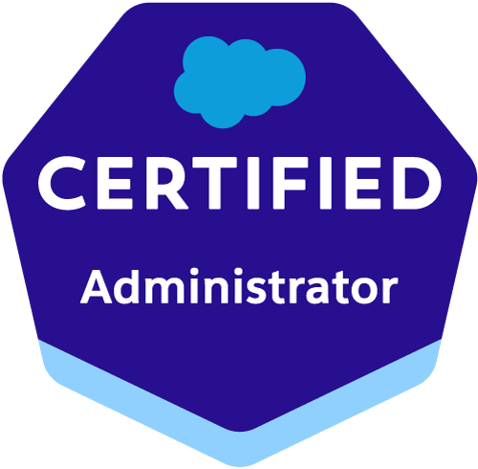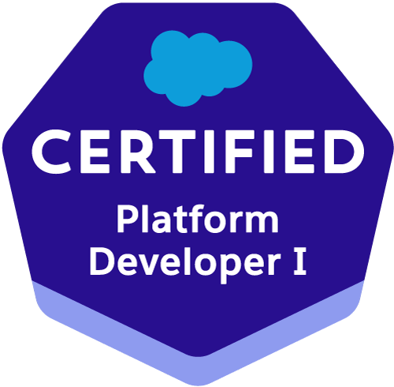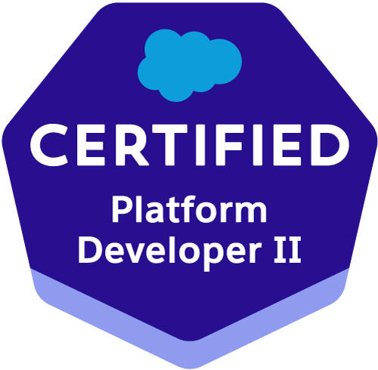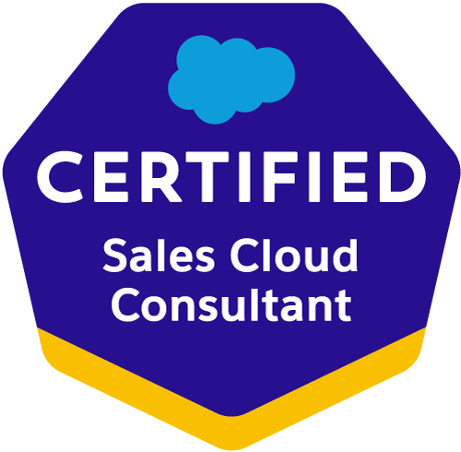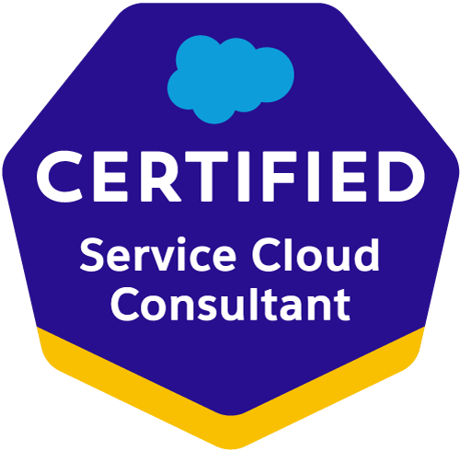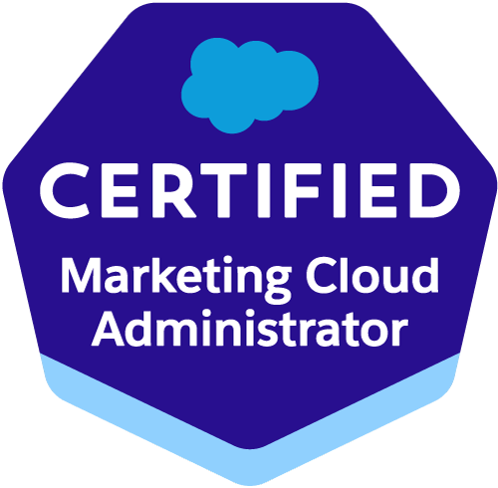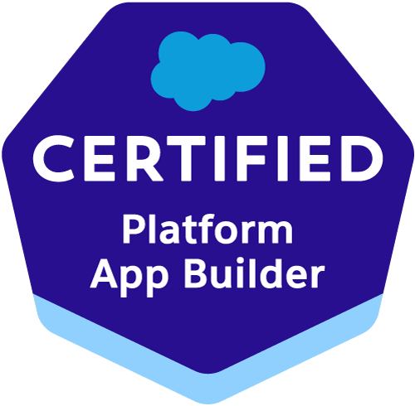
Email : vik9935@gmail.com
Contact no: +91 9919299599

PROFESSIONAL SUMMARY:

- Overall 4 Years of experience as Salesforce Development and Administrator.
- Worked closely with Business Users to enable business administration and development on Salesforce.
- Proficiency in SFDC Administrative tasks like creating Profiles, Roles, Users, Page Layouts, Email Templates, Approval Process, Workflows, Reports, Dashboards, Tasks, and Events.
- Experience in data migration.
- Experience in designing Custom Formula Fields, Field Dependencies, Validation Rules, Work Flows, Process Builder, Visual Flow and Approval Processes for automated alerts, field updates, and Email generation according to application requirements.
- Experience in Coga composer(Basic)
- Experience in Docusign
- Experience In Nintex Drawloop
- Understanding, Analyzing, and Streamlining Salesforce administrative and development requirements.
- Knowledge of SOQL.
- Experience on Salesforce Apex, Salesforce Triggers, VisualForce page, Aura component, Batch class,REST API and Test Class
- Excellent communication and interpersonal skills, accustomed to working in both large and small team environments.
- Knowledge in GIT(CI/CD) BitBucket.

EDUCATIONAL QUALIFICATION:
- BTECH (CS) from BBD University Lucknow, UP. 2011-2015

SOFTWARE PROFICIENCY:

- Programming Language: HTML, CSS, JAVA, Apex, Salesforce Triggers, VisualForce page, Aura component, Batch class, REST API, and Test Class
- Tools: Data loader, Ant Migration tool

Salesforce Administrative and Development Skills:

- Good experience in Salesforce administration(Data Loading, Formulas, workflow, Process Builder, Flow, Approval Process, and Validation Rule)
- Good experience on Salesforce Apex, Salesforce Triggers, VisualForce page, Aura component, Batch class, REST API, and Test Class.
- Good Knowledge of Salesforce SOQL query.

CERTIFICATION:

- Certified Salesforce Administrator(201)
- Certified Platform App Builder
- Platform Developer 1(PD1)
- Platform Developer 2(P21)
- Java script Developer
- Service cloud consultant
- Sales cloud consultant
- Marketing Cloud Admin
- Certified Advance Administrator
- Business Analyst
- Salesforce Associate

PROFESSIONAL EXPERIENCE:
Software Developer
Aspire Software Consultancy - Bangalore
PROJECT #1

Project Title: Renovo Financial
Environment: Salesforce.com platform
Role: Salesforce Administrator and Development
Tools: Data Loader, Ant Migration tool
Project Description: Renovo Financial is a fast-growing Chicago-based Private lender for exceptional real estate investors who build Single-family or small multi-family properties. Renovo provides loans for rehabs and flips, temp-to-perm Financing for rental rehabs, and new construction
Roles & Responsibilities:
- Understanding of Salesforce technical requirement specifications.
- Creating Objects and fields.
- Creating Profiles and permission sets.
- Creating Sharing settings
- Creating Validation rules and workflow
- Creating Approval Process.
- Creating Reports and dashboards
- Loading Data to objects by mapping respective fields with a data loader.
- Working on Salesforce workbench.
- Creating Process Builder and Flow.
- Creating Apex class.
- Creating VF pages.
- Creating Lightning component
- Creating Trigger, Batch classes, Test Classes
- Designing Email Templates.

PROJECT #2

Project Title: BBNA
Environment: Salesforce.com platform
Role: Salesforce Administrator and Development
Tools: Data Loader, Ant Migration tool
Project Description: BBNA is the largest manufacturer of engineered building solutions in the world and provides a solution for Global Facility Construction Needs.
Roles & Responsibilities:
- Understanding of Salesforce technical requirement specifications.
- Creating Apex class.
- Creating VF pages.
- Creating Lightning component
- Creating Trigger, Batch classes, Test Classes
- Email Templates.

PROJECT #3

Project Title: District 10
Environment: Salesforce.com platform
Role: Salesforce Administrator and Development
Tools: Data Loader, Ant Migration tool
Project Description: It’s a B2C application for holiday options, with various features involving accommodation inventory, flights, transfers, ski hire, and ski passes with the various process to help quickly book the Ski holiday.
Roles & Responsibilities:
- Understanding of Salesforce technical requirement specifications.
- Creating Objects and fields.
- Creating Profiles and permission sets.
- Creating Sharing settings
- Creating Validation rules and workflow
- Creating Approval Process.
- Creating Reports and dashboards
- Loading Data to objects by mapping respective fields with data loader.
- Working on Salesforce workbench.
- Creating Process Builder and Flow.
- Creating Apex class.
- Creating VF pages.
- Creating Lightning component
- Creating Trigger, Batch classes, Test Classes
- Designing Email Templates.

DECLARATION:
I abide that to the best of my knowledge the above furnished information is authentic.
Date:08-05-2023
Place: Bangalore (Vikrant Upadhyay )

