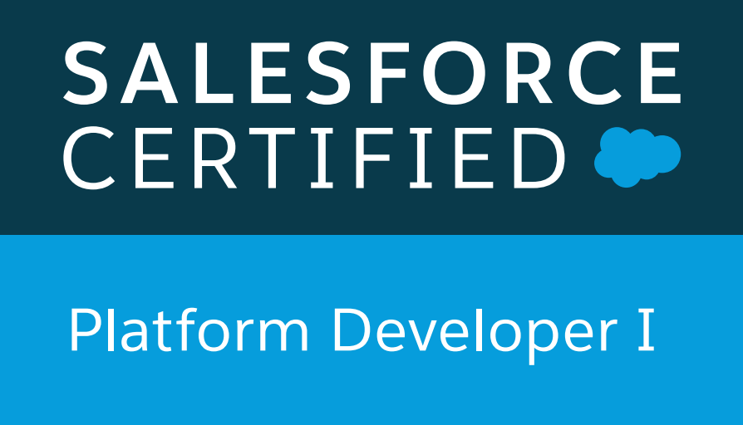 **RAJAT SINGH**

**Gurgaon, Haryana, India 122018 | Ph No: 7768073223 | rajatshivam@gmail.com**

**Summary**

A result-driven, customer-focused, articulate and analytical Software Engineer who can think “out of the box”. Strong in design and integration problem-solving skills. Expert in Java, Javascript, HTML, CSS, Angular JS, **Salesforce.com(Force.com,Apex )**. Skilled in developing requirements specifications, user documentation, and architectural systems research.

Strong written and verbal communications. Interested in a challenging technical track career in an application development environment.

Experienced In :

**Salesforce Platform Developer1 certified with 4years of development experience**

* Proficient in **setup**, **customize** and **deploy** to salesforce.com , perform hands on customizations using **Apex**, **Visualforce**,  **reports** salesforce.com **Web services API**
* Implemented various advanced fields like **Pick list**,  **Formula Fields, , Validation Rules, Workflows**, **sharing rules** and **Approval Processes** for automated alerts, field updates, and Email generation according to application requirements
* Complete knowledge **of Apttus clm**
* Successfully implemented **Apttus clm functionalities like query templates, agreement rules, IWA**
* Have a complete knowledge of sales cloud, service cloud**, Apttus CLM**
* Developed SPA’s using **Salesforce Lightning,Lightning App builder**
* Has complete knowledge of **Lightnin**g **Component Bundle,Lightning Events**
* Engineering web development, all layers, from database to services to user interfaces.
* Analysis and design of databases and user interfaces.
* Managing requirements.
* Providing full lifecycle support to clients from initial client interaction and requirements analysis through design, coding,
* testing, debugging, implementation, and integration.
* Managing and supporting multiple projects.
* Highly adapatable in quickly changing technical environments.

**TECHNICAL SKILLS:**

|  |  |
| --- | --- |
| **Salesforce Technologies and Apttus** | Force.com , Data Loader, Salesforce.com customizations like Workflow Rules, Role Hierarchy, Validation Rules, Formulae, Custom objects, Page Layouts, Record Types, **X-author, Apttus CLM, Query Templates, Agreement Rules, DDA** |
| **Operating Systems** | Windows 98/2000/XP/2003/vista/2007. |
|  |  |
| **Web Development** | XML, HTML, CSS, Visualforce, JavaScript. |
| **Languages** | C, C++, Java, Java Script, SQL, Apex |
| **GUI and Tools** | Eclipse, Force.com IDE, Apex Data Loader, workbench |

**Education Detail**

* B.Tech in Computer Science and Engineering(2011-2015) from Amity University
* 10+2 with Science (2010) from CBSE Board with 64% marks.
* High School (2008) from CBSE Board with 80% marks.

**Software Skills**

* **LANGUAGES/SCRIPTS :** Java, **Salesforce(Apex)**
* **WEB TECHNOLOGIES :** HTML, CSS, Javascript
* **FRAMEWORKS : Force.com**, Apex,
* **DATABASES :** SQL,SOSL
* **SOFTWARE :** Eclipse**, JBOSS**

**Experience**

**ROLE** Software Engineer

**Employer** : **Accenture**

**Project Name : Viacom18**

**Date :** Aug,2019 – Present

* Worked to enhance the the visual page functionality
* Reseached and gathered customer requirement and implemented functionality
* Worked on Apex Triggers and Visualforce
* Used **SOQL & SOSL** with consideration to **Governor Limits** for data manipulation needs of the application using platform database objects.
* Developed **Apex Classes, Controller Classes (Custom and Extension) and Apex Triggers** for various functional needs in the application.
* Implemented custom **validation rules, custom formulas, Email Templates, Assignment Rules and Auto-Responses for Cases and Leads**.
* Implemented **SOQL, SOSL** query
* Successfully implemented **Apttus CLM functionalities like query templates, agreement rules, IWA**
* Implemented **custom validation rules, custom formulas, Email Templates, Assignment Rules and Auto-Responses for Cases and Leads.**
* Implemented SOQL, SOSL query
* Created **Agreement rules, workflow rules and approval process to automate contracts.**
* Successfully implemented **Apttus CLM Lifecycle**
* Successfully created the **query templates**
* Successfully created smart fields ,clauses and uploaded templates to the specified agreement **using X-author.**

**ROLE**: Software Engineer

**Employer :Mindmerchant**

**Project Name :Standard Life Insurance**

**Date oct 2018** – April2019

* Involved in **gathering requirements** from the business and implementing those in Salesforce.com
* Worked on **Standard objects** like Accounts, Contacts, Lead, and Cases, and **Custom Objects** like Territory, FMR, Fuel & Shop Accounts, Account Setup Requests, and more
* Created multiple **custom objects, custom fields**, **relationship** between two objects, **page layouts** and **record types**
* Developed different **Validation Rules** to ensure that the valid data is being entered into the organization
* Developed **workflow** **rules** and **approval processes** to automate the business process
* Applied many logic into sending out **email templates** firing through **Workflow** based on the requirement
* Utilized **Salesforce.com out-of-the-box** functionalities over customization wherever possible

**ROLE** Software Engineer

**Employer :** Atos Syntel

**Project Name : Cuna Mutual**

**Date :** March,2016 – October 2018

* Worked to enhance the the visual page functionality
* Develop pocs.
* Reseached and gathered customer requirement and implemented functionality
* Worked on Apex Triggers and Visualforce
* Used **SOQL & SOSL** with consideration to **Governor Limits** for data manipulation needs of the application using platform database objects.
* Developed **Apex Classes, Controller Classes (Custom and Extension) and Apex Triggers** for various functional needs in the application.
* Implemented custom **validation rules, custom formulas, Email Templates, Assignment Rules and Auto-Responses for Cases and Leads**.
* Implemented **SOQL, SOSL** query

**ROLE** Software Engineer

**Employer :** Syntel

**Project Name :** American Express CMP

**Date :**November,2015- February,2016

* Worked on an Merdian portal which is used to fetch data from via creating offers.
* Made a dashboard using HTML, CSS and Javascript .
* Performed Unit Testing for the developed functionality.

**Strengths**

* Flexibility and Adaptability.
* Positive Attitude.
* Enjoys Responsibilities.
* Quick learner.
* Good time management skill.
* Action-oriented and result-focused.

**Extra Curricular & Hobbies**

* Part of Quiz Team.
* Playing Chess.