******** immediate joiner –currently unemployed********

|  |  |
| --- | --- |
| **Education** |  |

|  |  |  |
| --- | --- | --- |
| Qualifications | * BE (EEE) passed out in APR – 2007, RMK Engineering College (Anna University) (73%) * PGXPM – part time (Post graduate executive program in management) – Great Lakes Institute of Management (CGPA 3.74\4). - 2017 | |
| **Experience History** | | |  | |

|  |  |  |  |
| --- | --- | --- | --- |
| **Company Name** | **Designation** | **Duration** | **Employee**  **Id** |
| Tech Mahindra | Associate Tech Specialist | 17 Jun 2019 to 31 Aug 2020 | 631546 |
| IBM India Pvt Ltd | Package Solution  Consultant | 24 Dec 2014 to 15 Jun 2019 | 03022V |
| Accenture Services | Software Engineering Team Lead | 27 May 2011 to 01 Sep 2014 | 10698121 |
| Infosys Technologies Ltd | System Engineer | 24 Dec 2007 to 20 May 2011 | 101804 |

|  |  |
| --- | --- |
| **Professional experience** |  |

|  |  |  |  |  |  |  |
| --- | --- | --- | --- | --- | --- | --- |
| Profile | | * Have vast experience in Siebel Implementation, Maintenance, Support and Transition projects.**(Configuration, scripting, Workflows, EAI, Open UI, EIM)** * Have around 1 year experience in **UCM (Universal Customer Master)** development. * Have worked at Indian client location and involved in supporting end users, meetings with business managers and stake-holders for status updates and presentation of new functionalities. Efficient in handling client expectation and interfacing skills. * Provided Knowledge transition to the external vendors on the current application. * Experienced in following Siebel applications: Siebel eautomotive, Siebel edealer, Siebel Sales, ePharma, call-centre, Power Communications and Siebel UCM. * Undergone training in areas like C, C++ Programming, Computer Hardware, UNIX, Web Technologies, Java, Oracle 9i, Siebel Call Centre and necessary soft skills. | | | | |
| Key Skills | | * Siebel Configuration   + Configuration(Table Level to Screens, symbolic URLs)   + Scripting   + Workflows * Siebel EAI   + Java based web services.   + Web services   + JMS Integration   + HTTP Integration   + Outbound email communications   + VBC\EBC Configurations   + File based integrations * Siebel EIM & Data Load   + Data Load using Java Software   + Data Fix using VB macros   + Extraction queries fine tuning to load data to Big Data.   + EIM jobs for Purging and Restore. * Siebel Open UI   + Creation and Modification of PM, PR PostLoad JS Files.(using JavaScript and JQuery)   + Creation and Modification of SWT Files using JavaScript, HTML and SWE Tags.   + Editing CSS Files for UI changes using HTML. * Siebel TBUI   + Creation of new & modifying existing Complex Task Based UI. * Siebel Administration   + Server bounce   + Incremental\full compile   + Component creation (Receiver components\ WPM )   + Component monitoring and triggering email & sms alerts for failure handling. * PL\SQL   + Complex queries for data export.   + Performing SQL Loader for temp tables   + PL\SQL Procedures for mass updates.   + Automation using bat files.   + Shell scripting for data loads. * Java   + Create Standalone applications for file processing and web-service calls.   + Create java web-services to integrate Siebel and mobile applications and deploy it in glassfish server. | | | | |
| Career History | |  | | | | |
| **Date** | | **Company Name** | | **Location** | **Roles & Responsibilities** | **Accomplishments** | **Technology** | |
| Jun 2019 to Aug 2020 | | Tech Mahindra | | Chennai | Lead the Development & Issue fix of Archival, Purge and Restore interfaces.  Deployment of deliverable to next higher environments.  Testing support & Deployment support.  Handover to the subsequent team member | Successfully developed all the interfaces in very short frame of time.  Identified key gaps, defects and fixed the code. | PL SQL, Siebel EIM,  Shell scripting, SQLLDR, Impala SQLs fine tuning, MySQL | |
| Jan 2015 to Jun 019 | | IBM India Pvt Ltd | | Chennai | Technical lead  - Responsible for smooth running of application - maintenance of all the interfaces - Enhancements & Tickets handling | Delivered some critical interfaces for the client using java based technology and glass fish servers Maintain the complete interfaces without any issues and proactively kept monitoring mechanisms in place to avoid service failures. | Siebel , PLSQL,UNIX Shell scripting, Java | |
| Jan 2014 - Sep 2014 | | Accenture Services | | Bangalore | Technical lead  - Deliver framework for outbound interfaces (used by more than 50 outbound web services) & implementation of Siebel application for the first release.  - Lead a team to complete RFC on timelines. | Green field implementation project. Setting up of all the base code is done like the framework for outbound web services.  360 degree view developments etc. | Siebel, SQL, HTML, Java script, JQuery | |
| Jan 2013 - Dec 2013 | | Accenture Services | | Bangalore | Senior Software Engineer - Take RFC and complete it from design to production support - Lead a small team to complete RFC on given timelines and quality criteria | Completed critical RFC's in given timelines with the junior team members. | Siebel, XML | |
| May 2011 - Dec 2012 | | Accenture Services | | Bangalore | Senior Software Engineer - Deliver RFC assigned with high quality and defect free.  - Lead a small team to complete the data load of around 300 man days’ work. | Successfully delivered complex data load work with minimal defects avoiding a lot of rework. | Siebel, SQL Loader | |
| Jan 2010 - Apr 2011 | | Infosys Technologies | | Bangalore | Software Engineer  - Support end users through ticketing tool and calls sometime. - Support key functionalities and fix defects arising. - develop enhancements and deliver. | Got good recognition from the client for supporting end users well.(more info in the last section) | Siebel | |
| Jul 2008 - Dec 2009 | | Infosys Technologies | | Pune | Software Engineer  - Support end users through ticketing tool and calls sometime. - provide status update to client business manager on weekly basis | Successfully decommissioned a Siebel application | Siebel | |

|  |  |
| --- | --- |
| **Other relevant information** |  |

**Recognitions from the previous organizations.**

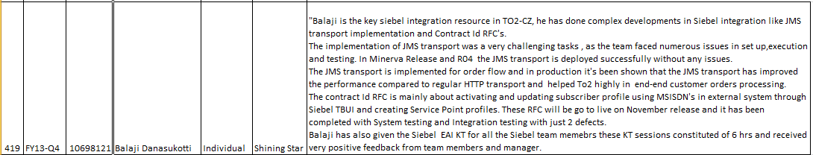

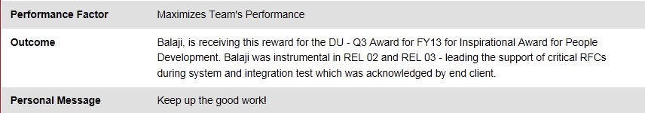

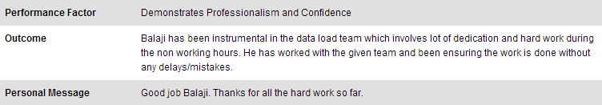

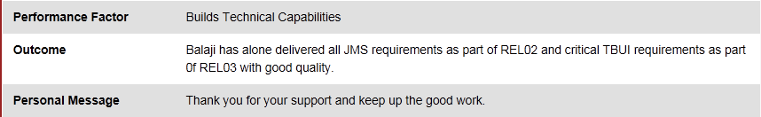

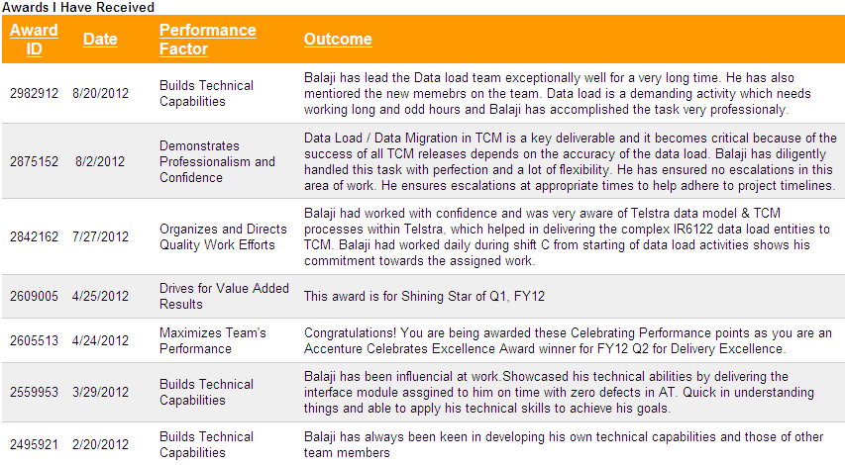

**Other Recognitions:**

* Got “Backyard Bravo” award from client in Yahoo, below are the comments.

|  |
| --- |
| Thank you very much for your amazing work! Fast processing, Accurate work, excellent communication, solution oriented and analytical thinking! |

* Have been selected as one of the best performer, from among the client employees and various stakeholders, and awarded cash price at client place Yahoo.

**Other Details:**

Total Experience : 11 years 6months

Current Work Location : Chennai

Aadhar Number : 818424077751

*All information above is right to my conscience in all aspect. -* ***Balaji D***

|  |  |
| --- | --- |
|  |  |