Rudra Nath Makhal  SFDC Technical Lead/Architect with AURA/LWC Experience  Phone: +91 9432283374  Email: rnmakhal@gmail.com  Date of Birth: 30.05.1989 | 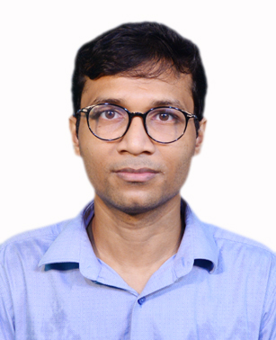
SFDC Certifications:
- Salesforce Certified Platform Developer I
- Salesforce Certified Platform Developer II
- Salesforce Certified Administrator
- Salesforce Certified Platform App Builder
- Salesforce Certified Sales Cloud Consultant
- Salesforce Certified OmniStudio Developer
- Salesforce Certified Sharing and Visibility Architect
- Salesforce Certified Application Architect
- Salesforce Certified Data Architect

EMPLOYMENT HISTORY:

Organization | From | To | Designation | Responsibility
Wipro Technology | Aug, 2011 | Jan, 2014 | Associate Consultant | Worked a pure Salesforce Developer gathered experience VF, Apex etc
Tata Consultancy Services (TCS) | Feb, 2014 | Mar, 2016 | IT Analyst | Worked a Senior developer, Mentoring Juniors.
Cognizant Technology Solution (CTS) | Mar, 2016 | Present Date | Technology Architect | Working as a Lead/Architect. Leading 3 Projects with team strength between 10-15. Working on Solutioning.

EMPLOYMENT EXPERIENCE:
- Total SFDC experience of more than 10 years, implemented over 10 SFDC projects.
- Project implementation of latest technology like Aura Components/LWC.
- Currently working as a Salesforce Lead/Architect Cognizant Technology Solutions Ltd.
- Lead team with team strength of 10-15 resources, delivering quality solutions.
SFDC TECHNICAL HIGHLIGHTS:
- Hands-on experience in the area of SFDC Customization and Force.com migration tools.
- Well versed with Salesforce.com Out-of-Box functionality – user management, roles and profile creation/maintenance, page layout customization, views/search layouts creation, reports/dashboard development, validation rules, button configuration and workflow automation, field updates and approval processes, business hours management.
- Programming in APEX and development of Visual Force pages.
- 4 years of experience in LWC and Aura Components.
- Implemented Salesforce Encryption, Classic Encryption, Masking, working on tools like Shield Security Cockpit.
WORKING AS A SFDC LEAD:
- Currently Leading 3 projects parallelly.
- Helping out team technically.
- Working on solutioning.
- Code review and technical flow optimization etc.
- Grooming new resources.

ACADEMIC QUALIFICATION:
- B.Tech in Electronics and Communication form Heritage Institute of Technology, Kolkata . Year of passing is 2011.
- ISC(12th) exam done from National Gems Higher Secondary School , Kolkata. Year of passing is 2007.
- ICSE(10th) exam done from National Gems Higher Secondary School , Kolkata. Year of passing is 2005.

