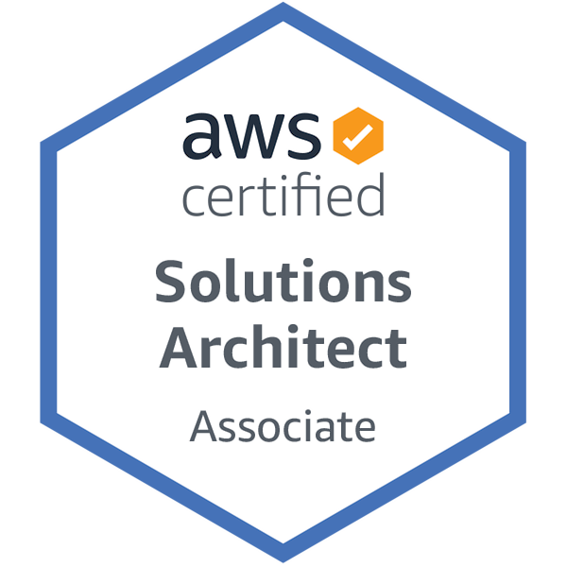
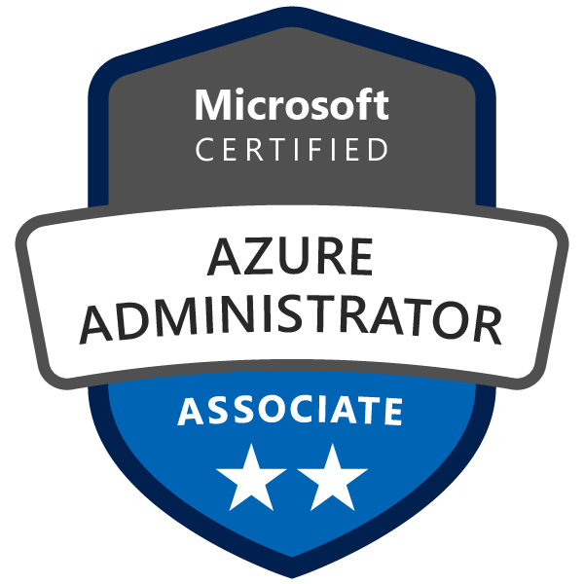
Sowmith Muppidi
sowmithmr@gmail.com | +1 (202)-430-6185
https://www.linkedin.com/in/sowmith-reddy-m/

PROFESSIONAL SUMMARY

DevOps/Cloud Engineer with 7+ years of IT experience in Cloud and DevOps Methodologies as primary focus in architecting/automating and optimizing mission-critical deployments over a large infrastructure. Proficient in Configuration Management and developing CI/CD pipelines.

- Expertise in AWS Cloud Administration services like: EC2, S3, EBS, VPC, ELB, AMI, SNS, RDS, IAM, Route 53, Auto scaling, Cloud Front, Cloud Watch, Cloud Trail, CloudFormation, OPS Work, Security Groups.
- Implementing infrastructure on new AWS systems and migration of existing infrastructure to Cloud platforms and automated the process using Terraform, CloudFormation Templates, modules and create customized VPC’s, subnets and NAT to ensure successful deployment of Web applications.
- Utilized Amazon Route53 to manage DNS zones and give public DNS names to elastic load balancers IP's and AWS Beanstalk for deploying and scaling web applications and services.
- Made use of Google Cloud Platform (GCP) services like Compute Engine, Cloud Composer, Cloud Load Balancing, Cloud Storage, Stack Driver monitoring and Cloud Deployment manager to launch VM’s, store and manage databases.
- Extensive experience in deploying micro service-based applications on to Google Cloud with the help of services like GKE, Kustomize, Helm, Docker and Terraform.
- Hands on experience with big data tools like Hadoop, Spark, Apache Airflow, PySpark, Spark SQL, Hive, Pig, Impala and NoSQL databases like (MongoDB and HBase).
- Expertise in Architecting and Implementing Azure Service Offering, such as Azure cloud services, Azure storage, IIS, Azure Active Directory (AD), Azure Resource Manager (ARM), Azure, Blob Storage, Azure VMs, SQL Database, Azure Functions, Azure Service Fabric, Azure Monitor, and Azure Service Bus.
- Worked with Azure Scalability and Azure Availability to Build VMs in availability sets using the Azure portal to provide resiliency for IaaS based solution and Virtual Machine Scale Sets (VMSS) using Azure Resource Manager (ARM).
- Implemented a CI/CD pipeline using Azure DevOps (VSTS, TFS) in both cloud and on-premises with GIT, MS Build, Docker, Maven along with Jenkins’s plugins.
- Proficient in writing Infrastructure as a code (IaC) in Terraform, Azure Resource Management, AWS Cloud formation. Created reusable Terraform modules in GCP, Azure and AWS cloud environments.
- Expertise in branching, tagging, and maintaining the version across the environments using SCM tools like GIT, and Subversion (SVN) on Linux and windows platforms.
- Experience with capacity planning, continuous integration and application deployment using Jenkins and Bitbucket for version control, Maven and Gradle for Building and Packaging.
- Hands on experience on using Build Automation tools like Maven, Ant, Gradle, and frameworks like Spring Boot, Spring MVC with Jenkins for build and deployment and Nexus Repository Managers for Maven builds.
- Experienced with configuration management tools like CHEF to manage system configurations and automate the build and deployment process using Ansible Playbooks on servers using SSH connections.
- Proficient in creating custom Ansible playbooks written in YAML, encrypted the data using Ansible Vault and maintained role-based access control by using Ansible Tower to manage web applications.
- Involved in using Terraform and Ansible, migrate legacy and monolithic systems to Azure and managing Ubuntu and RHEL virtual servers on Azure by creating Ansible Nodes.
- Experience working on several Docker components like Docker Engine, Hub, Machine, creating Docker images, Docker Registry and handling multiple images primarily for middleware installations and domain configurations.
- Proficient in implementing Docker/Kubernetes for containerization, virtualization, Ship, Run and Deploy the application securely to fasten Build/Release Engineering with Blue/Green strategies.
- Experience in implementing, administering, and monitoring severs with tools like Splunk, AWS CloudWatch, and building, deploying Java and SOA applications and troubleshooting the build and deploy.
- Utilized AppDynamics to monitor the Application performance and Infrastructure health by analyzing the user dashboard and logs management.
- Experience with Cloud Platform and VMware Technologies (AWS, Open Shift, OpenStack, RHEL 6.6, Centos 7, 6, Ubuntu 14.04 LTS).
- Ability to write deployment, build scripts and automated solutions using scripting languages such as Bash/Shell, Ruby, Power Shell, Perl, Groovy Scripting, Python boto3 and Python.

CORE COMPETENCIES

Infrastructure as Service | AWS, Google Cloud Platform, Azure
Version Control Tools | Git, GitHub, GitLab, SVN, Bitbucket
Big Data Frameworks | Hadoop, Spark, Apache Airflow
Continuous Integration Tools | Jenkins, Bamboo
Configuration Management Tools | CHEF, Ansible, Terraform, ServiceNow
Containerization Tools | Docker, Kubernetes, Docker Swarm
Testing Tools | SonarQube, Selenium, JUnit
Application Server | Apache Tomcat, JBOSS, Oracle, WebLogic 9.0/10.0
Monitoring Tools | Splunk, CloudWatch, AppDynamics, Dynatrace
Scripting Languages | UNIX, Groovy, Shell Scripting, YAML, Python, Bash, Perl
Databases | MongoDB, SQL Server, PostgreSQL, Hive, NoSQL
Bug Tracking Tools | JIRA, Bugzilla
SDLC | Waterfall, Agile, Scrum
Operating System | UNIX, Linux (Ubuntu, RHEL, Centos), Windows

PROFESSIONAL EXPERIENCE

HUMANA, Austin, TX August 2020 – Till Date
Google Cloud Engineer

Description: Humana is a leading Health Insurance provider, who work to improve healthcare and make it more accessible to people. As a part of GCP Operations team, I work on providing infrastructure to host Author by Humana applications on the Cloud Platform.
- Built and Managed Google Cloud infrastructure to host .NET and Java-based microservices for various teams with the help of services like GKE, Istio, Compute Engine, Pub/Sub, and BigQuery.
- Automated the infrastructure creation by building CICD pipelines for different environments using Gitlab CI and Terraform. Written Gitlab CI YAML files to build Terraform pipelines which indeed creates infrastructure on GCP.
- Created various Google Cloud Terraform modules for reusability into different projects, some of the modules include Compute Engine, Compute Templates, CloudSQL, BigQuery, VPC, Pub/Sub, External, and Internal Load Balancers.
- Deployed Cloud Functions to trigger services like Pub/Sub, Cloud Storage, and Datastore for real-time processing of messages on Pub/Sub or process files on Cloud Storage when a Compute Engine modifies or writes to it and uploads the data and messages to Datastore.
- Made use of Cloud Functions with Python to update the Instance Templates and Managed Instance Groups (MIG) to accommodate the new image versions and patching support for the existing Compute Engine Instances.
- Configured Serverless VPC Access Connector for serverless environments (Cloud Functions and App Engine) to access an Internal Load Balancer which has backend service on a Managed Instance Group without exposing to the public internet.
- Created a workflow to move Cloud Asset Inventory to BigQuery by creating cron jobs for scheduled exports using App Engine and importing into BigQuery using Dataflow templates to better understand the utilization of Google resources.
- Built External Load Balancers with GKE and Compute Engine as backends to acknowledge traffic on the applications from the internet and communicate with CloudSQL Backend databases to send out responses and store data.
- Created Organization, Project-wide IAM policies, and Firewall rules on GCP to restrict unwanted access from public internet and individuals.
- Created Cloud Armor security policies to benefit from DDoS protection and to protect Google Load Balancer and GKE workloads from SQL Injection, Cross-site scripting, and access from restricted locations.
- Managed GKE and Compute Engine version upgrades and patching regularly to keep the infrastructure up to date and maintain the applications without downtime during regular hours.
- Made use of Istio a service mesh mechanism on Google Cloud for Automatic Load Balancing, fine-grained control of traffic, automatic metrics, logs, and a better understanding of Ingress and Egress traffic on Kubernetes Clusters.
- Created Kubernetes YAML configuration files to deploy Services, Ingress for the pods, and created Gitlab CI templates to deploy APIs on the Kubernetes Clusters.
- Implemented code quality and security scanning mechanisms like SAST, Clair, and Kubesec which indeed scans the Docker containers and GKE manifest to provide vulnerability in our environment.
- Created dashboards and metrics in Google Stackdriver to monitor the logs of both GKE and Compute Engine instances and analyze the logs and generate reports using BigQuery.

Environment: GCP (Compute Engine, Dataproc, Dataflow, Pub/Sub, Cloud SQL, Bigtable, BigQuery, GKE), Kubernetes, Docker, Istio, Kustomize, Helm, GitLab CI, Gitlab SAST, Terraform, Stack Driver, GIT and JIRA.

VERIZON, Irving, TX June 2019 – July 2020
Sr. DevOps Engineer (Cloud)

Description: Verizon is a global leader in telecommunications and a global security solutions provider. The organization provides top notch networking and entertainment services to the customers. As a Sr. DevOps Engineer, created pipelines to migrate application servers and On-premises databases like SQL Server to Cloud and automated infrastructure for different environments.

- Migrated on-premises client’s application from a physical data center to AWS utilizing relevant services that include (CloudFormation, VPC, EC2, Lambda, Route53, S3, RDS, ELB, IAM, CloudWatch) by focusing on high-availability, fault tolerance, auto-scaling and disaster recovery.
- Experience working with migration services like AWS SMS, Database Migration Service (DMS), Direct Connect to migrate on-premises workloads such as .NET and Node.js web-based APIs with SQL Server, and MongoDB backend to AWS.
- Implemented AWS CodePipeline to automate release pipelines and created CloudFormation templates to launch EC2 Instances using AMIs for test and production environment with respect to specific applications and created users, groups, to assign roles and permissions using IAM service.
- Setup AWS VPC’s, created AMI’S (Amazon machine images) using VM Import/Export to import virtual machines (VM) images to EC2 and launched AWS EC2 instances with different private and public subnets.
- Proficient in implementing Azure services - Azure Migrate, Azure Integration, VNET, App Service, and Azure DNS to migrate, establish security, connectivity, and configure webservers.
- Worked on Azure Site Recovery and Azure Backup- Deployed Instances on Azure environments and in Data centers and migrating to Azure using Azure Site Recovery and collecting data from all Azure Resources using Log Analytics and analyzed the data to resolve issues.
- Worked on Serverless services, created and configured HTTP Triggers in the Azure Functions with application insights for monitoring and performing load testing on the applications using the Visual Studio Team Services (VSTS) also called as Azure DevOps Services.
- Created Jenkins CI/CD pipeline jobs for end-to-end automation of build, test, deliver artifacts and troubleshoot the build issues during the Jenkins build process.
- Managed Jenkins artifacts in Nexus repository and versioning the artifacts with time stamp, deploying artifacts into servers in AWS cloud with Ansible and Jenkins.
- Used MAVEN as a build tool on java-based projects for the developing build artifacts on the source code and deployed artifacts into Nexus (Jar and War file) and defined dependencies and plugins in Maven pom.xml for various activities and integrated Maven with GIT to manage and deploy project related tags.
- Integrated Jenkins CI with GIT version control and implemented continuous build, based on check-in for various cross functional applications and created GitHub Webhooks to setup triggers for commit, push, merge and pull request events.
- Involved in Architect, Build and maintain Highly Available secure multi-zone AWS cloud infrastructure utilizing Chef with AWS CloudFormation and Jenkin for continuous integration.
- Integrated Ansible with Jenkins to provide automation of continuous integration and implemented Jenkins Workflow and Plugins for repeatable deployments of multi-tier applications, artifacts, and services to Docker.
- Created Ansible inventory for automating the continuous deployment and wrote playbooks using YAML.
- Have experience of working with Docker, pulling images from Docker Hub, running containers based on an image, creating Dockerfile to manage customized containers, container volume management, docker inspect, docker commit to capture the file changes/settings into a new image and pushing the image to docker hub.
- Deployed application which is containerized using Docker onto a Kubernetes cluster which is managed by Amazon Elastic Container Service for Kubernetes (EKS).
- Configured ‘Kubectl’ to interact with Kubernetes infrastructure and used AWS CloudFormation Templates (CFT) to launch a cluster of worker nodes on Amazon EC2 instances.
- Deploying windows Kubernetes (K8s) cluster with Azure Container Service (ACS) from Azure CLI and utilized Kubernetes and Docker for the runtime environment of the CI/CD system to build, test and Octopus Deploy.
- Administered and configured ELK Stack (Elasticsearch, Logstash, Kibana) on AWS and performed Log Analysis and created monitoring charts and performed log management using log entries and ELK stack for over 150 servers.

Environment: AWS (EC2, S3, ECS, EKS, ELB, RDS, CloudWatch), Azure (Migrate, Integration, Active Directory, ARM, Blob Storage, VMs, App Service Fabric, VNets, VSTS, AKS), Jenkins, Maven, Ansible, GIT, Kubernetes, Docker, Nexus, ELK and JIRA.

FINRA, Washington, D.C June 2018 – May 2019
DevOps Engineer

Description: FINRA plays a critical role in ensuring the integrity of America’s financial system, Writes and enforces rules governing the ethical activities of all registered broker-dealer firms and registered brokers in the U.S and Examine firms for compliance with those rules. As a part of development team, I was responsible for building scalable web applications using Docker and Kubernetes, configured the resources, worked on release automation to achieve Continuous Integration and Continuous Delivery (CI/CD) and monitored the services using tools like AppDynamics.

- Creating Amazon EC2 instances using command line calls and troubleshoot the most common problems with instances and monitor the health of Amazon EC2 instances and other AWS services.
- Extensive experience on configuring Amazon EC2, Amazon S3, Amazon Elastic Load Balancer, IAM and Security Groups in Public and Private Subnets in VPC and other services in the AWS.
- Created AWS Launch configurations based on customized AMI and use this launch configuration to configure auto scaling groups and Implemented AWS solutions using RDS, DynamoDB, Route53, EBS and Elastic Load Balancer.
- Utilized AWS CLI to automate backups of ephemeral data-stores to S3 buckets, EBS and create nightly AMIs for mission critical production servers as backups.
- Used AWS Elastic Beanstalk for deploying and scaling web applications and services developed with Java, PHP, Python, and Docker on familiar servers such as Apache.
- Built automated job scheduling, monitoring, and cluster management without human intervention using Apache Airflow and exploring DAG's, their dependencies and logs using Airflow pipelines on GCP Cloud Composer for automation.
- Set up a continuous integration/continuous deployment (CI/CD) pipeline for processing data by implementing CI/CD methods with managed products on Google Cloud.
- Made use of Cloud Build to create a CI/CD pipeline for building, deploying, and testing a data-processing workflow, and the data processing itself.
- Experience in implementing Cloud Composer an Apache Airflow framework to define and run the steps of the workflow, such as starting the data processing, testing, and verifying results and deployed Apache Airflow workflows using helm scripts/charts on Kubernetes.
- Expertise in Branching, Merging, Tagging, and maintaining the version across the environments using SCM tools like Bitbucket and Subversion (SVN) on Linux platforms. Responsible for design and maintenance of the GIT Repositories, views, and the access control strategies.
- Maintained build related scripts developed in shell for Maven builds, modified build configuration files including POM.xml and published artifacts to Nexus using Maven-publish and release using Maven release plugin.
- Built EAR and WAR files with custom configuration settings using Maven Tool Kit and further developed Ansible Playbooks to pull the Artifacts stored in Nexus to continuously deploy the archives on to Apache Tomcat, JBOSS Web Server, and WebLogic Application Servers.
- Integrated Jenkins with GitHub repositories, Nexus Artifact repository and pushed successful build code using Maven. Written Chef Cookbooks for DB configurations to optimize and modularize product configuration, converting production support scripts to Chef Recipes and AWS server provisioning using Chef Recipes.
- Deploy and monitor scalable infrastructure on AWS & configuration management using CHEF. Collaborated in the automation of AWS infrastructure via Terraform and Jenkins - software and services configuration via CHEF Cookbooks.
- Migrating to ansible and triggering Puppet scripts through Ansible for some legacy applications and saving all YAML scripts on GIT Lab distributed version control systems, hence running the scripts through Jenkins.
- Created Python scripts to automate AWS services which includes web servers, ELB, Cloud Front distribution, database, EC2 and database security groups, S3 bucket and application configuration.
- Created Docker Swarm using CLI to Orchestrate, Schedule and deploy the services to Swarm and managed the Swarm behavior and created Dockerfile for each Micro-service-based applications to the Docker container.
- Created Docker images from scratch and customizing them as per the requirement, with working on Docker containers, Snapshots, managing Docker volumes, directory structure and removing Docker images.
- Utilized Docker and Kubernetes on EKS and ECS, to help developers build and containerize their application (CI/CD) to deploy either on public or private cloud.
- Launched multi-node Kubernetes cluster in AWS Elastic Kubernetes Service (EKS) and Google Kubernetes Engine (GKE) and migrated the dockerized application from AWS to GCP.
- Installed and managed Grafana to visualize the metrics collected by Prometheus and Implemented Performance testing using Apache JMeter and created a Dashboard using Grafana to view the Results.

Environment: AWS (EC2, Lambda, ELB, EBS, RDS, Route53, EKS), GCP (Compute Engine, Composer, Dataproc, Dataflow, Cloud SQL, BigQuery, GKE), Ansible, Chef, Docker, Kubernetes, Terraform, Jenkins, Maven, Nexus, Python, Grafana, Prometheus

CITI FINANCIAL, Hyderabad, India March 2015- July 2017
Build & Release Engineer

- Planning, deploying, monitoring, and maintaining AWS cloud infrastructure consisting of multiple EC2 instances and VMWare VM's as required in the environment.
- Planned build and release cycles and organized project metrics by coordinating with development teams as per the requirements.
- Worked with QA team to facilitate verification of releases and involved in running multiple builds at a time.
- Gathered Information from Clients, performed POC and setup Build/ Deployment Automation and Release Management for Java base project using Jenkins and Maven.
- Configured and managed AWS Glacier to move old data to archives, based on retention policy of database/applications.
- Setup Continuous Integration by configuring Build, Code coverage, deploy and test automation Jobs in Bamboo for different applications and worked with different teams in enterprise level to resolve the errors.
- Configured and maintained Bamboo to implement the CI/CD process for major releases and integrated the tool with Maven to schedule the builds.
- Worked on version control tools like SVN and GIT and used branching, forking, merging for maintaining project repositories and build using Ant and resolute the source code merging conflict in the GIT.
- Performed and deployed builds for various environments like QA, SIT, UAT and Productions Environments.
- Used CHEF for creating and managing Chef Cookbooks and Recipes to automate system operations and configured Chef Nodes environments and roles for better environment management in Dev and Prod servers.
- Expertise in writing Groovy, Python, Bash, Ruby scripts to automate the integration and deployment tasks in the Development, Test and Production environments.

Environment: AWS, GIT, SVN, Ant, Bamboo, Chef, Shell scripting, Python, Bash scripts, Web sphere, Nexus, Tomcat.

BANK OF AMERICA, Hyderabad, India Sep 2012 – Feb 2015
Linux Administrator

- Experience working with Operating Systems like Solaris, Managing SUN Solaris, Compaq, and Linux workstations and performed system administration of UNIX servers.
- Installed, maintained and support for the corporate Linux servers RHEL 3, 4, 5, CENTOS 5, Ubuntu.
- Involved in System Administration, System Builds, Server builds, Upgrades, Patches, Migration, Trouble Shooting, Security, Disaster Recovery and Performance Monitoring on UNIX (Red Hat Linux) Systems.
- Monitored the servers and Linux scripts regularly and performed troubleshooting steps - Tested and installed the latest software on server for end-users.
- Deployed latest patches for Linux and Application servers and performed RedHat Linux Kernel Tuning.
- Used Bash and Perl scripting for automating processes in managing disk space, deleting old logs, and scripts for cron jobs.
- Used SCP servers to deploy Java-based web application across multiple webservers in the Tomcat webservers and WAR files.
- Monitored system firewall rules and troubleshooted the common OS and Network issues in the servers to allow and deny traffic in the network.
- Installation and administration of TCP/IP, NFS, DNS, NTP, Auto mounts, send mail and print servers as per the client’s requirement.
- Install and configuration of Web hosting administration HTTP, FTP, SSH, & RSH.

Environment: Red Hat Linux, Unix, CentOS, Windows, Java, Python, Bash, SQL Server.

EDUCATION

Michigan Technological University May 2019
Master of Science in Data Science

Amrita University May 2012
Bachelor of Technology in Computer Science

