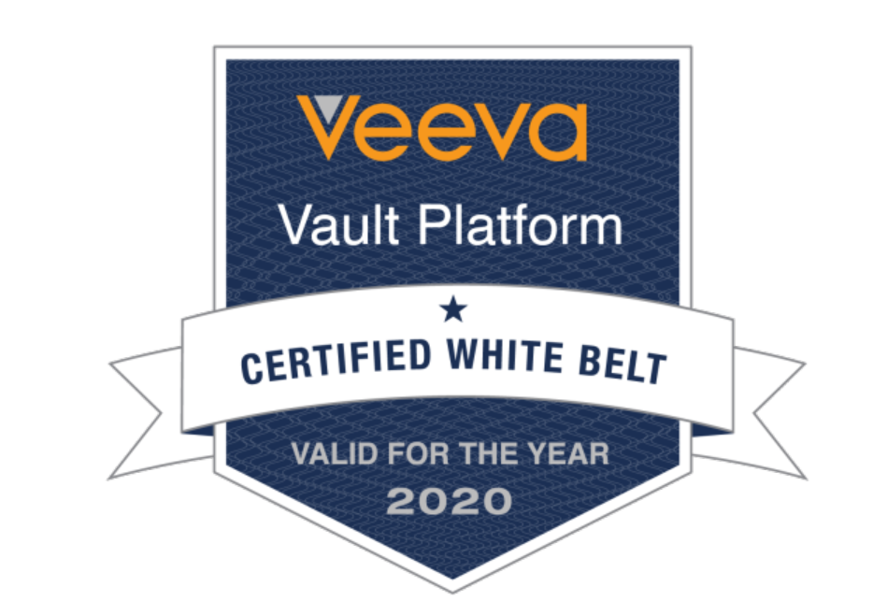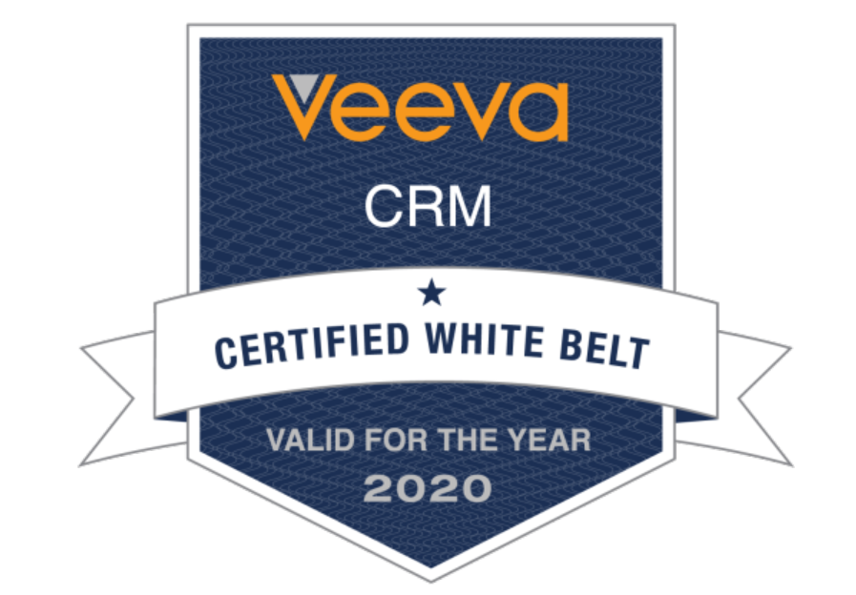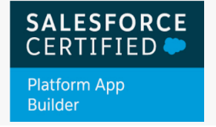 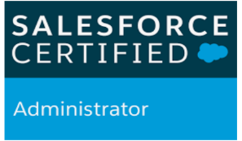

Full Name: Shubham Kumar Dapakara

Email address: dapakarashubh@gmail.com

Mobile No.: +15145699190

**Experience summary:**

* Having around 9 Years of experience in Configuration in Salesforce.com and VEEVA.
* **Went to Brazil for project improvement on Veeva.**
* Good understanding with Salesforce.com CRM and Veeva Management System.
* Having experienced in Reports and Dashboards.
* Working experience in Workflows, Approval process and Validation Rules.
* Good Knowledge in Veeva Configurations and Experience in Veeva
* Good Exposure in Apex Data loader in Veeva Systems CRM and Salesforce.com.
* Worked on CLM content and CLM migrating for different orgs in VEEVA Systems.
* worked on AutoRbit Salesforce migration tool to deploy the data from one box to another.

**Certification Details:**

* **App Builder**, **ADM 201** Certified Force.com Developer and Admin.
* **Salesforce Sales Cloud** Certified Consultant
* **Salesforce Service Cloud** Certified Consultant
* **Upgraded Veeva** CRM Administration Certified.
* **Veeva Vault** Administration Certified.
* Got Veeva Training on **Veeva Networks.**

**Professional Summary:**

* Currently working as Technical Lead at HCL CANADAfrom March 2020 to till date.
* Worked as Senior Consultant in HCL Technologies**,** Bangalore, India from July 2016 to Feb 2020.
* Past worked as, a Veeva Application Engineer in AstraZeneca INDIA PVT LTD, Chennai, India from March 2015 to July 2016.
* Past worked as,a Senior Software Engineer in CAPGEMINI INDIA PVT LTD, Bangalore, India from October 2012 to Feb 2015.

**Educational Profile**:

* B.E(72%) from Truba College of Engineering Indore in **2012**.
* SSC (71%) from V.V.H.S.School in **2008**.
* HSC (70%) from V.V.H.S.School in **2006**.

**Skill Set:**

CRM : Salesforce.com CRM, VEEVA Systems CRM

OOPS : Apex

UI : Visual Force Page

**Project 1**:

|  |  |  |  |
| --- | --- | --- | --- |
| **Project Name** | **Merck USHH, AH Global** | | |
| **Role** | Veeva Application Consultant | | |
| **Client** | **Merck Pharmaceuticals** | |  |
| **Duration** | July 2016 – Till date | | |
| **Team size** | **4** | **Module – US** | |
| **Environment** | **Tools** | **Veeva Systems, Data Loader, BMC Remedy, iRep application** | |

**Project Description**

This is a Maintenance (support and enhancement) project catering to Pharmacy domain. The scope is to provide application support to users of VEEVA. VEEVA CRM application is built on the Salesforce platform, designed specifically for the pharmaceutical and biotechnology industries. This project refers to the business and services provided by Merck.

Merck is using a Veeva CRM, the life sciences industry’s leading SaaS-based CRM solution.

Merck Sharp & Dohme, MSD outside the United States and Canada, is an American pharmaceutical company and is one of the largest pharmaceutical companies in the world. In the scope of this project- Veeva is a CRM which manages Market Representative Calls and sample management, in which user basically uses iRep.

**Contribution**

* Worked on Veeva configuration and administration.
* Analyzed business data, created data migration templates, executed data loading.
* Created documentation on all data migration work.
* Supported the team with technical solutions wherever possible.
* Creating objects, fields, validation rules, business process, and Email template.
* Proficiency in administrative tasks like Creating Roles, Profiles, Users, Email Services, Page Layouts, Workflows and approval process

**Project 2**:

|  |  |  |  |
| --- | --- | --- | --- |
| **Project Name** | **Astrazeneca Veeva CRM** | | |
| **Role** | Veeva Application Engineer | | |
| **Client** | **Astrazeneca** | |  |
| **Duration** | March 2015 – July 2016 | | |
| **Team size** | **6** | **Module – EU** | |
| **Environment** | **Tools** | **Veeva Systems, Data Loader, Service Now ,iRep appllication** | |

**Project Description**

Maintenance of CRM (Customer Relation Management) application built using SalesForce. Mainly it is used for Pharmaceuticals and Bio InfoTech organizations. Application was deployed for 65 countries (9 Regions) (divided into 8 Prod & Sandbox Environments)

**Contribution**

* Monitoring the Application.
* Providing the support to Users of application and User Training Issues.
* Alignment of accounts to user’s territory using Brick to Terr/Zip to Terr/Account Territory Loader.
* Managing user experience (licenses, profiles and permissions, restricting access using FLS, creating record types, page layouts).
* Introducing business logic (creating formula fields, cross object formulas and roll up summary fields)
* Building user interface (creating custom App, custom tabs and custom page layouts).
* I have been working on Veeva CRM application where I used to setup role hierarchy, territory hierarchy, creation of profiles for users ,workflow rules, approval processes, roll up summary fields, creation of custom reports ,creation of sandbox for the new hired training reps ,IREP , VMobile configuration, Veeva Messages, Key messages, setting, page layouts, addition of custom fields and relationship, product metric configurations, my accounts configuration, call management configuration, cycle plan configuration, sample management, territory management , loading of CLM content ,Migration of the CLM content management, CRM Insights ,creating dashboards and reports.

**Project 3**:

|  |  |  |  |
| --- | --- | --- | --- |
| **Project Name** | **BI CRM Application** | | |
| **Role** | Veeva System Supporting | | |
| **Client** | **Boehringer Ingelheim** | |  |
| **Duration** | June 2013 – Jan 2015 | | |
| **Team size** | **12** | **Module – 1 BI client** | |
| **Environment** | **Tools** | **Veeva Systems, Data Loader, BI Client Tool, BISM Tool,iRep appllication** | |

**Project Description**

Founded in 1885 by Albert Boehringer in [Ingelheim am Rhein](http://en.wikipedia.org/wiki/Ingelheim_am_Rhein), and headquartered in Germany.  The Boehringer Ingelheim group is one of the world's 20 leading pharmaceutical companies. Still headquartered in Ingelheim, it operates globally with 140 affiliates and more than 50,000 employees. The company's key assets of interest are respiratory disease, cardiovascular disease, Parkinson's disease, HIV, thromboembolic disease, cerebrovascular disease, oncology, diabetes, and hepatitis. Since it was founded in 1885, the family-owned company has been committed to researching, developing, manufacturing, and marketing novel products of high therapeutic value for human and veterinary medicine.

**Contribution**

* Designed, and developed the Custom objects, validation rules, Custom tabs, Components,

Sharing Rules to suit the needs of the users.

* Worked on various salesforce.com standard objects like Accounts, Contacts, Leads,

Opportunities, Reports and Dashboards.

* Created and deployed several reports for different user profiles based on the need in the

Organization.

* Created various Page layouts and configured Page layout assignments for various profiles based on record types.
* Performed CLM migration into Salesforce/Veeva application using apex data loader through CSV files.
* Interacting directly with clients and provide the solution.

Project 4:

|  |  |  |  |
| --- | --- | --- | --- |
| **Project Name** | **Philips-OneEMS** | | |
| **Role** | Sales force Developer, Supporting Team | | |
| **Client** | Philips | |  |
| **Duration** | Jan 2013- May 2013 | | |
| **Team size** | **6** |  | |
| **Environment** | **Tools** | **Salesforce.com, Apex, Visual Force Pages , Data Loader, HTML & Eclipse** | |

**Project Description**

This project comes under Philips Healthcare section for Event Management Solution. This project is used to develop a process for customer care for the medical devices provided by Philips. As a Philips customer he/she can contact the Philips customer care center via web, email, phone, direct contact (in person), etc. The system allows the users to identify the customers depending on the Functional Locations, where they brought the respective Assets. The Assets are linked with unique Account per each customer.

Cloud Computing is playing the Major Role of creation of services for this project. Here Services are integrated with Third Party tools like Cast Iron for integration purposes.

* Developed Apex Classes (controller), Visualforce Pages.
* Created various Page layouts and configured Page layout assignments for various profiles based on record types.
* Monitoring the application and analyzed the cases

Project 5:

|  |  |  |
| --- | --- | --- |
| **Project Name** | **Customer Experience Platform** | |
| **Role** | Sales force Developer | |
| **Client** | **Capgemini India Pvt. Ltd** | |
| **Duration** | Oct 2012 To Jan 2013 | |
| **Team size** | **8** |  |
| **Environment** | **Tools** | **Salesforce.com, Data Loader** |

**Project Description**

The purpose of the project is to develop an end-to-end product named customer Experian platform, which stores all customer information, feedback related to product/service in a system. Also integrated with account’s social sites like Facebook, twitter, google plus, tripit, foursquare and allow business to do segmentation on specific areas. And send survey to business/customers, capture response and analyze.

**Contribution:**

* Data migration involves-**bulk CSV import/export, data loading** with respective record field mapping.
* Customizing custom fields, transaction body fields, CRM fields, entity fields, item fields, transaction column fields, item options, field validations, sourcing, display properties, formula fields, identify the list record types, transactions, transaction record types.

**Declaration:**

I do hereby assert that, the information provided above are quite genuine and flawless one to the best of my Knowledge and belief.

Place: Montreal

Date: (Shubham Dapakara)