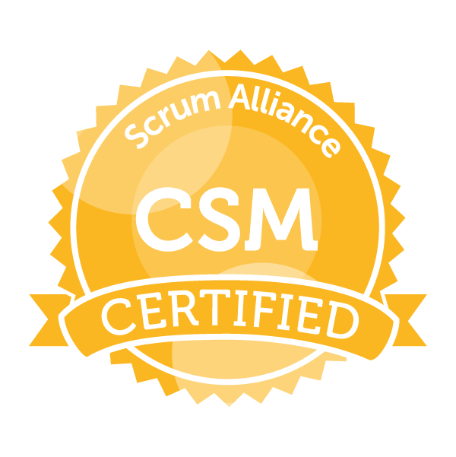 **Pravin Kadam**

Mobile: +91 8087316466/7972260376

Email - [kadam.pravin43@gmail.com](mailto:kadam.pravin43@gmail.com)

LinkedIn - <https://www.linkedin.com/in/prkadam/>

**_____________________________________________________________________________________________**

# Professional Summary

* **9+ years of work experience** in IT industry with expertise in Agile Methodology (Scrum), PHP, MySql , PostgreSQL, HTML, Javascript, Ajax, JQuery
* **Certified Scrum Master** having 5 years of experience as Scrum Master
* Working as a  **Technical Lead** from last five years.
* Well versed with Agile methodologies and have strong knowledge in SCRUM Framework.
* An expert in successful project implementation with proper management, scope containment and quality assurance.
* High initiative with strong self-management and communication skills.
* An expert in evaluating end-user requirements, troubleshooting for the applications, presentations & Error Resolution Technique.
* Coordination with Project Manager and Client for project requirements and scoping.

# Agile Scrum Master

* Gathering and updating project materials, completing budgeting, forecasting, project documentation, business flows, and lessons learned documents
* Scheduling and allocating work, providing advice and guidance, and resolving problems to meet technical performance and financial objectives
* Coordinate all Scrum Ceremonies including Sprint Planning, Daily Standups, Sprint retrospectives, Sprint Demos, Story Grooming, and Release Planning
* Coaching and mentoring other Scrum Masters on our program team. Partnering to ensure that our ways of working are consistent across teams
* Assist in defining and deploying new product development processes and in facilitating the continuous improvement of existing processes
* Coaching and mentoring other Scrum Masters on our program team. Partnering to ensure that our ways of working are consistent across teams
* Liaising between developers and project stakeholders; fostering quality communication between engineering disciplines

# Technical Competency

* Languages: : PHP, C#.net
* Sub Skills: : XML, HTML, Javascript, Jquery, Ajax, React JS
* Databases: : PostgreSQL, MySql5.0
* Web services: : Zoho API services
* MVC Architecture : Codeigniter, Fusebox
* API Integration : Zoho API Integration, Zoho Repots , PdfCrowd API Integration
* Software Skills : PHP Storm, Dreamweaver5, Visual Studio 5
* VCS : SVN, Bitbucket
* Domains : Accounting and Banking, Applicant Tracking System, Recruitment

# Professional Experience

# **Oct** 20**14** – **May 2021** DBXento Systems Pvt. Ltd. Pune ( **Technical** Lead/Scrum Master)

# **Jun** 20**21** – **Present** DBXento Systems Pvt. Ltd. Pune ( **Technical** Lead/Scrum Master)

* Leading scrum team consisting of 12 members to streamline a multifaceted compliance project
* Being a Scrum Master I am responsible for facilitating and monitoring the scrum processes and scrum meetings
* Increasing the team efficiency, motivating the team and resolving conflict
* Helping the team to clarify goals and actions to achieve them
* Shielding the team from distractions and interferences outside of the cross functional team
* Facilitates Daily Stand-Up, Sprint Planning, Backlog Grooming, Sprint Retro
* Work within the core delivery team empowered/tasked with design, development, modification, and implementation of computer applications, and building high performing delivery teams. Utilize project coordination expertise and tools such as Client Admin/Trello to support upstream and downstream teams throughout SDLC
* Develops and manages web development and support procedures, tools, and documentation. This includes writing scope documents, managing source code, and developing technical support standards and procedures
* Providing technical solutions to the development team by regularly reviewing their code using Code Phabricator & Bitbucket tool
* Deliver knowledge transfers to the new employees
* Actively participate in designing database schemas, code logic architectures
* Taking part in project requirement discussions and timeline management and task distribution along with team managers
* Doing analysis and unit testing of the tasks, following agile SDLC model, code reviews, code refactoring and standard maintenance
* Taking care of coding standards, introducing new things, notifying to-dos and not to-do’s to colleagues

**Feb 2012 – Sep 2014 Key Recruitment Solutions Pvt. Ltd. Pune ( PHP Developer)**

* + - Understanding the existing project setup & bringing the change as per the requirements raised by users.
    - Understanding software requirement specifications
    - Develops and manages web development and support procedures, tools, and documentation. This includes writing scope documents, managing source code, and developing technical support standards and procedures
    - Actively participate in designing database schemas, code logic architectures.
    - Taking part in project requirement discussions and timeline management and task distribution along with team managers.
    - Doing analysis and unit testing of the tasks, following agile SDLC model, code reviews, code refactoring and standard maintenance
    - Taking care of coding standards, introducing new things, notifying to-dos and not to-do’s to colleagues

**Project Details**

|  |  |
| --- | --- |
| **Employer:** | **DBXento Systems Pvt. Ltd., Pune** |
| **Project Name:** | Entrata Core ( Property Solutions ) [https://www.entrata.com](https://www.entrata.com/) |
| **Duration** | February 2014 – present |
| **Environment** | PHP, PostgreSQL |
| **Tools** | PHP Storm, SVN, SQL Manager, Phabricator |
| **Project Description** | This is the US based product of the company which deals with the renting of the properties. It includes accounting, residents, late notices, leads, etc. Accounts Payable is a part of Entrata core software. All the transactions related to Invoices, Purchase Orders, Journal Entries, Check etc. are managed through AP system. The Accounting module automates entire process of accounts payable (AP) and provides hassle free flow of accounting practices. Clients can track their financial activities with the help of AP system. It provides user friendly UI, accountants specific customizations and on demand changes. |

|  |  |
| --- | --- |
| **Employer:** | **Key Recruitment Solutions Pvt. Ltd. Pune** |
| **Project Name:** | Easyweb ATS |
| **Duration** | February 2013- September 2014 |
| **Environment** | PHP5, MySQL |
| **Tools** | Zend Studio, Dreamweaver, Xampp (MySql), Worked on zoho web services |
| **Project Description** | Easyweb ATS is an easy-to-use Applicant Tracking System and Recruitment Software that helps staffing agencies and recruiting departments track job openings, resumes, candidates and contacts more quickly and efficiently. |

|  |  |
| --- | --- |
| **Employer:** | **Key Recruitment Solutions Pvt. Ltd. Pune** |
| **Project Name:** | Lead Database |
| **Duration** | August 2012- January 2013 |
| **Environment** | PHP5, MySQL |
| **Tools** | Zend Studio, Dreamweaver, Xampp (MySql), Worked on zoho web services |
| **Project Description** | Lead database is the utility which extracts data from Visual Web Ripper and exports it into MySQL database with different tables. Each table is referred as ‘lead’. These all leads are then filtered with specific criteria’s and transferred to the main Lead database |

# Educational Qualification

|  |  |  |  |
| --- | --- | --- | --- |
| **Qualification** | **University** | **Percentage** | **Year** |
| Master of Computer Science (M.Sc.) | University of Pune | 59% | 2011 |
| Bachelor of Computer Science (B.Sc.) | University of Pune | 63% | 2009 |
| H.S.C | Maharashtra Board | 55% | 2006 |
| S.S.C | Maharashtra Board | 70% | 2004 |

# Achievements

* Certified Scrum Master (CSM) | External - 2021
* Completed PHP Certification- Ninja | Internal – 2019.
* Completed PostgreSQL Certification- Ninja | Internal – 2019
* Got two Bronze Badges for achieving 100% sprint for consecutive 3 sprints by maintaining same or above the velocity of the first sprint

* Participated in Xento Premier League(XPL) 2015 and 2016.
* Employee of the month Awards, September 2013
* Played cricket at school lever for 3 years from Sau. Vimalabai Garware High School.
* Played intercollegiate volleyball for 2 years

# Personal Details

|  |  |
| --- | --- |
| Date of Birth | 21st September 1988 |
| Father’s name | Mr. Prakash D. Kadam |
| Languages Known | English, Hindi, Marathi |
| Nationality | Indian |
| Present Address | 210/1A, Erandawana, Ganeshnagar, Pune 4 |

Place :

Date :

Pravin Kadam