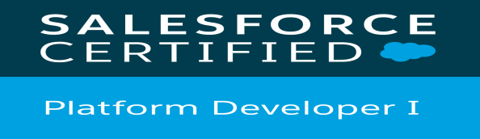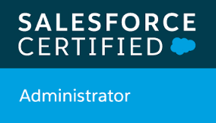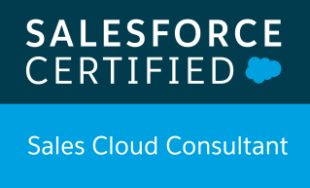

Akrati Jain

+91-9158075937
Akratijainak2023@gmail.com

Profile Summary:
- 3.11 Years of Total IT Experience.
- 3 Plus Years of Experience as Salesforce Developer.
- Proﬁcient in creating proﬁles, permission sets, roles and sharing rules.
- Proﬁcient in process automation which includes Process Builder, Workﬂow rules, Approval processes.
- Experience in creating Apex Triggers, Visual force pages and classes for different use cases.
- Experience in implementation/development using Lightning Aura Components, Apex, Visualforce pages, Classes, Controllers, Triggers, VF and Custom objects, SOQL and SOSL.
- Working Experience on Salesforce Conﬁguration, Customization and Integration using REST and SOAP .
- Actively involved in Analysis, Coding, and Testing.
- Good Analytical and Programming skills.
- Experience in Data loader and using Workbench.
- Working Experience of Lightning Aura component.
- Working Experience of reports and dashboards.
- Working Experience in using Visual Studio Code for LWC.
- Working Knowledge in developing LWC.

Highlights:
- Developed SF based Lightning Application on Force.com Platform in Salesforce.com environment with Apex programming language, Visual Force and Lightning Aura Components.
- Analysis of user stories and task and providing technical approach for implementing functionality.
- Implemented and delivered multiple user stories and task specified in sprint.
- Followed all standard practices while implementing functionality.
- Attended Salesforce Lightning Workshop.

Work Experience:
- October 2016 – January 2019 – Tata Consultancy Services- Salesforce Developer
- February 2019 –Present- Yash Technologies Private Limited
Technical Skills:
Languages: | Salesforce Apex and VisualForce, JavaScript, HTML , Core Java, Salesforce Lightning
Platform: | Windows 7, Cloud
Technologies: | Salesforce, Force.com, Apex, HTML, CSS
Software/Tools: | Eclipse, JIRA, Dataloader

Certification:

- Salesforce ADM 201
- Salesforce Platform Developer 1
- Salesforce Sales Cloud Consultant

Work Experience:

Client | Bank of Montreal
Project Title: | SFDC Phase 1 Migration Project
Company Name: | TCS, Pune
Organization | Tata Consultancy Services
Team Size: | 5
Role: | Salesforce Developer
Description: | US Commercial Banking/Business Banking & Corporate Finance Division(CFD) was having multiple CRM Platforms. So it included integration of multiple CRM platforms into single and migration to a Salesforce CRM Solution, Salesforce real time integration with Outlook, Data Migration from Oracle CRM, Creation of pre-defined and adhoc reports and an automated email distribution solution, Ability to import Client data, Single Sign on by using both Configuration and Customization.
Environment: | Salesforce Lightning: Apex, Visual Force with Slds styling, JavaScript
Roles & Responsibilities: | - Direct Interaction with customer for requirement gathering and to showcase implemented functionality.  - Developing VF pages and Apex code and corresponding test class for assigned stories.  - Implementing Configurational changes and Process Automations.  - Perform Unit Testing for implemented module.  - To validate and deploy change set on production org.  - Creation of Reports and Dashboards.

Client | Bank of Montreal
Project Title: | Commercial Finance Division (SFDC Phase 2)
Company Name: | TCS, Pune
Organization | Tata Consultancy Services
Team Size: | 4
Role: | Salesforce Developer
Description: | CFD BMO Sales is Migration of the existing CFD Users & historical data on the CFD Salesforce instance. It Included French Translation, Additional functional capabilities required by CFD using Customization and Configuration. Creation of predefined Reports and Dashboards required by CFD.
Environment: | Salesforce Lightning: Apex, Visual Force with Lightning Design System, JIRA
Roles & Responsibilities: | - To attend scrum call with customer for requirement gathering and to showcase implemented functionality.  - Implementing Configurational changes and Process Automations.  - Developing VF pages and Apex code and corresponding Test class for assigned stories.  - Perform Smoke and Unit Testing for implemented module.  - Creating, Validating and Deploying Changesets in Production Org.  - Creation of Reports and Dashboards.  - Monitoring and Maintenance of Application.  - Successful Application management and improvement on the performance of Delivery.  - Worked on Major Requirement For TPS Redesign.

Client | John Deere
Project Title: | Salesforce CRM
Company Name: | Yash Technologies Private Limited
Organization | Yash Technologies Private Limited
Team Size: | 1
Role: | Salesforce Developer
Description: | John Deere has launched More Tools page within Operations Center application. More Tools is for them to show connectivity to Operations center and offer link to the products delivered by third party software companies. Salesforce to More Tools Integration is major part of Project. Internal Reporting Requirements are also the part of Project.
Environment: | Salesforce Lightning: Apex, Visual Force, Lightning Components
Roles & Responsibilities: | - Worked on developing Lightning Components.  - Worked on Rest Integration.  - Worked on Triggers, Batch Classes and Test classes.  - Creating, Validating and Deploying Changesets in Production Org.  - Perform Smoke and Unit Testing for implemented module.  - Implemented Validation rules, Workflows, Formula Fields as per the Requirement.

Awards:

- On the Spot Award for contribution in Successful implementation of SF Phase-1 in TCS.
- Pat on the Back Award for Understanding and Implementing all the requirements rigorously in John Deere Project in Yash Technologies.

Qualification:

Course /Degree | University/Board | Year of Passing | Percentage
Bachelor of Engineering  (Information Technology) | Shri Vaishnav Institute of Science and Technology | 2016 | 8.21 CGPA
Standard XII / H.S.C. | Premier Children Higher Secondary School | 2011 | 81%
Standard X / SSC | Bharat Mata English Medium School | 2009 | 88.5%

