**MAMTA PARYANI**

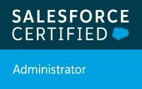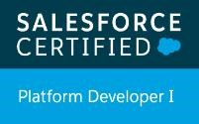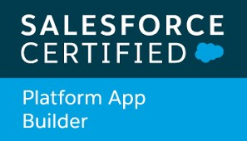

+91 8796426910 mamtaparyani283@gmail.com

[Type text] [Type text]

# Profile Summary

* Serving notice period. LWD : 12th May
* 2.6 year of experience as Salesforce Developer in Accenture.
* Salesforce Certified Administrator.
* Salesforce Certified Platform App Builder Certification.
* Salesforce Certified Platform Developer 1.
* Copado Certified Administrator.

# Professional Experience

**Accenture Salesforce Developer October 2018 -Till Date**

* Working as a Salesforce Developer for an American multinational analytics and technology client.
* Have an idea on Salesforce.com services: Sales Cloud.
* Worked on ERP based managed package like Financial Force PSA.
* Currently working on a Vaccine Management Project in Aura components.
* Responsible for creating new functionalities and enhancing the existing ones for the end users.
* Experience in Apex classes, Test classes, Batch Apex, custom user interfaces with Visualforce, Custom controllers.
* Creating and Updating Data Models, Custom Objects, Workflow, Approval Process, Custom Metadata, Email templates etc.
* Creating formula fields, roll up summary fields, sharing rules, roles, profiles, settings, reports, dashboards etc.
* Performing unit testing on the newly created functionalities.
* Hosted daily updates and performed regular demos to key stakeholders and oversaw monthly releases and projects using Nova Suite and PM fixes.

# Academic Achievements

|  |  |  |  |
| --- | --- | --- | --- |
| **Degree** | **Year** | **Institute, University/ Board** | **% /CGPA** |
| BE, (IT) | 2014-2018 | Sinhgad Institute of Technology and Science, Pune | 72% |
| H.S.C. | 2012-2014 | Pemraj Sarda College, Ahmednagar (Pune University) | 64% |
| S.S.C. | 2010-2011 | Sacred Heart Convent School, Ahmednagar (Pune University) | 92.36% |

# Academic Projects

* Car Management System: Developed system which performs add, delete, search and update operations. In order to maintain detailed information of car showroom, this system can store the details about the status of various cars and their availability.
* Final year major project: Image Recognition System using Image Processing: The system is based on image processing and makes the process easy and user friendly to recognize all kind of banknotes.

**Languages worked on**

* Apex, SOQL, Java, Html, Css, C++, C, SQL.

# Other Activities

* ABACUS - Secured 4th place at state level Abacus competition.
* CODESENSE - Participated in C/C++ coding competition in college. • Volunteered in technical events in college.

# Skills, Strengths And Competencies

* Highly motivated, Team oriented
* Strong business communication skills

