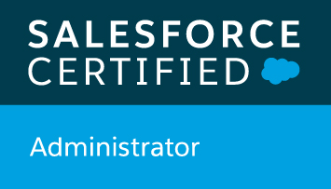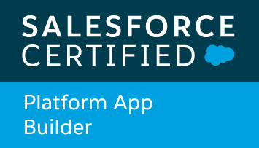 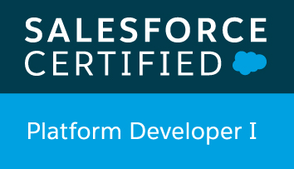

**Akanksha Chakradhar** Salesforce Developer

9538766652 || [chakradharakanksha@gmail.com](mailto:chakradharakanksha@gmail.com) |<https://www.linkedin.com/in/akankshachakradhar6a27533a/>

# Profile Summary

|  |  |
| --- | --- |
| * 7.8 years of Development and techno functional experience in Oracle Knowledge application development and Salesforce Lightning (2.5 years) * Design, code, and support solutions to meet business needs in Salesforce, including configurations, customizations and integrations * Strong working knowledge of APEX (classes and web services), Triggers, Visual Force, SOQL, Lightning Components. * Experience in customizing UI using Aura and LWC components and controllers. * Worked on integrating SFDC with external systems using Platform Events, Apex Rest and Outbound Messages. * Extensive understanding of Salesforce.com Service cloud concepts including case management and related functionalities including solutions and field service. * Proficiency in Salesforce administrative tasks like creating Roles, Profiles, Users, Page Layouts, record types, and FLS management management for complex business requirements for a wide range of profiles and users.. * Experience in Inquira Integration,Implementation,Configuration, Production support and maintenance.(OKM 8.6). |  |

# Experience

|  |  |
| --- | --- |
| Application Development and Support | **01/2018-Current** |

**Dell Technologies**

***Project – Salesforce Lightning Service Cloud/OKM upgrade***

Role – Developer

* Service cloud implementation: - Configured and customized Salesforce standard and custom objects and fields, Escalation rules, Assignment rules, Approval Processes as per business needs.
* Developing APEX classes, Triggers, SOQL, and lightning components.
* Developed SOAP and REST based Web services in Apex. Exposed external REST services, Platform Events in Apex code to integrate external systems
* Activities included, business analysis and meetings with different departments, write Apex code, custom Visual force pages, triggers, test classes, reports, dashboards, develop data integration solution to transfer data between database servers and Salesforce.com.
* Created Validation Rules, Workflows , Process Builders and Flows.
* Customizations using CSS and JavaScript in Aura and LWC Components.
* Enabled SSO using SAML for SFDC system in coordination with Identity Provider.
* Coordinating with Multiple dependent teams such as Middleware, connected social media apps for Integration related issues with Salesforce.
* Worked on record types, page layouts and FLS management for complex business requirements for a wide range of profiles and users.
* Resolution of bugs/defects from both functional and technical stand points

**IT Analyst 12/2015-12/2017**

**NCR Corporation India Pvt Ltd.**

***Project –* Oracle Knowledge Upgrade/Performance Improvement/Production Support/Responsive UI**

Role- Developer

* Identified the bugs with the newer version of OKM and get the workaround/fix from Oracle.
* Post-release support.
* Analyze the existing infrastructure and integration points.
* Involved in Quarterly Dictionary tuning activity required to optimize search results.
* Involved in migration project. (Migration from legacy system RKS to OKM).
* Optimizing the performance by making changes in the configuration.
* Leading calls with business on production issues and providing updates.
* Performed all testing related to responsive UI implementation.
* Trained users on OKM application.



|  |  |
| --- | --- |
| Programmer Analyst | **04/2013-12/2015** |

**Cognizant Technology Solutions**

***Project –* Café- (Commercial Agent’s Front End)**

Role – Developer

* Worked in Agile Scrum Methodology which involved 3 weeks Sprint.
* Involved in all phases of the software development life cycle (SDLC) including the requirements analysis, Low level design, development, testing, deployments, Integration.
* Performed stub generation activity to consume web services, created wrapper classes, and mapped the wrappers to the service calls in Answer Flows.
* Development of Processes in Answer Flow Editor, deploying them.
* Complete ownership of Change Requests (majority in AF, IC and IM components) from Requirement analysis, design, Coding, testing to Demo for client.
* Coding for bringing about modifications/enhancements in existing JSPs and also creation of new ones.
* Creation of documents in Information Manager.
* Fixes for production issues and various bugs inby performing root cause analysis.
* Involved in higher environment build and deployment activities (QA,STAGING and UAT).
* Adhering to the processes set by client (currently using Rally tool for Scrum) during development.
* Interacting directly with Business, Designers, Scrum Master, Developers, Technical Support and try to base line the requirement specifications and resolve project issues.

**Project – OKM COE Explorations**

Role – Developer

* Installation of OKM components on Windows : Local installation of all OKM(8.5.1) components on Windows, basic customization for POCs.
* AF integration with IC **:** Exporting the AnswerFlow Editor data into Runtime and customizing the Infocentre code to make the Answer Flow Processes available on InfoCentre.
* Install and deploy AF Editor, Runtime and SampleUI.
* Customizing the JSP files in the IC codebase to integrate with AnswerFlow Sample UI.
* Customize the InfoCenter.

# Technical Skills

* **Product Expertise :** Salesforce Lightning (Service Cloud), Inquira 8.5(OKM), OKM 8.6,
* **Programming Languages:** Java (Core), Apex
* **Web Technologies:** Java Web Services, HTML, JSP, JavaScript, JSON, VisualForce, Lightning
* **Databases:** ORACLE
* **Operating Systems:** Windows, LINUX
* **Webservers:** Apache Tomcat, Oracle Weblogic

### Tools and Utilities: Eclipse, JIRA, SVN, Putty, WinSCP, ALM, Rally, Visual Studio IDE

# CERTIFICATIONS

* Salesforce Platform App Builder
* Salesforce Platform Developer 1
* Salesforce Administrator
* Oracle Certified Java Developer (1Z0-851)

# PERSONAL DETAILS

D.O.B: Aug 28,1990

Marital Status: Single

**Akanksha Chakradhar**