Ritik Ashok Chotelal
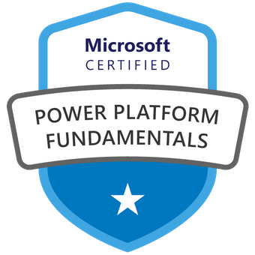
SharePoint and PowerApps Engineer.
Email: - Chotelalrithik1997@gmail.com, Phone:- 7055736521

Current location: Gachibowli, Hyderabad

Professional Summary
Overall, 2 + years of IT experience in SharePoint Online, Power Apps,
Power Automate, PowerShell and SharePoint/ OneDrive Migration. Have attitude to work hard, continuously improve by taking feedback from leads and colleagues.

Technical Certifications
PL-900: Microsoft Power Platform Fundamentals [Microsoft Office 365].

Skills
- PowerApps  - Power Automate  - InfoPath Forms  - PowerShell | - SharePoint Online  - SharePoint Migration  - Python  - Html and CSS

Experience

March 2023 - Present

Power platform developer, Overture rede private limited

OCT 2021 – Feb 2023

Associate software engineer, techdimension It solutions

Project Details
Project 1 - Client: Sub-contractor in Nokia
PROJECT Description: Converts all the excel works into apps with the help of Power Automate for automation.

Role: - PowerApps/ Power Automate Developer

Project Scenarios: -
- Created a flow which can run office script in excel
- Sending mail with deep linking of Created file.
- Conditional Rendering / Validation
- Cascading Dropdown
- Alerts
- Multiple connectors

Project 2 - Client: Infosys
PROJECT Description: - Development of Power Apps, automate including Managed/ Unmanaged solutions

Role: - Power Apps, Automate Engineer

Responsibilities:
- Development of solutions (Managed/unmanaged packages)
- Enhancement of existing Power Apps/ Automate

Project 3 - Client: A Major Children’s Hospital in US Midwest
PROJECT Description: Redeveloped 4 Complex InfoPath forms to PowerApps and 1 SPD Flow to Power Automate

Role: - PowerApps/ Power Automate Developer

Apps Scenarios: -
- Created PDF using power automate flow
- Multiple roles
- Conditional Rendering / Validation
- Cascading Dropdown
- Alerts
- Multiple connectors

Project 4 - Client: A Major Children’s Hospital in US Midwest
PROJECT Description: Migrating the content from on-prem SharePoint 2013 to SharePoint online, size of OneDrive content around 3.5 TB, 100 + sites (Teams and Communication)

Role: - Migration Engineer

Responsibilities:
- Handled Migration of the content from on-prem SharePoint 2013 to SharePoint online site
- Remediation for Migrated content in target
- Execute the script for user mapping

Project 5 - Client: A Healthcare Technology leader in USA
PROJECT Description: - Migrating the content from SharePoint online site to SharePoint online and OneDrive of all 150 users, Size of data 2 terabytes.

Role: - Migration Engineer

Responsibilities:
- Handle Migration of the content from SharePoint online to SharePoint online
- Remediation for Migrated content in target
- Execute the script for read-only in Source tenant

Project 6 - Client: A major alcoholic beverage company from Australia
PROJECT Description: - Migration the Source Teams to Target Teams tenant

Role: - Migration Engineer

Responsibilities:
- Handling Migration of the teams
- Remediation for Migrated teams in target
- Verify team channels

ACHIEVEMENTS
- Member of NSS

- Runner Up in Intercollege Group discussion

- Student head in hospitality department in international conference day

Place: Noida (Ritik Ashok Chotelal)

