**Shilpa Sahu**

Mobile:9010602716, 9407455488

Email id**:** [shilpa.sahu3010@gmail.com](mailto:shilpa.sahu3010@gmail.com)

**Professional Summary**

Carrying 5 years of experience in content writing, editing, marketing and research. Developed a full range of content, including website content, whitepapers, case studies, blogs, email marketing, newsletters, corporate communication, press releases, infographics and social media.

**Skills**

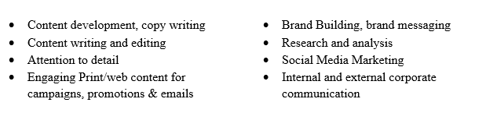

**Work Experience**

Working as a **Senior Marketing Content Writer** at **Innovapptive Inc,** (An SAP Partner)fromAug 2017 to till date

* Research and create with SEO in mind to expand the content reach
* Develop copy for blogs, case studies, white papers, emails, sales and website
* Edit, proofread and improvise print and digital content
* Write Social Media content e.g. Twitter, LinkedIn, Facebook, Glassdoor
* Work creatively with marketing team to create compelling documents
* Work closely with Product Mangers, developers to gather product and customer knowledge to execute projects

Worked as **Content Writer** @ **Synactive India Pvt Ltd** (SAP Partner)from2016 to Aug 17

* Wrote professional and creative content for eBook, Case Studies for Client, Process Flow brochures for IT products, Website, Product launch, Promotion, Infographics
* Developed content for Company/Brand portfolio, Website’s landing pages, Newsletters, Consumer friendly PDF file, Email Marketing, Internal case studies for sales teams.
* Assigned the tasks of writing product descriptions, user manual and getting started kit
* Handled social media branding/marketing during SAP events, TechEd and many more
* Involved in marketing strategy planning, events of the company and providing a walkthrough of all products of the company.

Worked as **Content Writer** @ **E-prospects Ltd.** from June 2015 to 2016

* Created Newsletters, provided content for email marketing, social media marketing, online portals, & Facebook campaigns
* Was responsible for conducting research and writing content on a regular basis
* Handled the task of editing and proofreading content before uploading it on web pages
* Wrote quality & creative content on IT products, Insurance, Finance, Legal Market & offer of the Month

Worked as aStaff Writer@ **Global Data** fromFeb2014 to May 2015

* Performed research on different topics/countries/products & wrote content for external clients, companies, and products
* Analyzed and interpreted findings by breaking down data
* Contributed to content idea generation for publications
* Uncovered newsworthy stories, Press Release, Company’s corporate communication

**Educational Summary**

* Master of Business Administration MBA (IT & HR) from DAVV University, Indore, 2012
* Bachelor of Engineering in Computer Science from RGPV University, Indore, M.P, 2009
* XII from School for Excellence, Chhindwara, M.P, 2005
* X from SVM, Chhindwara, M.P, 2003

**Personal Details:**

* Name: Shilpa Sahu
* Father’s Name: Shri K N Sahu
* Date of Birth: 30/10/1986
* Current Address: Near Madhapur PS, Kauvri Hills, Hyderabad

**Declaration:**

I hereby declare that the above-furnished information is best of my knowledge.