Azure & DevOps
Name: K . Karthikeyan 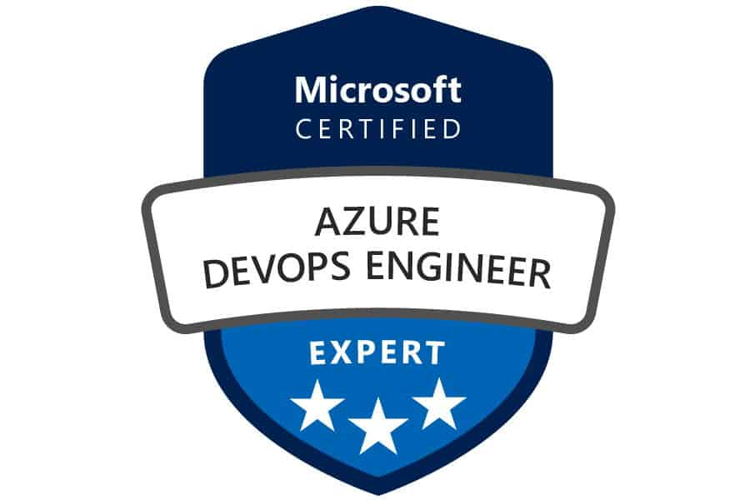
Email: kkarthikkannan22@gmail.com
Contact No :+91- 6381746306

Objective:

Having experience of 3 years in IT industry and 3 years relevant experience in Azure and DevOps Engineering automating, building, deploying and releasing code from one environment to another environment.

Work Experience:

- Creating and Managing Azure resources as per the Infrastructure requirement.
- Automating the Azure deployment using Jenkins multi branch pipeline.
- Configuring Azure Virtual Network, NSG and Traffic manager.
- Configuring Virtual Network Peering.
- Worked on Azure PaaS solutions like Azure Web Apps, Function app, Cosmos DB.
- Configuring Azure API management service and hosting backend API’s and the operations in API Management service. Customizing the Azure API management Developer portal.
- Integrating the Azure API management with AWS Cognito for authentication.
- Deploying the Python code to Azure APPS service by creating a Docker image.
- Developed Terraform modules for resources like VM, Data Bricks,etc.
- Build servers in App Services, creation of additional data volumes, RDS, creating security groups, load balancers in the defined virtual private connection.
- Responsible for creating monitors, alarms, and notifications for all resources in across environment.
- Worked on Code commit and branching strategies from local machine to GitLab.
- Worked on Azure Kubernates Service like deploy Micro services deployment
- Intensive reporting to prepare Updates, and Final Reports.
- Worked on automate key rotation in storage account and cosmos DB.

Company Details:

Period | Company | Position
June 2019 to till date | GloSoft Technologies | Azure, DevOps

Contribution and Responsibilities:

Activities performed:

- Build and Deploy infrastructure using Jenkins tool through Terraform.
- Worked on Data science Model.
- Configuring NSG, VPN and NSR in Azure.
- Azure Cloud Extensive knowledge of networking and building Servers.
- Hands on experience in scaling and resizing of services instances like compute and database.
- Building pipeline and configuration in Azure Data Factory.
- Worked on Azure Data lake service for Data Warehouse.
- Troubleshooting issues on ADF, HDInsight Cluster and Analysis tool.
- Troubleshooting batch job issue in ADF pipeline.
- Worked Azure DevOps CI/CD.
- Worked JIRA for ticketing management.
- Involved RBAC management on resource level.
- Worked on ACL issues and access issues.
- Assigned SPN access for across resources.
- Being a part of Change Management process, responsible for installing hot fixes on ADF whenever necessary, as defined by the Change Management.

Contribution and Responsibilities:

- Creating and Managing Azure resources as per the Infrastructure requirement.
- Automating the Azure deployment using Jenkins multi branch pipeline.
- Configuring Azure Virtual Network, NSG and Traffic manager.
- Configuring Virtual Network Peering.
- Worked on Azure PaaS solutions like Azure Web Apps, Function app, Cosmos DB.
- Configuring Azure API management service and hosting backend API’s and the operations in API Management service. Customizing the Azure API management Developer portal.
- Integrating the Azure API management with AWS Cognito for authentication.
- Deploying the Python code to Azure APPS service by creating a Docker image.
- Developed Terraform modules for resources like VM, Data Bricks,etc.
- Build servers in App Services, creation of additional data volumes, RDS, creating security groups, load balancers in the defined virtual private connection.
- Responsible for creating monitors, alarms, and notifications for all resources in across environment.
➢ Worked on Code commit and branching strategies from local machine to GitLab.

Project Details:
Client: Office Depot
Period: June- 2019 to Till
Description:
The ODP Corporation is an American office supply holding company headquartered in Boca Raton, Florida. The company has combined annual sales of approximately $11 billion, and employs about 38,000 associates with businesses in the United States.

Roles and Duties:
- Creating and Managing Azure resources as per the Infrastructure requirement.
- Worked Azure DevOps CI/CD.
- Worked JIRA for ticketing management.
- Automating the Azure deployment using Jenkins multi branch pipeline.
- Configuring Azure Virtual Network, NSG and Traffic manager.
- Configuring Virtual Network Peering.
- Worked on Azure PaaS solutions like Azure Web Apps, Function app, Cosmos DB.
- Configuring Azure API management service and hosting backend API’s and the operations in API Management service. Customizing the Azure API management Developer portal.
- Integrating the Azure API management with AWS Cognito for authentication.
- Deploying the Python code to Azure APPS service by creating a Docker image.
- Developed Terraform modules for resources like VM, Data Bricks,etc.
- Build servers in App Services, creation of additional data volumes, RDS, creating security groups, load balancers in the defined virtual private connection.
- Responsible for creating monitors, alarms, and notifications for all resources in across environment.
- Worked on Code commit and branching strategies from local machine to GitLab.
- Worked on Azure Kubernates Service like deploy Micro services deployment
- Intensive reporting to prepare Updates, and Final Reports.
- Worked on automate key rotation in storage account and cosmos DB.

PERSONAL DETAILS:

Name : K. Karthikeyan
Father Name : Kannan
Date of Birth : 27/01/1997
Sex : Male
Marital Status : UnMarried
Nationality : Indian
Religion : Hindu
Language Known : Tamil and English

DECLARATION:

I hereby declare all the information furnished above is true and correct to the best of my knowledge and belief.

Place: Chennai
Date:
Karthikeyan K

