Swapnika Chandra 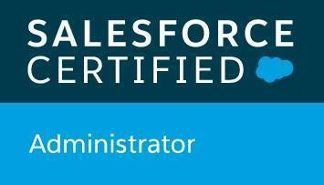 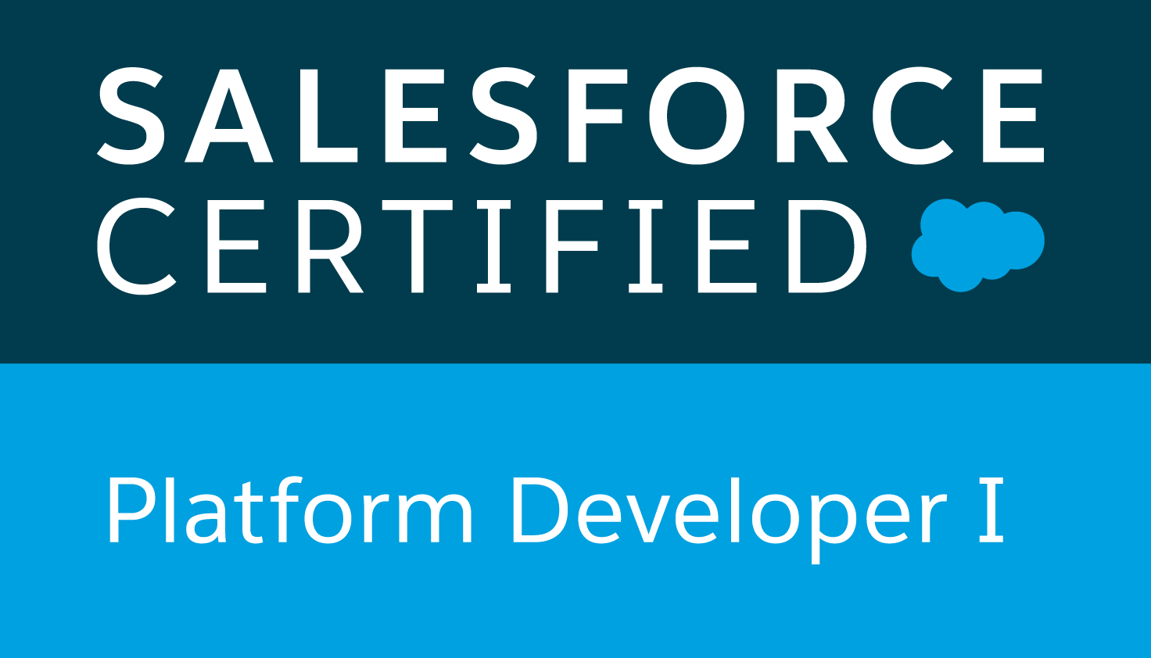

# **2X Certified Salesforce Developer**

www.linkedin.com/in/g-swapnika | 3145327012 | nika.salesforce@gmail.com

# **Professional Summary:**

* **Certified Salesforce Professional** with **8+** **years** of experience in the IT industry and **6+ years** of experience in **Configuring, Implementing, Developing, Customizing, Testing, Deploying** and **Integrating** Salesforce CRM Applications.
* Expertise in performing **Salesforce Administrative Tasks**: Organization Setup, User Management, Lead/Contact/Opportunity Management; creating or customizing objects/fields/tabs, Users, Profiles, Permission Sets, Roles, Groups, User Queues, Quick texts, Quick Actions, Page Layouts, Reports & Dashboards and achieving **Process Automation** through Workflows, Lightning Flows, Approvals and Process Builder.
* Professional in **Implementing, Developing** and **Customizing** Salesforce CRM applications with the help of Visualforce Pages/Components, APEX Classes, Controllers, Triggers, Classes, SOQL, SOSL, DML Statements, Apex Collections and Salesforce APIs through Developer Console, Eclipse with Force.com Plug-ins.
* Good understanding of **Lightning Component Library and SLDS classes (Lightning Design System)**; integrated custom-built **Lightning Web Components** and replaced existing **Aura Components** on the Salesforce platform using Lightning Component Framework, **modern web stack** (modern JavaScript, HTML, CSS) and native web browser engine.
* Implemented two-way Integrations using **REST & SOAP** based **web service APIs** to allow external Java based applications invoke Apex classes & methods.
* Expertise in Organizing / Conducting **Brainstorming**, Joint Application Development (JAD), and Steering Committee sessions with the project team along with the Stakeholders to gather required functional details, future vision and to get project approvals.
* **Integrated Data sources** (Applications) with salesforce CRM for building the holistic 360* view for any data source for typical dashboard view. Not limited to salesforce CRM.
* Designed, implemented the **Bulk & Rest API integrations** for exporting & importing the data from salesforce CRM to DownStream Applications (Two-way Integrations).
* Professional in Documenting Use Cases, **Business Requirement Document (BRD),** System Requirement Specification (SRS), Test Requirement Documentation (TRD) and Requirements Traceability Matrix (RTM).
* Expertise in **designing/developing** Test Scenarios, Test Plans, Test Cases, Test Scripts and Test Data by working closely with the QA **team** to meet the functional requirements of the project.
* Experienced in handling Salesforce **data import/export** through Salesforce **Data Loader and** **Import Wizard.**
* Professional in **Integrating/Deploying** Salesforce to other platforms like Oracle, AWS, and Microsoft applications by using **REST, SOAP** Technologies.
* Experienced in implementing Salesforce **Continuous Integration** and **Continuous Deployments** setup using **ANT Migration tools**, also got experience doing deployments using Change Sets, Eclipse IDE, AutoRabbit tools.
* Successfully controlled the different versions of the projects using version control tools Ex: **Bitbucket and GitHub.**
* Ability to work and meet deadlines without immediate supervision, demonstrate a strong attitude to achieve team goals, always willing to run the extra mile and follow a purposeful approach to problem solving.

# **Technical Skills:**

* **Force. Com**: APEX, Classes, Triggers, Visualforce, Controllers, Lightning Components, Lightning App Builder APEX Testing, Debugging, SOQL, SOSL, DML Statements, Workbench, Lightning Application.
* **Salesforce CRM Functionality**: Sales/Service Clouds, Users, Profiles, Permission Sets, Record Type, Email Templates, List Views, Queues, Groups, Workflows, Validations, Approvals, Process Builders, Login policies, Monitoring, Live Agent, Chatter, Call Center.
* **Salesforce Integration**: Salesforce Lightning Connect, Salesforce APIs: REST, SOAP, Tooling, ETL, and ESB.
* **Sandboxes & Deployment**: Developer, Full, Change Sets, Eclipse IDE, Force.com ANT Migration tool, and Packages.
* **Languages & Databases**: APEX, Visualforce, SQL, AWS, Java, HTML, CSS, Java Script, MongoDB, SQL server 2016.
* **Frameworks & Tools**: Agile, SCRUM, Sprint Cycle, Junit, jQuery, JIRA, Developer Console, Eclipse IDE, Workbench and Informatica.
* **Version Control & Management**: GitHub, Sandbox, Bit Bucket.
* **Industries**: Health Care, Banking, Digital Services, Insurance and Automotive.
* **Network**: Ubuntu Linux, Wireshark, VMware, Windows server 2012 r2, VLAN, VPN
* **Collaboration/Presentation**: WebEx, GoToMeeting, Zoom, Prezi, Screen – O- Matic, Slack, Skype, and MS Office

# **Certifications:**

* **Salesforce Certified Administrator (201) Credential ID -** 21615986
* **Salesforce Certified Platform Developer I (401) Credential ID -** 21703032

# **Professional Experience:**

**Client: Blue Cross Blue Shield of Michigan, Detroit, MI**

**Title: Sr. Salesforce Developer April 2020 – Present**

## **Responsibilities:**

* Part of a team which is responsible to **implement, develop, customize, test, deploy** and **integrate** the salesforce Sales cloud, Service cloud applications by ensuring it meets business needs.
* Gathered the requirements by coordinating with the **functional leads, business analysts,** developers and project managers and utilize the full functionality of the **Salesforce.com CRM solution**.
* Followed **Agile Methodology**, created user stories based on the **product backlogs** items and added to different sprint cycles depending on the severity by utilizing **JIRA tool.**
* Developed an application by creating the **lighting component pages** by utilizing, **Aura Framework** and Lightning Bundles such as Component, Controller, Helper, Style, Design, Renderer and SVG File to validate claims of providers.
* To retrieve data from the server-side **controller** to the lightning component, utilized Apex Controllers which makes a call outs for external requests through different API’s.
* Developed various **Apex Triggers**, **Apex Classes**, Controllers and Extensions for various business needs in the application.
* Expediting and fully automating scheduling appointments through the development of a **Lightning component & Visualforce Page** to utilize **Calendly's functionality** and integrate it into Salesforce, saving 20+ hours weekly.
* Designed and enhanced functionality of several Lightning Web Components by optimizing code in the component bundle consisting of **JavaScript**, **Metadata (XML)** and **CSS** files.
* Worked on Page Layouts, Record types, **Lightning Experience Record Pages**, Validation rules, Workflow rules and Process Builder to accomplish business automation.
* **Triggered interface events** by user interactions, which includes **Lightning Component framework** and involved in building Lightning Components using the aura framework.
* Expertise in **aura framework**, **Lightning Components,** and **Salesforce Lightning Design System (SLDS)**.
* Involved in designing multiple **Lightning Web Components** to replace **Aura Components** by evaluating the Aura components’ attributes, interfaces, structures, patterns, and data flows.
* Moved JavaScript code from the Aura components’ **client-side controller**, **helper**, and **renderer** files to a single JavaScript File of the Lightning Web Component; also shared code between **LWC** and **Aura components**.
* Created multiple **Lightning Components**, added CSS and Design Parameters that makes the Lightning component look and feel better, created Aura based Components, Attributes, and Controllers which can be compatible to access through **Lightning App builder.**
* Integrated with **Enterprise Patient System** using Rest API to retrieve client’s information, Developed Batch jobs to feed and Maintain the Enterprise Patient System.
* Part of a team, responsible to **Migrate** existing applications, visual force pages, and users from Salesforce **Classic Org to Lightning Experience**, to utilize all the features of salesforce.
* Worked closely with the QA team along with BA, to develop test plans, scenarios & cases, to implement process automation, and to gather the insights from the performed tests and enhance the development process.
* Controlled the different versions of the application by creating **sandboxes** like Developer, Developer Pro, Partial copy and full. And utilized Change Sets, Force.com IDE, AutoRabbit, **ANT migration tool** and Packages to deploy the configuration, meta-data from sandboxes to Production Org.
* Implemented **Flosum** for the deployment of features from Sandboxes.
* Created the development policy for the whole team and moved from Change sets to **Flosum’s** patches.
* For Code Repository, Version Control utilized **Bitbucket**, **JIRA** and Collaborated with the team through Outlook, Slack and GoToMeeting.

**Environment:** Saleforce.com platform, Apex Classes/Controllers, Visualforce Pages, Data Loader, Sandboxes, Lightning design system (LDS), Lightning Component/Controller, Ant Migration Tool, REST API, SOAP API, Workflow & Approvals, Reports, Bit Bucket, JIRA, Eclipse IDE Plug-in and Force.com.

## **Client: Cox Automotive, New Hyde Park, NY**

**Title: Sr. Salesforce Developer June 2018 – March 2020**

## **Responsibilities:**

* Worked closely with project managers, architects, team leads and stakeholders to gather project requirements, to get approvals for completed work, and to know the future vision of the project.
* Customized the existing web, desktop, and mobile applications with respect to the business analyst requirements, by using **Visualforce Pages/Components**, **Apex Triggers**, **Classes and Controllers** to improvise the **application UI** and to develop **business logic functionality.**
* Involved in **Service cloud** and **Sales cloud** for Implementation/Customization.
* Part of a team to move Salesforce Org from **Classic to Lightning** Experience through Salesforce Migration Assistant, enhanced Salesforce UI & Functionality by Salesforce Lightning Design System and Apex Controllers as a POC.
* Implemented Customer, Partner **Communities** to provide the access into salesforce production for Customers/Partners to check due dates, invoice information, and other details.
* As a team Integrated salesforce production to other platforms like Oracle, Microsoft, **DocuSign**, and IBM bi-directionally using Salesforce REST, SOAP in real-time.
* Built reusable UI/UX components with Lightning component framework.
* Used SOQL & SOSL for **data manipulation** needs of the application using platform database objects and Developed UI containing angular/jQuery in Salesforce.
* Subject matter expert in **identifying, planning,** and **implementing** new Salesforce.com and Lightning Experience features and functions, new screens, workflow, force.com objects, reports, and Apex code to meet business requirements.
* Worked with IBM Sterling CPQ (AppExchange tool) for Quote Generation with related discounts and automating the process through various stages of the life cycle.
* Responsible for designing and implementing cloud-based solutions, including private communities and public cloud deployment models for a variety of mid-size companies.
* Managed **~1000 salesforce users** by creating User Profiles & Permission sets, designed **Role Hierarchies** to control access to data, and implemented/monitored Login Policies, IP Ranges, Password Resets.
* Employed several **asynchronous methods** like **Batch Apex**, **Queueable Apex**, **Scheduled Apex** and **future methods** for **higher user efficiency**, **scalability** and to work with increased platform governor limits.
* Achieved scheduled jobs through **Asynchronous Apex** methods like schedulable, queueable and batch apex.
* Debugged the Apex Code using various **debugging processes** like Checkpoint Inspector, Log Inspector and User Debug Logs to erect or troubleshoot the errors and Developed test classes to ensure the minimum code coverage is 75%.
* Monitored various components of the system like Login History, Data and Storage Resources, Setup Changes, And Debug/Scheduled Logs to make sure the production is working as expected.

**Environment:** Saleforce.com platform, Apex, Data Loader, Visualforce Pages, Live Agent, Communities, Role Hierarchy, Login History, Data Security, Workflow & Approvals, SOQL, User Management, Reports, Sandbox, Asynchronous Apex, Debug Logs, Eclipse IDE Plug-in, GitHub, and Slack.

## **Client: Verizon, Plano, TX**

**Title: Salesforce Developer September 2016 – May 2018**

## **Responsibilities:**

* Interacted with the business team to gather and document the requirements of the project and performed **Gap Analysis** identifying the data, business process and workflows of organization w.r.t Salesforce.com implementation.
* Customize the design by developing solutions in Salesforce native Apex programming language, SOQL, SOSL, Visual force page, DHTML, CSS, AJAX, and other programming Languages.
* Used **SOQL** and **SOSL** with consideration to Governor Limits for data manipulation needs of the application using platform database objects.
* Integrated Salesforce org with **external SQL Server** **Databases** using **inbound Web Services** as well as creating **custom WSDL Files** and **Apex Callouts** by generating stubs from the external WSDL File; also exposed **Apex methods** and **classes** as **REST resources** which are accessed by **HTTP requests/responses**.
* Created Workflow Rules to automate Tasks, Email Alerts, Field Updates, time-dependent actions, and **Outbound API Messages**.
* Used **Agile SDLC**, Scrum frameworks and **Sprint Cycles** to break down the project into different phases and to effectively complete/accomplish all the phases of the project.
* Involved in Setting up Sales Cloud Queues, **web-to-lead** setup, lead conversion mappings, **assignment rules**, auto response rules etc.
* Built an application by **creating/customizing** objects, tabs, fields, defined relationships, validation rules, APEX, Classes, Triggers for business logic, and designed UI using page layouts, visual force pages.
* Developed an application extensively for **Case Management** utilizing salesforce **out-of-the-box functionality** with the combination of **Force.com platform** components such as Apex Classes, Triggers, and Visualforce Pages.
* Created/Developed **Apex triggers** to check/verify/identify errors, record updates and alert users / administrators /developers to perform corrections/changes for effective results.
* To achieve **Lead/Case Management** designed web pages using visualforce pages and hosted on HerokuPlatform to capture customers’ needs/enquiries and implemented logic to migrate leads/cases into queues/groups depending on the customers’ need/inquiry.
* Performed field mapping of Salesforce and Legacy CRM systems.
* Responsible to manage Customer/Partner Cases by Implementing **Case Assignment Rules**, Case Auto-Response Rules, Escalation Rules and Utilized Web – to – Case & Email – to – Case features for effective Case Management.
* Controlled the access of the users into Organization Portal through **Security Control** features like Sharing Settings, Login Access Policies, Network Access, and Single Sign-On Settings.

**Environment:** Sales Cloud, Service Cloud, Data loader and Data management, Salesforce Out-of-the Box Functionality, Case Management, Assignment Rules, Web-to-Lead, Security Control, Workflow rules and Approval processes, sandbox, Partner Portal, and GitHub.

## **Client: Chase Bank, Plano, TX**

**Title: Salesforce Developer/Administrator November** **2014 – August 2016**

## **Responsibilities:**

* Participated in the complete project life cycle which includes, gathering the client requirements, analyzing, designing, developing, and testing the project with respect to client requirements.
* Engaged with the sales team and business analysts to gather business and user requirements.
* Involved in handling **Salesforce Business Processes:** Lead Management, Case Management, Campaign Management, Forecasting, Pipeline Management, Order Management, and Opportunity Management.
* Responsible for **SFDC Administrative tasks:** creating custom objects/tabs/fields, Users, Profiles, Permission Sets, Page Layouts, Email Templates and Automation Process: Validation/Workflow/Assignment/Escalation rules, Approval Process.
* Designed Custom Formula Fields, Validation rules, Field Dependencies, **Workflow rules, Approval Process and Process Builder** for **automated alerts, fields update and email generation** according to requirement.
* **Imported/Exported** data from various resources/Org like spreadsheets, emails, and databases with tools: **Data Loader**, **Data Import Wizard, DML Statements, Data class method** and **Batch Apex.**
* Developed Various **Reports & Dashboards** by using **tabular/summary/matrix** for Reports and **Horizontal/Vertical** /Line /Pie /Donut / Funnel/Scatter Charts, Metric, Table **and Visualforce Page f**or **Dashboards.**
* Provided **solution design** to implement the requested functionality in salesforce.
* Configured salesforce objects like Accounts, Contacts, Leads, Opportunities, **Reports and Dashboards.**
* Well versed with Salesforce.com CRM integration, developing, and deploying the custom integration solutions, Hands on experience in **creating, troubleshooting, modifying** APEX code and Visualforce pages.
* Created **Many-to-Many relationships** and created Junction objects to implement **Roll-up Summary** fields to aggregate data from child records on the parent.
* Responsible for **capturing, analyzing,** and **designing** of different integration points involved in the system with external systems.
* Integrated Salesforce CRM and the legacy system using **Cast Iron Integration** tools like **Informatica, ETL Cloud Systems.**
* Maintained **data cleanliness and accuracy** by adding custom validation rules, custom formulas, reports, and dashboards.
* Responsible for all the activities related to configuring Data Loader, uploading data in CSV files into salesforce.com, checking for the correctness of the data.

**Environment:** Saleforce.com Out-of-the Box Functionality, Profiles, Workflows, Approvals, Data Migration, Relationships, Salesforce Standard Objects, Roll-up Summary, Visualforce, Email Templates, Data Loader, Informatica, Reports, Dashboards, Developer Console, Users, Profiles and Apex.

## **Client: Genex Corporate Services, Hyderabad, India**

**Title: Java UI Developer March 2013 – October 2014**

**Responsibilities:**

* Coded frontend interface with Bootstrap, Angular JS, CSS, and HTML5.
* UI components for email and link sharing of documents and files for a Content Management System using jQuery.
* Used CVS to maintain source and version management and used Eclipse as IDE.
* Experience in Continuous Integration and Continuous Deployment using Jenkins, Ansible and GitHub.
* Lead development team using J2EE creating a web-enabled invoicing system for multiple locations.
* Involved in writing and executing PL/SQL stored procedures and functions and triggers for Oracle to create a
* Database Management System
* Responsible for UI and UX design, graphic design, assembling Flash-based videos, coding XHTML, jQuery, CSS, and JavaScript.

**Environment:** JavaScript, Node.js, Angular.js, bootstrap, backbone, CSS, Html5, Oracle, PL/SQL, JDBC, Cassandra,

REST, Eclipse, Web-logic, GIT, GIT-Hub.

**Education Details:**

**Master of Science in Computer Science**

University of Missouri – St. Louis, MO

**Bachelor of Technology in Computer Science**

Vardhaman College of Engineering, Hyderabad, India