Piyush Sontakke
+91 9730444312
piyush.sontakke@gmail.com

Professional Summary

- Salesforce Certified professional with 9+ years of IT experience and 6+ years of Salesforce experience in design, development, testing and Support phases.
- Experience in developing applications using Salesforce Out of the box features and Customization.
- Experience in working in Agile scrum methodology, Agile Kanban methodology
- Worked on Salesforce Approval process, Process Builders, Workflows, Visual Flows, Security model
- Worked on Apex Triggers, Apex Classes, Visualforce Pages, Lightning Components
- Worked on data migration tool such as Data loader, Workbench, Jitterbit
- Worked on deployment tool such Ant, X-Author Migration Manager, GitHub, Snapshot
- Experience in implementing Apttus CLM managed package on Salesforce Platform
- Worked on Apttus CPQ, Apttus Approval process, Apttus Contract Wizard, X-Author

Career Summary

Company | Duration
Mphasis | July 2011 to November 2013
TCS (Tata Consultancy Services Limited) | December 2013 to January 2017  DB2/400  DB  DB2/400  DB2/400
Capgemini Pvt. Ltd. | January 2017 to Current

Certifications
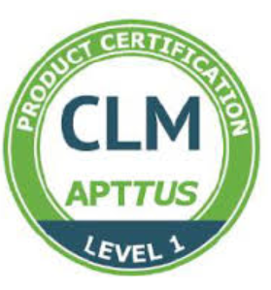

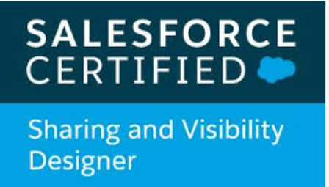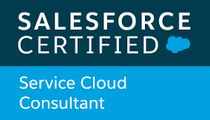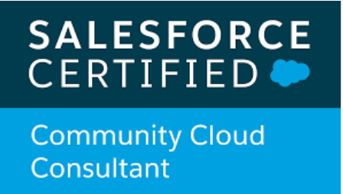
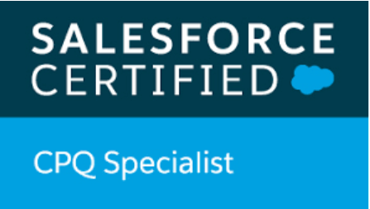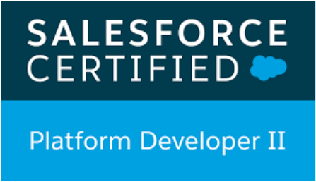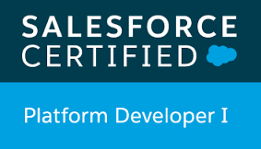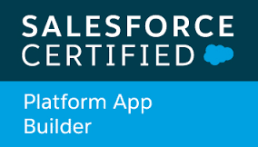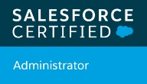

Professional Experience
Becton, Dickinson and Company, commonly known as BD, is an American medical technology company that manufactures and sells medical devices, instrument systems, and reagents. BD also provides consulting and analytics services in certain geographies  Responsibility as Team Lead:-  - Requirement gathering from stake holders  - Effort estimation  - Solution designing and Impact analysis  - Assigning the tasks to the team members  - Implement the requirement using Apttus CLM and CPQ  - Unit testing and Code review.  Environment:  Salesforce (Apttus CLM, Apttus CPQ, Apttus Approval Process, X-Author, Apex, Visualforce, Salesforce Out of the box, Lightning components, Workbench)  Responsibility as Team Lead:-  - Worked as a part of an Agile Team to deliver User Stories that meet customer expectations.  - Designed and developed the functionality as per the requirement and to achieve the business benefits.  - Unit testing and Code review.  - Effort estimation  - Worked with Salesforce Sales Cloud Application  - Territory Management  Environment:  Salesforce (Apex, Visualforce, Salesforce Out of the box, Approval Process, Process Builder and Workflows, Lightning components, Workbench)  Michelin CLM Team- Capgemini | Work as part of an Agile Team to deliver projects that meet customer expectations and achieve the business benefits
  Becton & Dickinson Apttus Team- Capgemini
  Team Lead
  Michelin Engage Team - Capgemini
  Team Lead /Scrum Team
  Michelin is a French tyre manufacturer based in France. It is the second largest tyre manufacturer in the world. In addition to the Michelin brand, it also owns the BFGoodrich, Kleber, Tigar, Riken, Kormoran and Uniroyal (in North America) tyre brands.
Team Lead/Scrum Team
Michelin is a French tyre manufacturer based in France. It is the second largest tyre manufacturer in the world. In addition to the Michelin brand, it also owns the BFGoodrich, Kleber, Tigar, Riken, Kormoran and Uniroyal (in North America) tyre brands.

Responsibility as a Team Lead–

- Worked as a part of an Agile Team to deliver User Stories that meet customer expectations.
- Attended Scrum ceremonies
- Designed and developed the functionality as per the requirement
- Unit testing and Code review.
- Effort estimation
- Solution designing using Apttus Contract Management
- Implementation of Apttus Contract Wizard
- Salesforce Visual Flow
- Apttus Template creation and field mapping usinf X-Author
Environment:
Salesforce (Apex, Visualforce, Lightning components, Workbench, Apttus Contract Management, Apttus Contract Wizard, X-Author, Approval process, Workflows)

JCI Selection Navigator Team - Capgemini
Developer/Scrum Team
Johnson Controls International Plc. is a global diversified technology and multi industrial leader serving a wide range of customers in more than 150 countries. It uses salesforce to Single point of entry (portal) and community for all channels,Configuration, pricing and quoting.
Responsibility as a Team member–

- Worked as a part of an Agile Team to deliver User Stories that meet customer expectations.
- Designed and developed the functionality as per the requirement and to achieve the business benefits.
- Unit testing and Code review.
- Integration with SharePoint and .Net.
- Effort estimation

Environment:

Salesforce (Apex, Visualforce, Javascript, HTML, CSS, JQuery, Workbench)
Honeywell, HRS Team - TCS
Developer/Scrum Team
The HRS app allows employee to raise a query or request with HR team and track the status of the request by
case raised with the the concerned team.

Responsibility as a Team member–

- Administered incident response and break-fix systems.
- Designed and documented relevant system code and configurations.
- Email- to-Case Set Up.
- Auto Response rules, Assignment Rules and Escalation Rules.
- Developed Visual force pages using Apex for proprietary Salesforce application to track the flow of business.
- Created custom objects and its related reports /dashboards to hide data access from other profiles across the
organization.
- Planned, scheduled, and directed all operational activities in work area to ensure optimum utilization of resources,
and abilities and to assure timely completion of work.
- Monitor problem tickets and support resolution for supported applications
Environment:
Salesforce (Apex, Visualforce, Salesforce Out of the box, Workbench, Data Loader, Jitterbit)

The Home Depot, Retail– TCS
Developer
The Home Depot is an American company, headquartered in Atlanta Store Support Center Cobb County, Georgia, U.S. s a home improvement supplies retailing company that sells tools, construction products, and services.

Responsibility as Developer:-

- Translate requirements into clearly defined technical tasks.
- Conduct technical design reviews and demos to the customer
- Implemented service cloud for customer’s business requirement.
- Create user manuals for new applications and train users till total adoption.
- Work on new acquisitions data: Data mapping and loading into our database.
- Designed Workflow rules, Visual force pages and using Apex
Code created triggers and classes
- Created Sharing rules for user groups and day to day permission to the users and support issues Sandbox refreshes.
- Designed & deployed Custom tabs, Custom Objects,
Components, Visualforce Pages, validation rules, Approval
Processes and Auto-Response Rules for automating business logic.

Environment:
Salesforce (Apex, Visual Force, Salesforce Out of the box, Workbench, Data Loader)

Developer

Western Union Money Transfer - Mphasis
Senior Analyst/Developer
The Western Union Company is an American financial services and communications company, which has been dealing with person to person money Transfers, money orders and various other types of transfers, Business payments and commercial services. Also the detailed consumer information which includes name, ID number, country, phone etc. is maintained in the data base.

Responsibility as Analyst/Developer:-

- Monitor the Cycles and ensure on time completion as per SLA.
- Monitor repeated Oncall Incidents and Offer the solutions to reduce Oncall incidents.
- Fix the bugs in the application to generate correct information, or handle error.
- Preparing technical design documents, test cases, test evidences
- Working on Adhoc requests
- Working on Production Support/On Call during Offshore time

Environment:

AS/400 (CL/400, RPG, COBOL/100, SQL/400, DB2/400, Synon)

Education Details

Qualification | Specialization | Percentage | Name of University | Active Year
B.E. (Bachelor of Engineering) | E&TC (Electronics & Telecommunication Engineering) | 64.6% | University of Pune,  Maharashtra, India | 2007-20011
12th (Intermediate) | Science | 86.4% | CBSE (Central Board of Secondary Education) | 2006-2007
10th (Matriculation) | General (Full Time) | 86.6% | CBSE (Central Board of Secondary Education) | 2004-2005

Personal Details
Name | Piyush Sontakke
Birth Date | 17-07-1989
Residence | Flat No- C-506, GK Royale Hills, Ravet, Pune - 412101, India
Nationality | Indian
Maritial Status | Married
Gender | Male
Passport Details | L7079880

