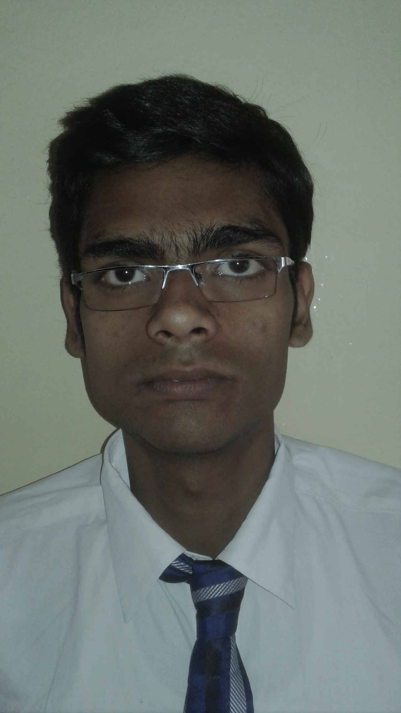

**CURRICULAM VITAE**  
**Name:** RAJIT DAS  
**Contact no:** 8918603605 / 9474313258  
**Email:** [rajitmldt@gmail.com](mailto:rajitmldt@gmail.com)

**CAREER OBJECTIVE**

**To implement my skill and knowledge towards the development of my organization and reach to**

**my full potential.**

**ACADEMIC QUALIFICATIONS**

|  |  |  |  |  |  |  |
| --- | --- | --- | --- | --- | --- | --- |
| **QUALIFICATION** | **UNIVERSITY** | **INSTITUTION** | **YEAR** | **SEMESTER** | **POINT** | **AVERAGE** |
| B.PHARM | MoulanaAbulKalam Azad University of Technology | Gupta College Of Technological Sciences | 2014 - 18 | 7th,8th 6th 5th 4th 3rd 2nd 1st | 8.30,7.71 7.67  7.18  6.71 6.48  6.90 7.08 | 7.36 |

|  |  |  |  |  |
| --- | --- | --- | --- | --- |
| **EXAMINATION** | **BOARD** | **INSTITUTE** | **YEAR OF PASSING** | **PERCENTAGE** |
| **Higher Secondary** | **ISC** | **The St. Xavier’s School, Malda** | **2014** | **75** |
| **Secondary** | **ICSE** | **The St. Xavier’s School, Malda** | **2012** | **82.75** |

PERSONAL INFORMATION

**NAME :** Rajit Das

**DATE OF BIRTH :** 3rd November 1995

**FATHER’S NAME :** Late Mr. Projesh Das

**MOTHER’S NAME :** Mrs. Sumana Das

**ADDRESS - GREEN PARK NEAR BISWARANJAN JALADHAR**

**MALDA - 732103**

**P.O - MOKDUMPUR**

**P.S - ENGLISH BAZAR**

**HOBBIES - Bike Riding ,Travelling**

**EXTRA CURRICULAR ACTIVITIES - Cricket,Football,Badminton**

**WORKING EXPEEIENCE - 1.WORKED AT ZUVENTUS HEALTHCARE LTD FROM JUNE 6 ,2018 TO OCTOBER 20,2018**

2. WORKED AT BHARAT BIOTECH INTERNATIONAL LTD AS A BUSINESS EXECUTIVE FROM OCTOBER 22 ,2018 TO JUNE 1 ,2019

3.WORKED AT GLAXO SMITH KLINE PHARMACEUTICALS LTD FROM JULY 2,2019 TO MARCH 30 ,2020

4.PURSUING MBA FROM WELLINGKAR INSTITUTE OF MANAGEMENT SCIENCES IN MARKETING DEPARTMENT

ACHIEVEMENTS - 1.HIGHEST SALE IN TERMS OF PCPM AT BHARAT BIOTECH FOR THE FINANCIAL YEAR OF 2018- 2019

2. RECEIVED CERTIFICATES FOR THE HIGHEST SALE OF NUKAST AND PROGERMINA IN THE YEAR OF 2018

B.PHARM PROJECT - A MARKETING SURVEY OF PROPANOLOL

LANGUAGES ( BOTH READ AND WRITE)- ENGLISH,BENGALI,HINDI

KNOWLEDGE - MS EXCEL,POWER POINT

DECLEARATION- I hereby declare that all the informations mentioned above are correct and I take the responsibility to ensure the correctness of the informations mentioned .

Signature - Rajit Das